**IBISHUSHANYO MBONERA**

**Imikoreshereze y’ubutaka**

**Itege itegeko No 24/2012 ryo kuwa 15/06/2012** ryekeye igenamigambi ry’imikoreshereze n’imitunganyirize y’ubutaka mu Rwanda. Iri tegeko rigamije gushyiraho igenamigambi ry’imikoreshereze n’imitunganyirize y’ubutaka mu Rwanda,hari aho berekana igice cy’ubutaka bw’Akarere bwagenewe ibikorwa by’iterambere ry’umujyi.

**-Hari igishushanyo mbonera kigaragaza imikoreshereze y’ubutaka nk’ahafatwa nk’umujyi mu Karere**

**-Hari imikoreshereze y’ubutaka bumwe:**

-Aho berekana uburyo bw’imikoreshereze y’ubutaka mu Mijyi cyangwa imidugudu irangwa n’uduce tw’ubutaka dukoreshwa turiho imikoreshereze y’ubutaka itandukanye kandi ivanze

IKARITA IGARAGAZA IMIKORESHEREZE Y’UBUTAKA MU KARERE

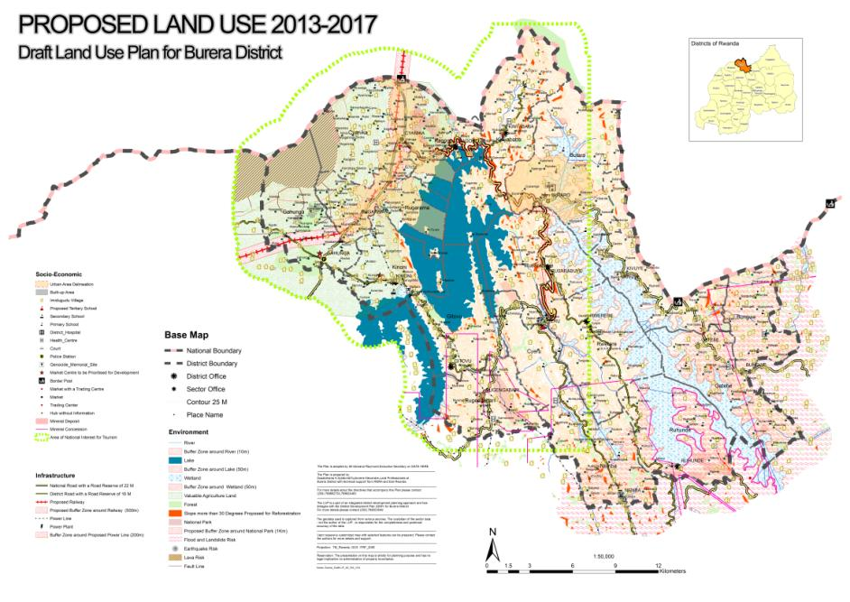

**IGISHUSHANYO MBONERA CY’UMUJYI W’AKARERE**

-**Itegeko No10/2012 ryo kuwa 05/02/2012 rigena imitunganyirize y’Imijyi n’imyubakire mu Rwanda,** mu ngingo yaryo ya 43 ivuga icyo igishushanyo mbonera cy’imitunganyirize y’ahantu n’umujyi cyigamije:

-cyerekana mu buryo bwa rusange,icyo ubutaka bwa buri gice cy’umujyi bugenewe gukoreshwa,kijerekana ibice bigomba kwinjizwa mu mujyii cyagwa ahagomba kurindwa kubera umwihariko waho n’ahagomba gushyirwa ibikorwa remezo

**Ingingo yaryo ya 44** ivuga uburyo igishushanyo mbonera cy’imitunganyirize y’ahantu n’Umujyi gitegurwa,cyemezwa,gihindurwa,gisubirwamo n’uko gitangazwa.

Ibishushanyombonera by’Imijyi y’Akarere byemejwe kuwa 10/09/2016 n’InamaNjyanama y’Akarere ubu cyatangiye gushyirwa mu bikorwa.

AMAKARITA Y’IBISHUSHANYOMBONERA BY’IMIJYI Y’AKARERE KA BURERA:(RUSUMO, BUKAMBA) YEREKANA AHO IBIKORWA BITEGANYIJWE MU MIJYI

