**REPUBULIKA Y'U RWANDA**

**UMUJYI WA KIGALI**

**AKARERE KA GASABO**

**Website : [www.gasabo.gov.rw](http://www.gasabo.gov.rw)**

**Email : [info](mailto:gasabo_district@yahoo.com)@gasabo.gov.rw**

**P O BOX 7066 KIGALI**

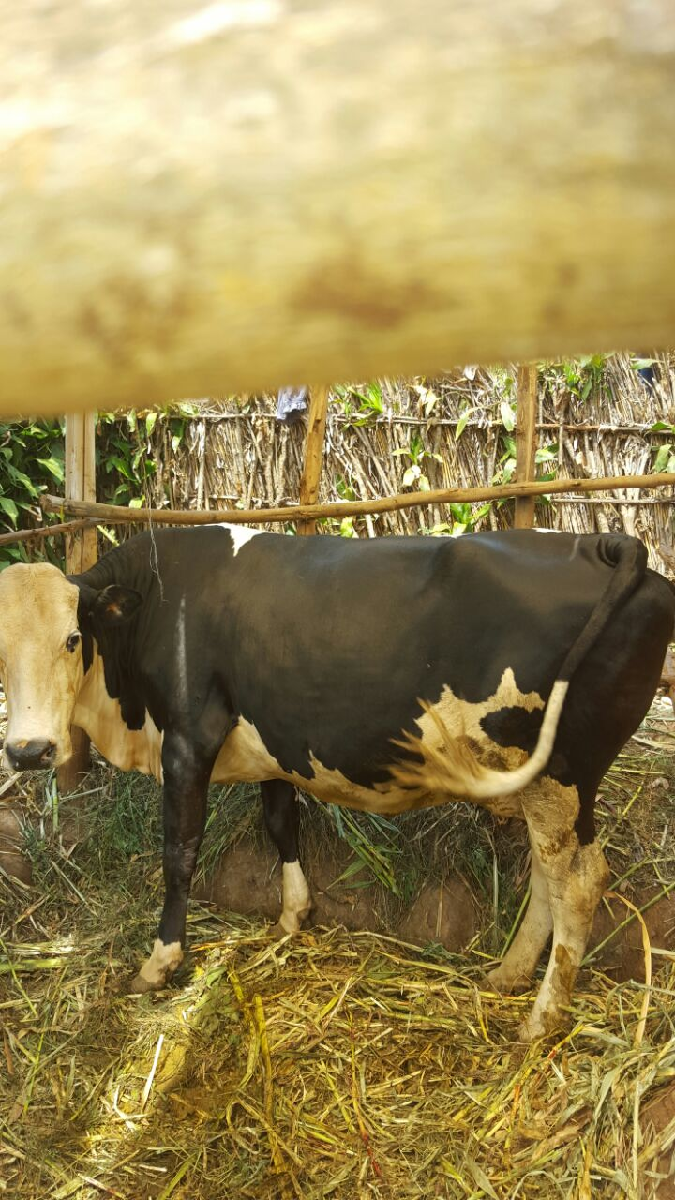

**INCAMAKE Y’IBYAVUYE MU ICUKUMBURA RY’IBIJYANYE NA GAHUNDA YA GIRINKA MU MIRENGE IGIZE AKARERE KA GASABO.**

**Nyakanga 2016**

**IBYIZA BYAGARAGAYE MU ICUKUMBURA RYA GAHUNDA YA GIRINKA.**

Itsinda ryagiye mu isuzuma, ryasuye buri muryango ukennye worojwe inka kuva 2006 kugeza muri Kamena 2016. Ryagaragaje ko abaturage bagiriwe umumaro na Girinka munyarwanda, kandi bashimira cyane Nyakubahwa Perezida wa Repubulika Paul KAGAME wabagabiye.

**Bimwe muri ibyo**:

* Byashimangiye Ubumwe n’Ubwiyunge bw’Abanyarwanda
* Ubu bafite Ubuzima buzira umuze ku bana n’abakuru
* Abana babasha kwiga neza
* Kubona umusaruro mu buhinzi
* Byabafashije kugana ibigo by’imaii bizigamira bivuye ku musaruro uturuka ku mata n’ifumbire.

**6.1. Imbonerahamwe igaragaza imibare y’ibyavuye mu isuzuma**

|  |  |  |  |  |  |  |  |  |  |  |  |  |  |  |
| --- | --- | --- | --- | --- | --- | --- | --- | --- | --- | --- | --- | --- | --- | --- |
| **Umurenge** | **Izatanzwe** | **Iziriho** | **Izapyuye** | **Izagurishijwe** | **Izabyaye** | **Izitarabyaye** | **Izifite iherena** | **Izitarifite** | **Inzungu** | **Inyarwanda** | **Imvange** | **Izituwe** | **Izitituwe** | **Ibiraro** |
| BUMBOGO | 606 | 405 | 84 | 117 | 336 | 270 | 27 | 579 | 102 | 44 | 460 | 284 | 52 | 330 |
| JABANA | 207 | 144 | 38 | 25 | 132 | 75 | 31 | 176 | 115 | 5 | 87 | 86 | 46 | 143 |
| GIKOMERO | 396 | 322 | 36 | 38 | 178 | 218 | 73 | 323 | 226 | 6 | 164 | 170 | 8 | 269 |
| NDERA | 250 | 178 | 46 | 26 | 109 | 141 | 61 | 189 | 158 | 5 | 87 | 73 | 36 | 164 |
| RUSORORO | 329 | 248 | 40 | 41 | 190 | 139 | 67 | 262 | 51 | 5 | 273 | 98 | 92 | 285 |
| NDUBA | 909 | 646 | 46 | 217 | 598 | 311 | 106 | 803 | 360 | 77 | 472 | 309 | 289 | 530 |
| RUTUNGA | 350 | 303 | 28 | 19 | 208 | 142 | 76 | 274 | 161 | 24 | 165 | 118 | 90 | 189 |
| JALI | 339 | 303 | 14 | 22 | 177 | 162 | 47 | 292 | 80 | 36 | 223 | 132 | 45 | 219 |
| KINYINYA | 2 | 1 | 1 | 0 | 2 | 0 | 1 | 1 | 0 | 1 | 1 | 0 | 2 | 1 |
| REMERA | 1 | 1 | 0 | 0 | 0 | 1 | 1 | 0 | 1 | 0 | 0 | 0 | 0 | 1 |
| GATSATA | 3 | 3 | 0 | 0 | 3 | 0 | 0 | 3 | 0 | 0 | 3 | 0 | 3 | 2 |
| GISOZI | 2 | 0 | 0 | 2 | 0 | 2 | 0 | 2 | 0 | 0 | 2 | 0 | 0 | 0 |
| KACYIRU | 38 | 7 | 27 | 4 | 18 | 20 | 1 | 37 | 38 | 0 | 0 | 12 | 6 | 0 |
| **TOTAL** | **3432** | **2561** | **360** | **511** | **1951** | **1481** | **491** | **2941** | **1292** | **203** | **1937** | **1282** | **669** | **2133** |