**ISHAMI RY’ITERAMBERE RY’ISHORAMARI N’UMURIMO**

Ishami ry’Iterambere ry’Ishoramari n’umurimo ryashyizweho hagamijwe guteza imbere ibikorwa byose bijyanye n’ubucuruzi , ishoramari, amakoperative n’umurimo. Ibi byose iyo bitejwe imbere, ubukungu bw’Igihugu nabwo burazamuka ndetse bigatuma imibereho myiza y’Abaturage nayo iba myiza.

Mu ishami ry’Iterambere ry’Ishoramari n’Umurimo, harimo udushami duto dukurikira:

1. Agashami gato gashinzwe gahunda zifasha abantu kubasha gutangira ubucuruzi cyangwa Ishoramari (Start-up Development );
2. Agashami gato gashinzwe Iterambere ry’ibigo by’ubucuruzi bito n’ibiciriritse ndetse n’Amakoperative (SMEs and Cooperatives Development);
3. Agashami gato gashinzwe iterambere ry’Ishoramari na Serivisi z’imari cyangwa z’amafaranga (Investment promotion and Financial Services);
4. Agashami gato gashinzwe guteza imbere Umurimo (Employment promotion).

Dore bimwe mu bikorwa bikorerwa mu ishami ry’Iterambere ry’Ishoramari n’Umurimo:

1. Gufasha abantu gutangira ibikorwa bibyara inyungu binyuze ku gutanga ubumenyi n’amahugurwa, gutanga ubujyanama, gufasha abantu gukora no gucunga imishinga ibyara inyungu;
2. Guteza imbere ibigo by’ubucuruzi bito, ibiciriritse n’Amakoperative binyuze mu kubifasha gutangira, kubona ibyangombwa no gutanga inama, ubumenyi n’amahugurwa igihe ari ngombwa ndetse no gutanga ubundi bufasha igihe cyose bishoboka;
3. Gushakisha no kugaragaza amahirwe ahari mu ishoramari mu Karere hagamijwe gushishikariza abantu gushora imari mu Karere;
4. Gufatanya n’abafatanyabikorwa gushyira mu bikorwa gahunda zose zigamije kureshya abashoramari kugira ngo baze gukorera mu Karere;
5. Gushyira mu bikorwa ingamba zose zigamije gufasha abantu guhanga imirimo;
6. Gukusanya amakuru ajyanye n’imirimo mishya ihangwa n’itangwa;
7. Gushyira mu bikorwa politiki ya Leta y’umurimo.
8. Gushyigikira no guteza imbere ibikorwa bitanga akazi ku bantu benshi, cyane cyane akazi katari ubuhinzi.

Amafoto akurikira agaragaza bimwe mu bikorwa bikorerwa mu ishami ry’Iterambere ry’ishoramari n’umurimo:

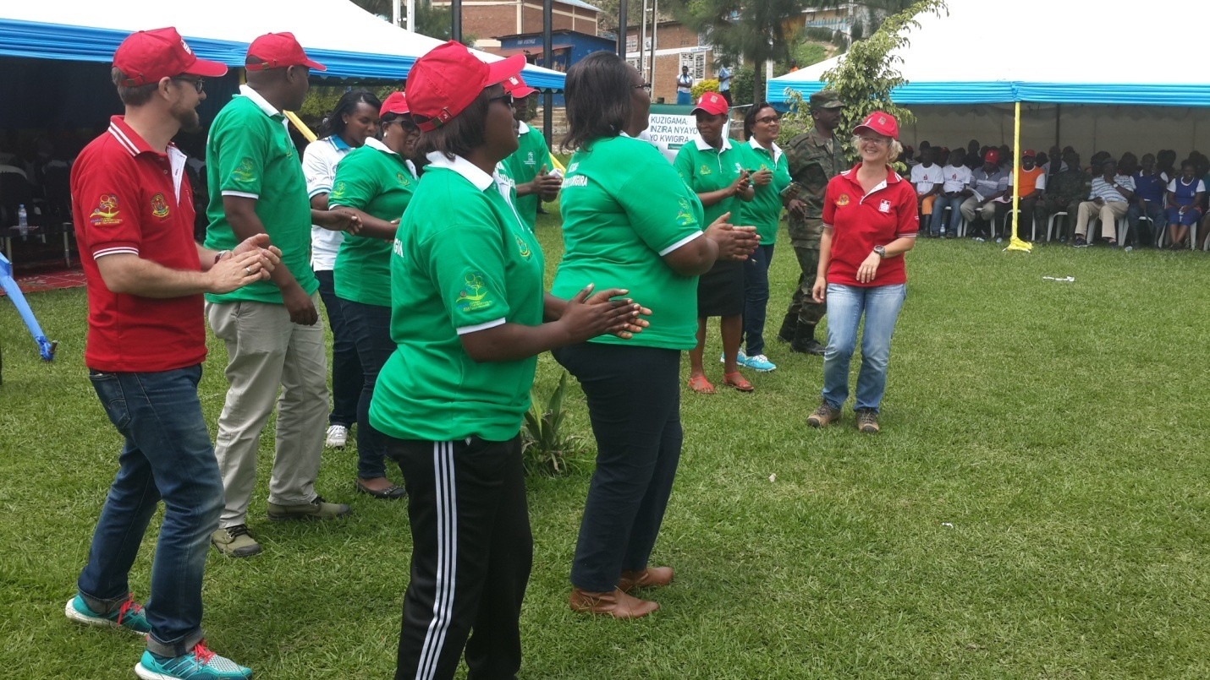

Aha hari ku munsi mukuru wo Kuzigama wizihijwe kuwa 29 Ukwakira 2016 mu Karere ka Karongi.

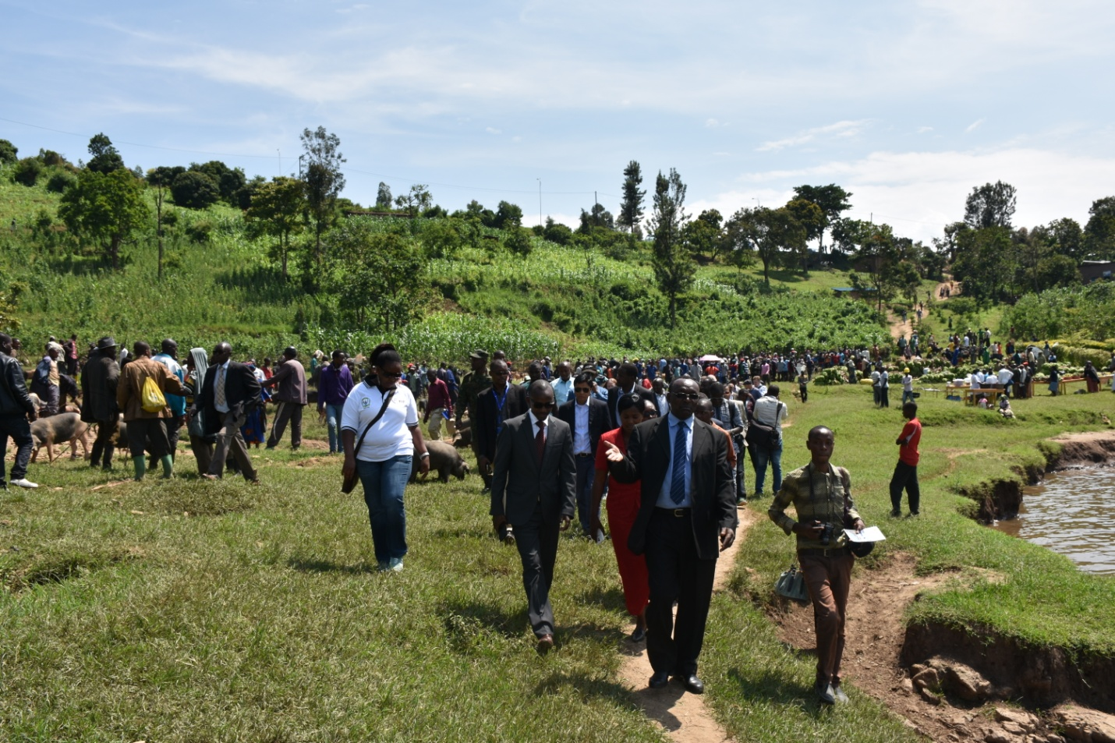

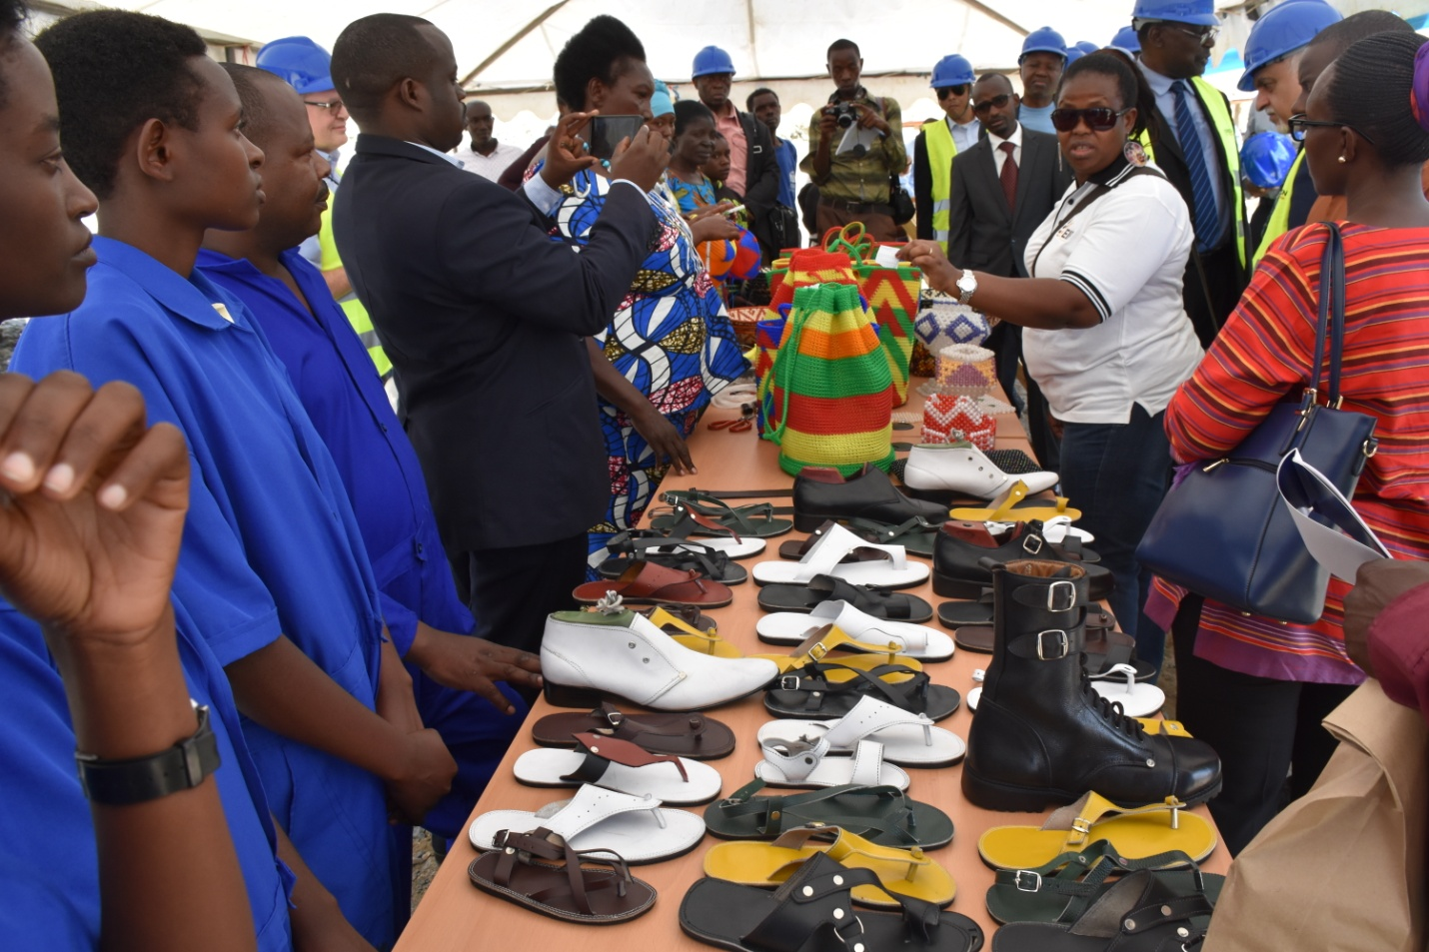

Aha Nyakubahwa Minister wa MINEACOM ari kumwe n’Abaterankunga basuye bamwe mu baturage bari kubakirwa isoko mpuzamipaka “Cross border Market” mu Murenge wa Bwishyura.

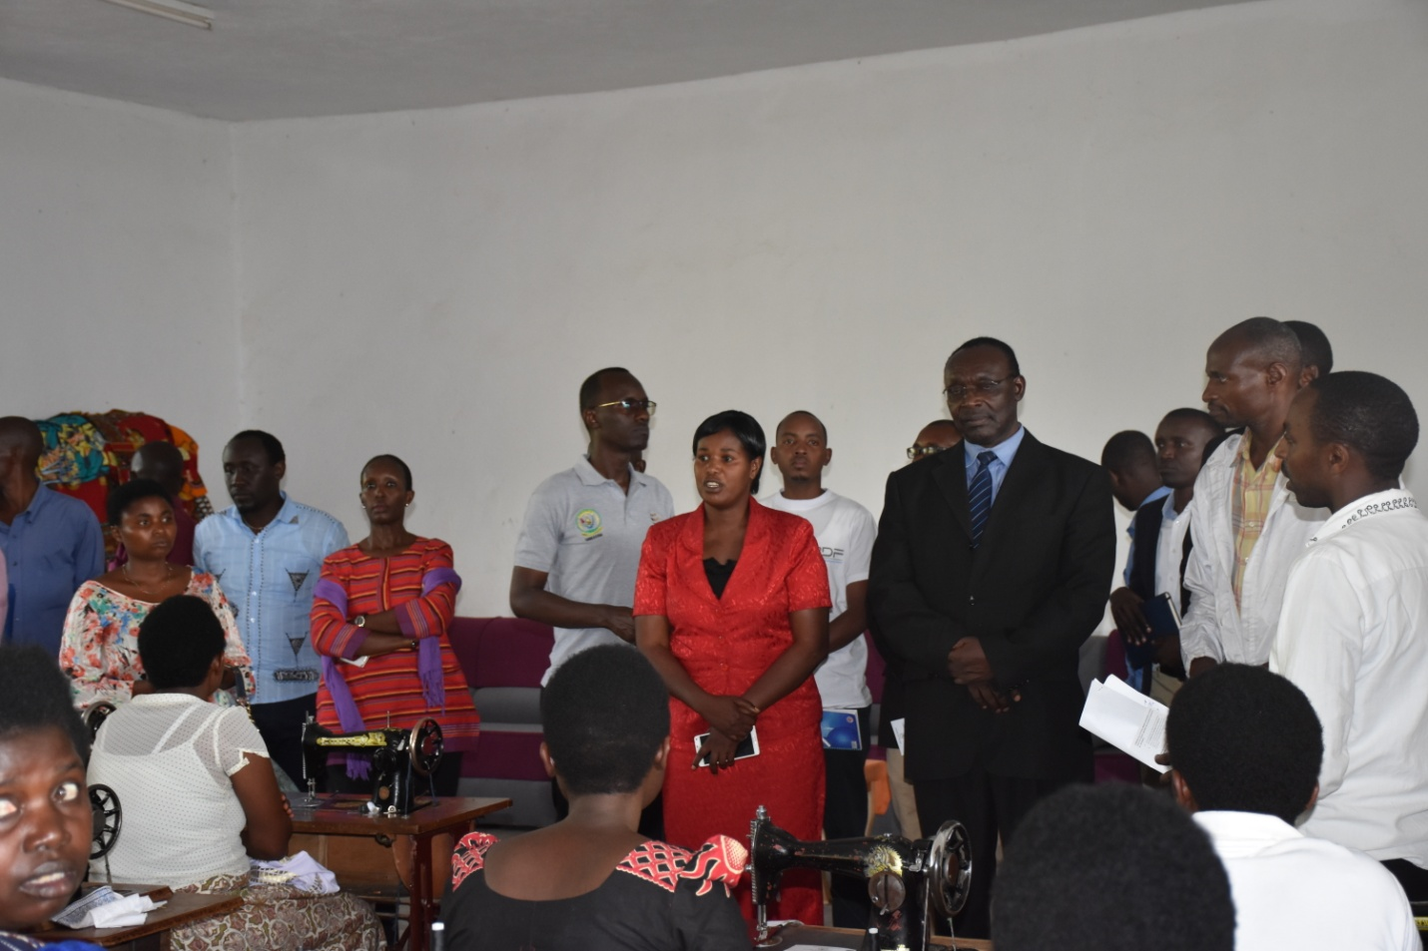

Aha Nyakubahwa Minister wa MINEACOM ari kumwe n’Abaterankunga basuye Agakiriro ka Karongi kari mu Murenge wa Rubengera, yaganiriye n’abagakoreramo.

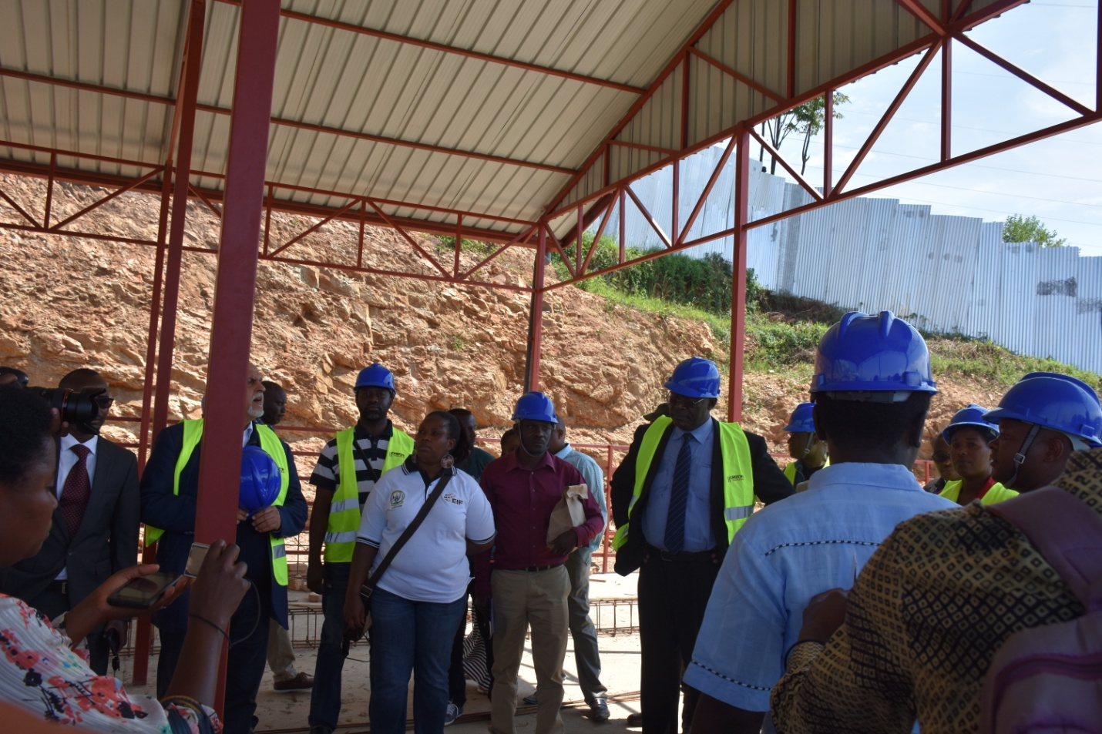

Aha Nyakubahwa Minister wa MINEACOM ari kumwe n’Abaterankunga basuye isoko mpuzamipaka “Cross border Market” riri kubakwa mu Murenge wa Bwishyura kuwa 02 Ukuboza 2017.

AHANTU NYABURANGA I KARONGI

* Ikiyaga cya KIVU;
* Uturwa turi mu Kiyaga cya Kivu
* Ibigabiro bya Rwabugiri;
* Urutare rwa NDABA;
* Isoko ya Nile.

AMAHOTELI ARI MURI KARONGI

|  |  |  |
| --- | --- | --- |
| NO | HOTELI | AHO IHEREREYE |
| 01 | MORIAH HOTEL | Bwishyura |
| 02 | HOTEL GOLF EDEN ROCK | Bwishyura |
| 03 | HOLIDAY HOTEL | Bwishyura |
| 04 | HOME SAINT JEAN | Bwishyura |
| 05 | COMORAN LODGE | Bwishyura |
| 06 | BETHANY HOTEL | Bwishyura |
| 07 | BEST WEST ECO HOTEL | Bwishyura |
| 08 | ROMANTIC HOTEL | Bwishyura |
| 09 | RWIZA | Bwishyura |
| 10 | MACHEO | Bwishyura |