**RAPORO Y’IGIKORWA CYO GUTOZA ITORERO RY’ABATOZA BO KU RWEGO RW’IMIRENGE CYABEREYE KURI DUDC RUBENGERA MU KARERE KA**

**KARONGI KUWA 7-8/8/2014**

1. **Iriburiro**

Mu KarerekaKarongikuri District Ubutore Development Center (DUDC) yaRubengerahabayeigikorwacy’iminsiibiricyogutozaabatozab’Intorebakomokamuriburimurenge mu mirengeigizeAkarerekaKarongi.

Igikorwacyogutozacyateguwegikurikiyegahundayogutozaabatozabokurwegorw’Akarerebaribamazegutorezwa I Nkumbakuvakuwa 25/06 kugezakuwa 03/07/2014 mu rwegorwoguteguraabatozab’Intorebazatozokurugerero, abazatoza mu itoreroryo mu mashuri, abazatoza mu ItoreroryokuMudugudundetse no gutoza mu nzegoz’imirimo.

Integorusangey’igikorwayariiyogutozaabatozab’IntorebazatozaIntorezokurugeerero, abatozab’Itorero mu mashuri, abatozab’Intore mu itorerokuMudugudundetse no mu nzegoz’imirimobatozwaindangagaciroremezon’izizishamikiyehozigishwa mu Itorerory’igihuguhashingiwekumitorezemishya.

Integozihariyezari :

* Gutozakurwegorwa DUDC abatozab’Intore 130 baturutse mu mirenge 13 igizeAkarerekaKarongihiyongereyehon’abagizeKomitempuzabikorwan’abarinzib’Indangagacirokurwegorw’Akarerebatozwaindangagaciroz’umuconyarwanda ;
* UburyobwoguteguraigitaramoNjyarugamaba no guhiga;
* Imyitozongororamubiri ,Ikarasisisna physical fitness test,

1. **Ukoigikorwacyitabiriwe**

Murirusangekitabiriwen’abatoza 131 barimoabagore 16 n’abagabo 115

1. **Abatoje mu Itorerory’Abatozabatorejwe iNkumba:**

-NDAGIJIMANA Jean Damascene ,Umutahiraw’Intore mu Karere,

- MULINDANKIK-Michel Ushinzweuburezi mu Karere,

-Lt GASARABWE Pole Pole, Brigade Pc

-IP Rutebuka Jean Baptiste

-NTAWICUMURAME Nelson Umuyoboziw’Ikigocy’amashuri

MUNYANZIZA Placideushinzweimiyoboreremyiza mu Karerena IMANISHIMWE Bernard batashoboyekubonekakuberaindimirimoy’Akarerebarimo.

Harikandiabatahirabosebokurwegorw’imirengeukoari 13 bakababarayoboyeicyogikorwa.

1. **Uburyobwakoreshejwe:**

Umurongongenderwaho (approach): Kuzirikanauruharerw’abatozwa, Kuzirikanaubundibumenyibw’abatozwa no kuzirikanakogutozaindangagaciroaiigikorwagihoraho

Mu gutozahakoreshejweuburyobwokwigisha( lecture), Gukorerahamwe, kwigirakubandi , uburyobwokwigabakora( learning by doing),uburyobw’amashusho, imikorongiro,kuvugaibigwiby’Intorezaserutse mu masiboyazo no gutaramakw’Intore.

1. **Ukoigikorwacyagenzen’ikoimirimoyakurikiranye**

UMUNSI WA MBERE

**09:00 - 9:50:**Kwakiraabatozwano gufataibyicaro: SEO Bwishyurana SEO

RugabanoSEORwankuba. Aha abitabiriyebujujeamafishiburiwese;

**09:50 - 10:00:** Morale y’Intore: Nelson, abayobozib’amasibo;

**10:00 – 10:10 :**Ijambory’ikaze no kugaragazaikigamijwe: NDAGIJIMANA Jean

Damascene;

**10:10 - 10:30:**Ijamboryogutangizaamahugurwaryagombagagutangwana Mayor

w’Akarerearikontiyashoboyekuboneka

**10:30 – 10: 50:** Umwandiko “Kwivugaibigwi mu magambo make”byayobowenaLt

GasarabwePole pole;

**10: 50 – 11:05:** Gukoraamatsinda 10 hashingiwekuNdangagaciroremezon’izindi

ngingo:Ibibyayobowena NDAGIJIMANA Jean Damascene;

**11:05 – 13:30:** Ibiganiro mu matsinda: Abatozabokurwegorw’Akarerebose;

**13:30 - 14:30:**Ifunguroryakumanywa: SEO Rubengera;

**14:30 – 16:00:** Gusubira mu matsinda: Abatozabose

**16:00 – 18:15:** Kugaragazaibyavuye mu matsinda, buritsindarigombakugira

uriyoboyekugirangoagaragazeibyavuye mu itsindaahagarariye

akavunyishirizwana MULINDANKIKO Michel mu batozaamuvuga

ibigwi;

**18:30 - 18:45**: Kugaragazaukoumunsiwagenzebyakozwen’itsindaryaririshinzwe

ubwanditsi;

**18:45 – 19:45:**Gufataifunguroryanimugoroba;

**19:45- 22: 30**: Intorezarataramyehashingiwekumazone 4 kandiburitsindarigerageza

guhangaibishyakugezaibwobatinze no kujyakuryama.

**19:45- 21: 30**: KujyakuruhukabyakurikiranwaganaIP Rutebukaafatanyijen’abatahira

bo mu mirenge.

**UMUNSI WA II**

**6:00 - 8:30:** Physical fitness test+ ikarasisibyakurikiranwena Lt Gasarabwe Pole Pole

na IP Rutebuka. Gusabitewen’ukoabatozwabaribaturutse mu mirengeumwanyaarimutowowokubashyushyambereyokwiruka, twagiriweinamakokwirukabitakorwahagakorwa ‘’sit ups’’ na ‘’push ups’’ gusa. Ikingenziniukoabatozababonyeibyobazajyagutoza.

**8:30 - 9:20**: Gukoraisuku no gukarababyakurikiranwen’abatahira mu mirenge;

**9:20 - 10:00:**Gufataifungurorya mu gitondobyakurikiranwenaSEO Rubengera;

**10:00- 10:20 :**Ikiganirokugitaramo , guhigakw’Intore no gukoraamatsinda 4

azitoramoabaserukiraabandi mu gitaramocy’imihigoNjyarugamba:

NDAGIJIMANA Jean Damasecene+ Lt Gasarabwe Pole pole

**10:20 – 12:30:** Guteguraigitaramo;

**12:30 – 13:30** Gutarama no guhigabyayobowena MULINDANKIKO Michel;

**13:30 – 13:45 :**kugaragazaukogutozabyagenzebyakozwena NDAGIJIMANA Jean

Damascene;.

**13:45- 14:00**: IjamborisozaryUmushyitsimukururyatanzwenaMadamu ISIMBI Dativa

Umuyoboziw’Akarerewungirijeushinzweimiberehomyiza;

**14:00-** Habayehoguhabwaitiki,gufungura no gutaha.

Igikorwacyarangiyeintorezihigiyekuzatozaibyiciroby’abatozabitandukanyenk’ukobyagaragajweharuguru. Vice Mayor ASOC yabemereyekoAkarerekazateguraintango y’’abahiziizasomwahon’uweshejeumuhigo. Hazabahon’umwanyawogusuzumaukobizajyabigendabikorwa.

Amwe mu mafoto mu gikorwacyogutozakuri DUDC

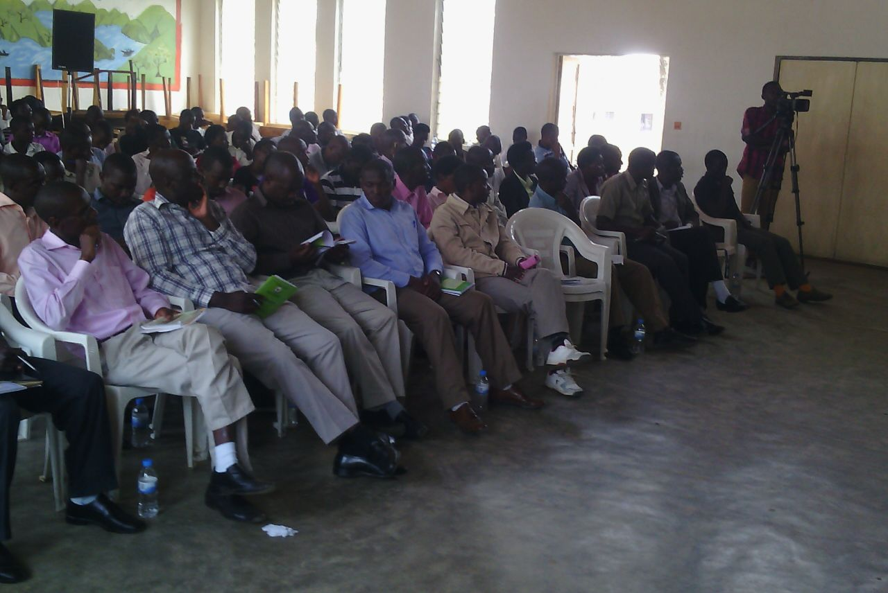

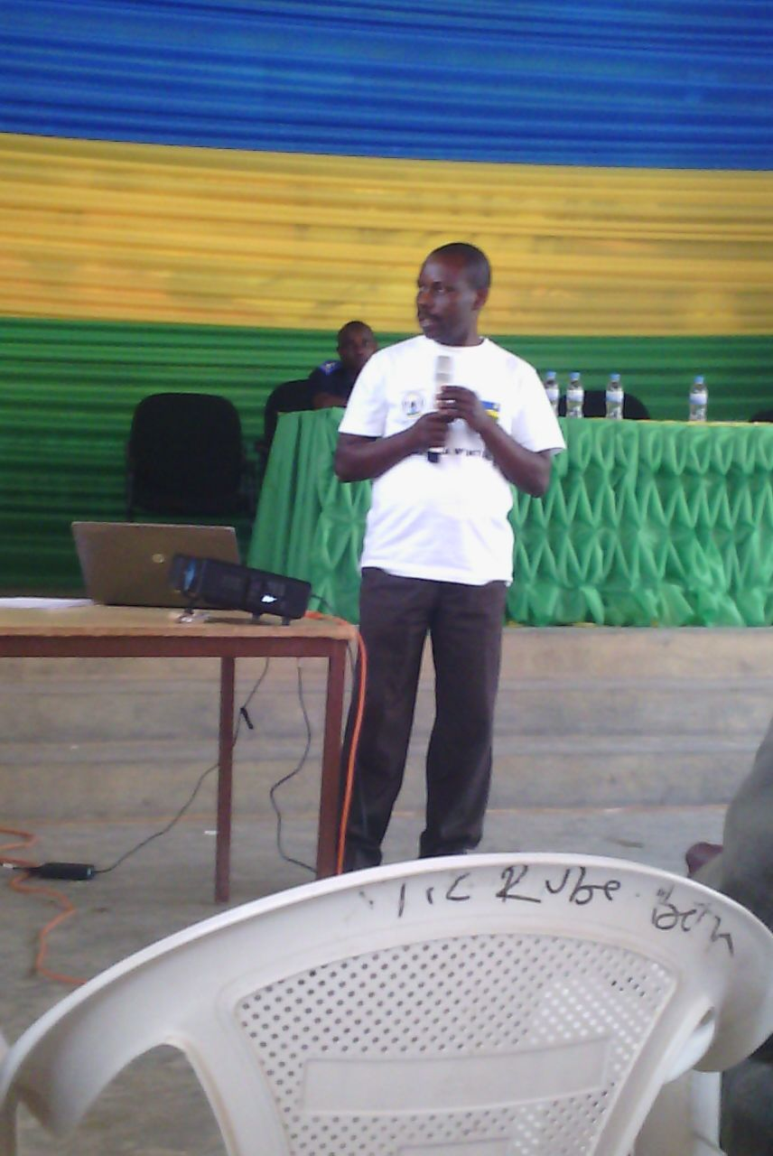

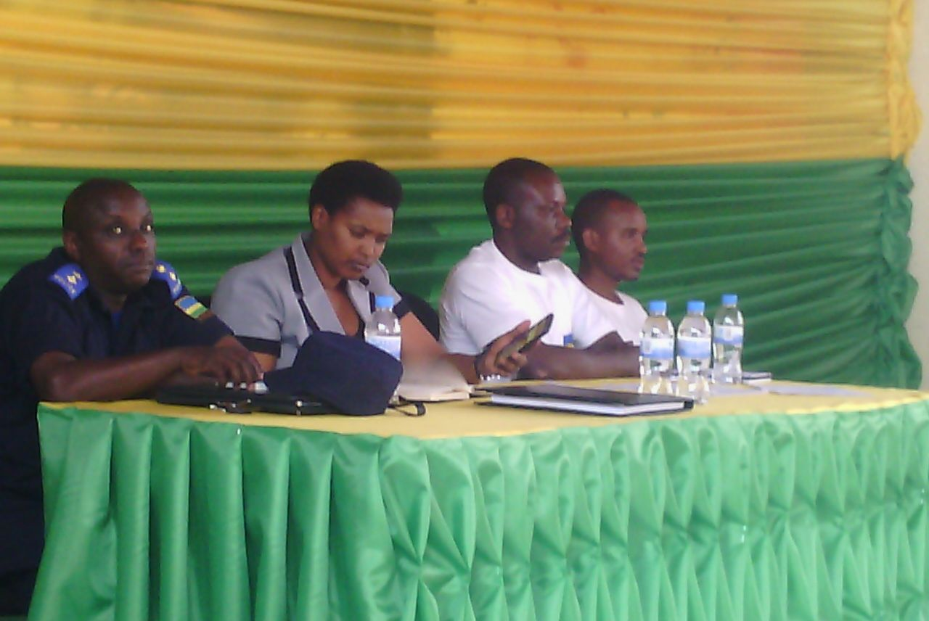

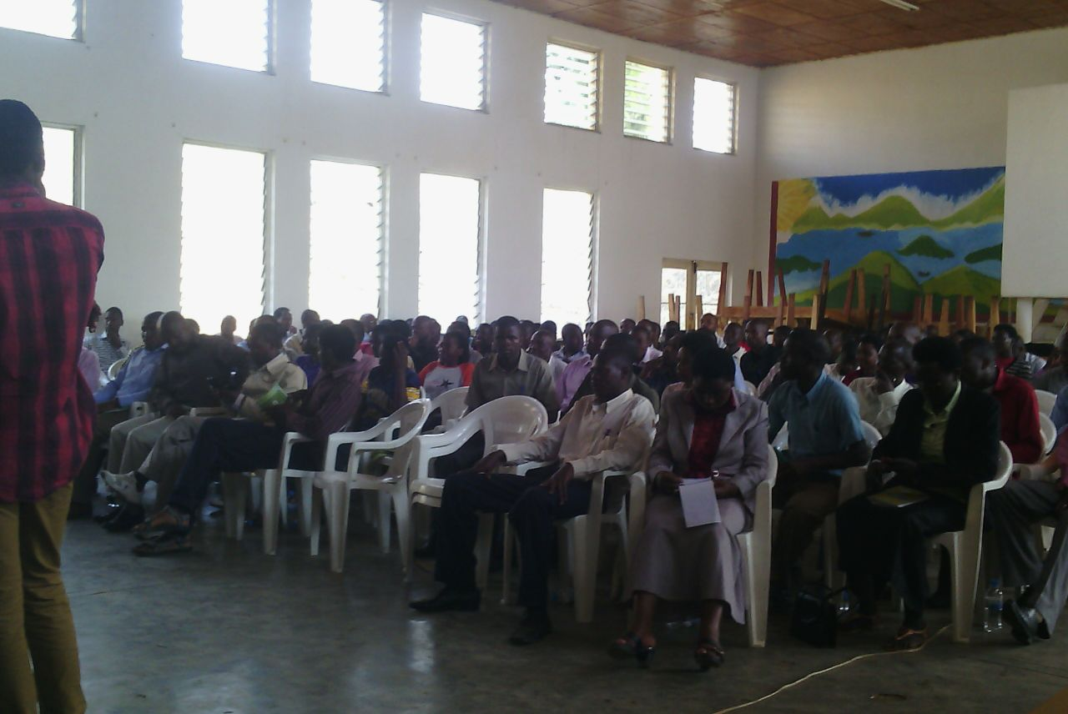

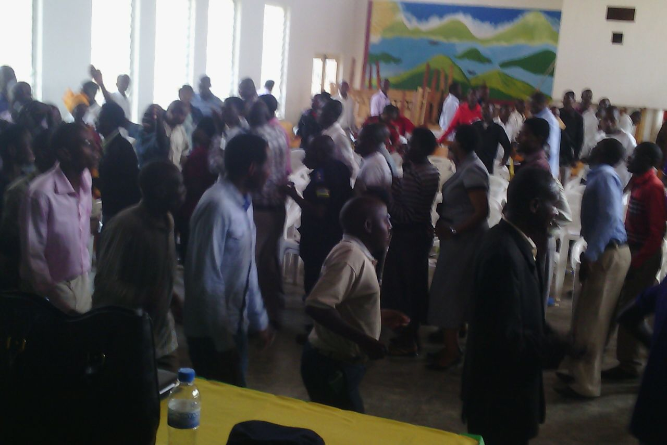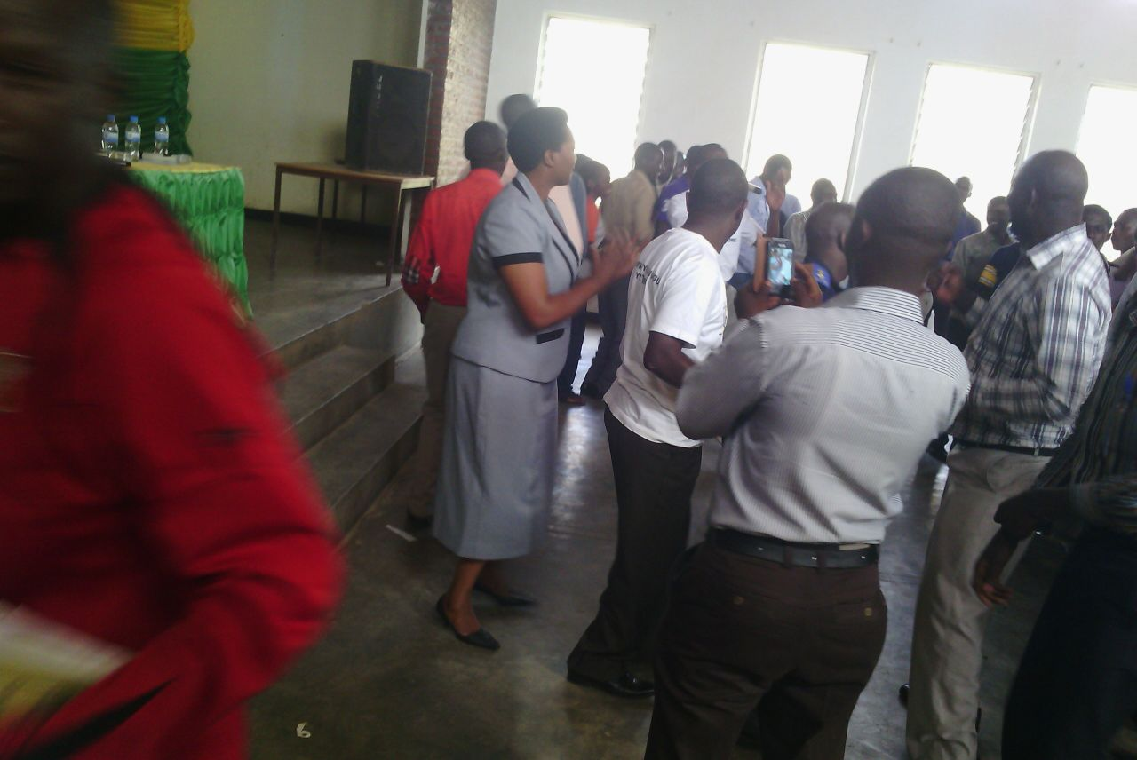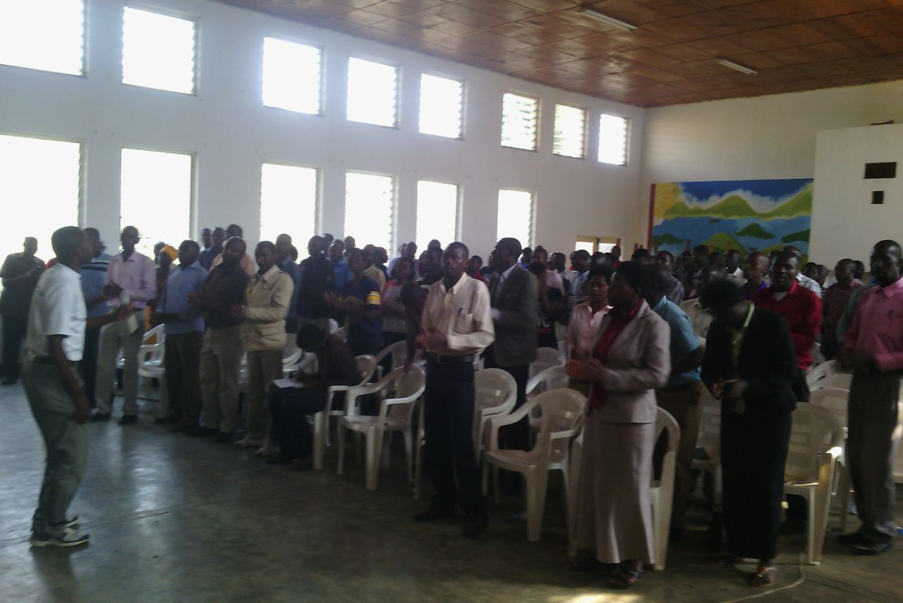

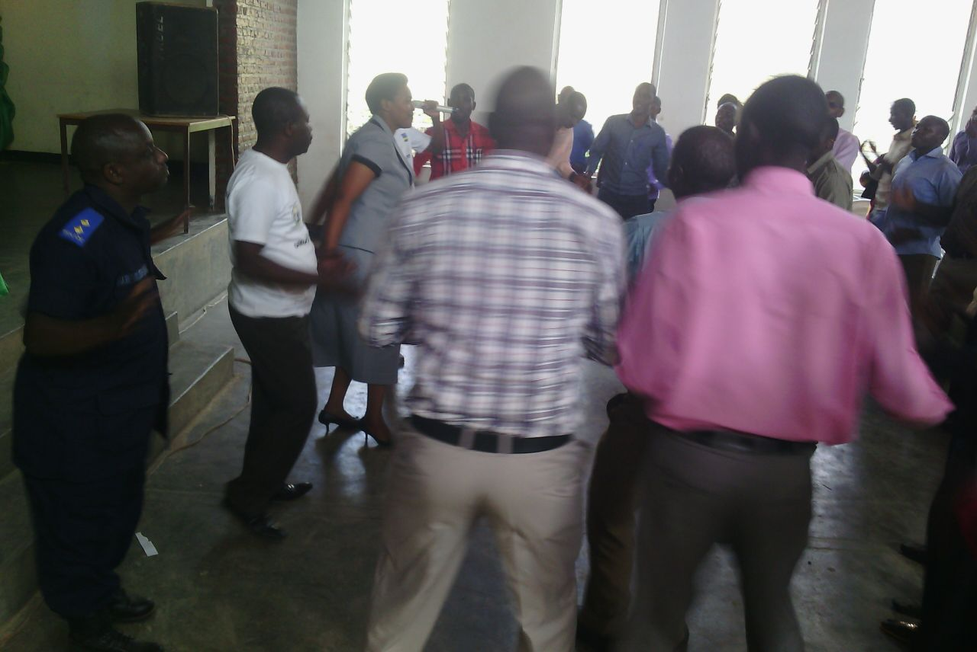

Bikorewe I Karongikuwa 10/8/2014

**NDAGIJIMANA *Jean Damascene***

UshinzweItorerory’Igihug mu Karere