REPUBULIKA Y’U RWANDA
[Year]

INTARA Y’I BURENGERAZUBA
AKARERE KA KARONGI
2016

RAPORO Y’IBIKORWA BY’ITORERO RY’IGIHUGU MU KARERE KA KARONGI
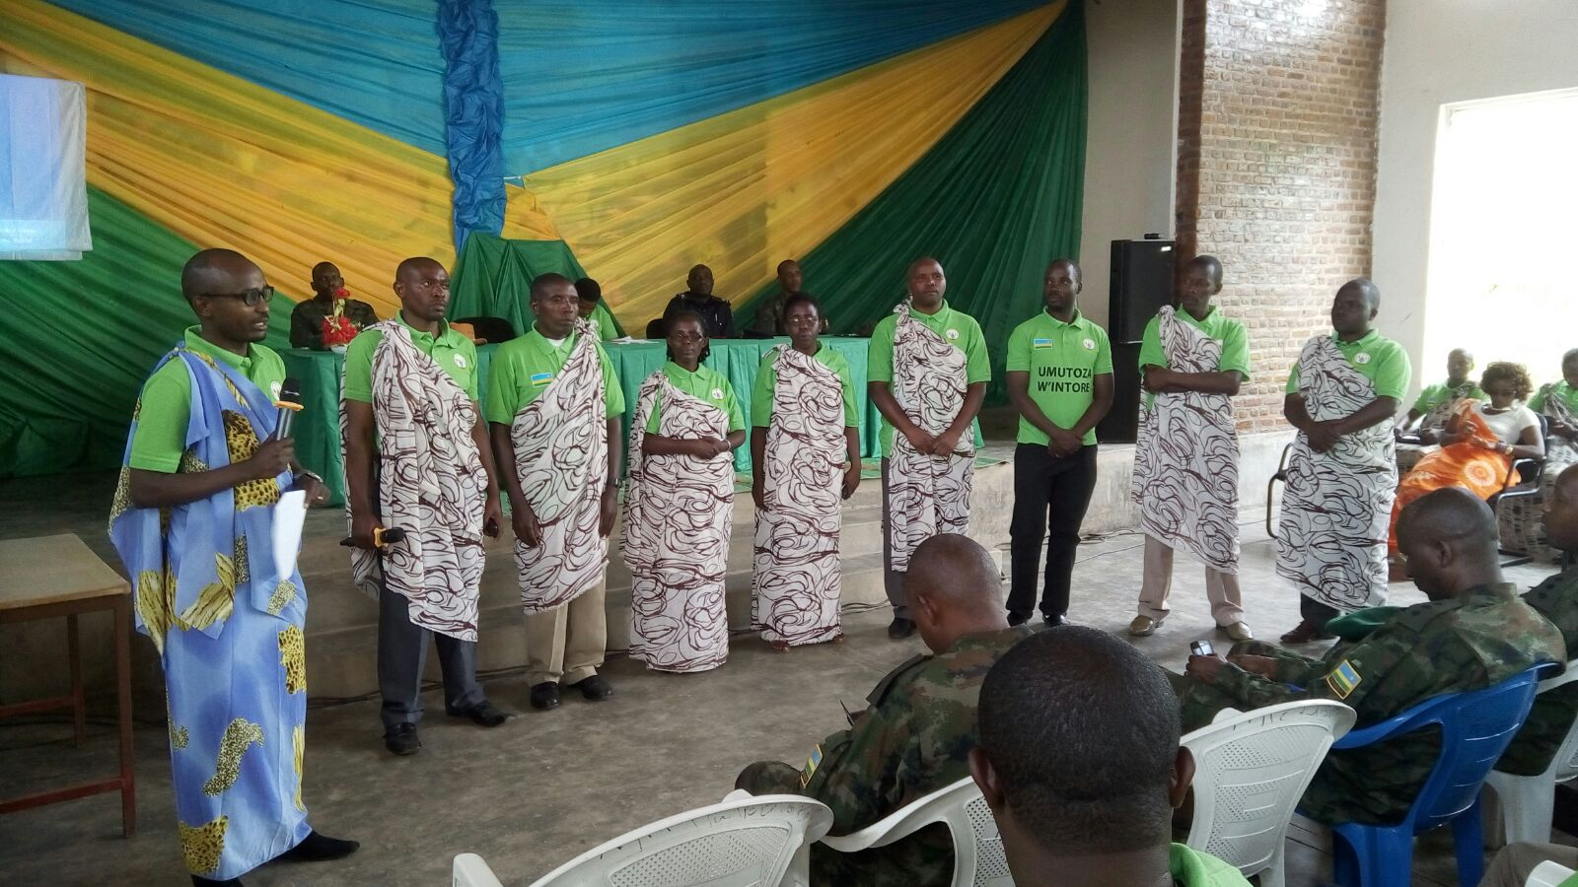
UMUVUZI W’AMACUMU KU KARERE YAKIRA IMIHIGO Y’ABATAHIRA MU MIRENGE BAHIGIYE KO BAZAKURIKIRANA IMIKORERE Y’URUGERERO MU MUHANGO WO KUVUGA AMACUMU KU BATOZA BATOJE INTORE ZO KU RUGERERO

REPUBULIKA Y‘U RWANDA 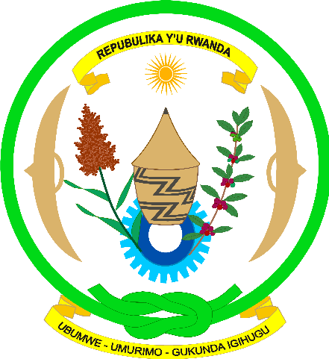

INTARA Y‘IBURENGERAZUBA
AKARERE KA KARONGI
E-mail: karongidistrict@karongi.gov.rw
P.O.BOX. 23 KIBUYE

RAPORO Y’IBIKORWA BY’ITORERO NO GUSOZA IGIHEMBWE CYA KABIRI CY’URUGERERO 2016 MU KARERE KA KARONGI
- Iriburiro:
Mu mwaka wa 2015-2016 muri serivisi y’ihuzabikorwa ry’ibikorwa by’Itorero ry’Igihugu hakojwe ibitandukanye birimo : Gutoza mu Itorero ry’Igihugu ibyiciro by’Intore haba ku rwego rw’Igihugu (NUDC) ndetse no ku Karere (DUDC), Gutoza no gukurikirana ibikorwa by’Urugerero rw’Inkomezabigwi icyiciro cya kane, Kwimakaza Indangagaciro na Kirazira, Gutegura Itorero ry’abarezi n’abakuru b’imidugudu, Gutoza Intore z’Ingamburuzabukene, Gutoranya no kohereza Intore z’indashykirwa zakoze neza Urugerero mu bigo nderabuzima kugira ngo zifashe mu bikorwa byo mu bwisungane mu kwivuza (MUSA),Gutanga ibiganiro kuri Radio Isangano, gukurikirana no gutanga ibiganiro ku gahunda ya Ndi Umunyarwanda.
Muri rusange byose byakozwe neza usibye ko ubushobozi bukiri buke kugira ngo serivisi ishinzwe Itorero ry’Igihugu ishobore guhuza no gukurikirana neza ibikorwa byose bikubiye muri iyo serivisi cyane ku birebana no gukurikirana Itorero mu mashuri , kubaka Itorero ku mudugudu no munzego z’imirimo n’ibikorwa byose byimakaza umuco w’ubutore hataragaragaramo ibikorwa byinshi umuntu yakwizera ko byagera ku mpinduka yihuse.
- Ibyiciro bitandukanye byatojwe mu mwaka wa 2015-2016
Muri uyu mwaka wa 2015-2016 hatojwe mu Itorero ry’Igihugu ibyiciro bitandukanye nk’uko imbonerahamwe ikurikira ibigaragaza birimo Innkomezamihigo,Imbonezamihigo, Indemyabigwi, Intagamburuzwa, Ingamburuzabukene, Impamyabigwi , Inkomezabigwi n’Indangamirwa nk’uko bigaragara mu mbonerahamwe ikurikira:

Ibyiciro byatojwe mu mwaka wa 2015-2016
Nº | Ibyiciro byatojwe | Aho batorejwe | Gabo | Gore | Bose
1 | Inkomezamihigo | UR Huye | 25 | 23 | 48
2 | Imbonezamihigo | Gabiro | 17 | 12 | 29
3 | Imbonezamihigo | Bugesera | 7 | 3 | 10
4 | Indemyabigwi | Nkumba | 8 | 2 | 10
5 | Intagamburuzwa | Nkumba, IPRC | 9 | 0 | 9
 |  | Induction week | 102 | 21 | 123
 |  | Nkumba, CMHS Nyamishaba | 5 | 4 | 9
 |  | Induction week | 209 | 119 | 328
6 | Ingamburuzabukene | UR Huye | 27 | 0 | 27
7 | Impamyabigwi | Nkumba | 2 | 1 | 3
8 | Inkomezabigwi | Kuri SUDCs Karongi | 921 | 964 | 1885
9 | Indangamirwa | Gabiro | 2 | 3 | 5
 | Total |  | 1334 | 1152 | 2486

NB: Twagombaga kuba twaratoje Indemyabigwi mu Itorero ry’abarezi bagera kuri 2739 nyuma ryimurirwa mu biruhuko uyu mwaka wa 2016-2017. Ikindi ni Itorero r’Abakuru b’Imidugudu naryo ritashoboye kuba ahanini hashingiwe ko manda y’abagombaga gutozwa yari irangiye bityo rikaba riteganywa mu mpera z’umwaka wa 2016 .
- Gutoza no gutuma Inkomezabigwi icyiciro cya kane ku Rugerero
  - Igikorwa cyo gutoza.
Kuwa 22/01/2013 nibwo Urugerero rwa mbere rw’Imbanzamihigo (2013), rwatangijwe na Nyakubahwa Minisitiri w’Intebe, hakurikiyeho Imparanirakurusha (2014), umwaka ushize habaye Inkomezabigwi icyiciro cya mbere (2015 ) none ubu muri uyu mwaka wa 2016 rukaba rugeze ku cyiciro cya kane ari narwo rwahawe izina ry’Inkomezabigwi (icyiciro cya kabiri).
Igikorwa cyo gutoza Inkomezabigwi icyiciro cya kabiri cyakorewe ku masite atandatu mu Karere ariyo y’aya akurikira.

Amasite yatorejweho n’uko abatozwa bari bagabanyijwe mu masite mu gihe cy’imyiteguro

Nº | Site | Imirenge | Imibare y’abatozwa mu mirenge |  |  | Total /umure | Total /site | Umuyobozi wa Site (course manager)
 |  |  | Gabo | Gore | Total
1 | TTC Rubengera | Bwishyura | 121 | 183 | 304 | 118 | 467 | BIKORIMANA Jean Baptiste
 |  | Rugabano | 69 | 54 | 123 | 123
 |  | Rubengera | 107 | 119 | 226 | 226
2 | ESAPAN Mugonero | Bwishyura | - | - | - | 186 | 400 | MUKURARINDA Elias
 |  | Gishyita | 58 | 65 | 123 | 123
 |  | Mubuga | 49 | 42 | 91 | 91
3 | GS Gisovu | Rwankuba | 85 | 99 | 184 | 166 | 385 | HABIMANA Jean Nepo
 |  | Twumba | 118 | 101 | 219 | 219
4 | ES Gasenyi | Gitesi | 55 | 74 | 128 | 128 | 356 | NTAWICUMURAME Nelson
 |  | Mutuntu | 133 | 77 | 210 | 210
 |  | Rwankuba | - | - | - | 18
5 | ES Kirinda | Murambi | 54 | 98 | 152 | 152 | 273 | MUKASHEMA Drocelle
 |  | Murundi | 54 | 67 | 121 | 121
6 | ES Urumuri | Ruganda | 55 | 57 | 112 | 112 | 300 | MUKARUKUNDO Clotilde
 |  | Gashari | 109 | 79 | 188 | 188
TOTAL |  |  | 1066 | 1115 | 2181 | 2181 | 2181

NB. Iyi mibare niyo yari iteganyijwe ariko siko baje bose kuko tugereranyije n’abatojwe usanga abatojwe bagera gusa kuri 86.4%. Hari imirenge usanga yararenze 100% ahandi bakaba bake. Byose biterwa n’uko iyo abanyeshuri barangije amashuri yisumbuye bahinduranya cyane aho bari basanzwe batuye mu buryo bwo gushaka amashuri cyangwa imibereho.
Igishya kiyongereyemo cyari ugukurikirana mu buryo busobanutse ikizamini cy’ubuzima buzira umuze , imikorongiro n’umuhango wo kwita izina kandi byose byashimishije abatozwa.

INCAMAKE MU MIBARE Y’ABATOJWE
N^{O} | Umurenge | Gabo | Gore | Total | %
1 | Bwishyura | 110 | 140 | 250 | 82.2
2 | Gashari | 54 | 55 | 109 | 57.9
3 | Gishyita | 55 | 61 | 116 | 94.3
4 | Gitesi | 68 | 77 | 145 | 117.8
5 | Mubuga | 51 | 36 | 87 | 95.6
6 | Murambi | 44 | 75 | 122 | 80.2
7 | Murundi | 46 | 62 | 108 | 89.2
8 | Mutuntu | 94 | 69 | 163 | 77.6
9 | Rubengera | 120 | 122 | 242 | 107
10 | Rugabano | 70 | 46 | 116 | 94.3
11 | Ruganda | 60 | 54 | 114 | 101.7
12 | Rwankuba | 65 | 81 | 146 | 79.3
13 | Twumba | 81 | 86 | 167 | 76.2
 | Total | 921 | 964 | 1885 | 86.4

  - Umuhango wo kuvuga amacumu kuri TTC Rubengera
    - Imibare y’abatoza batoje ku masite 6 batumiwe mu muhango wo kuvuga amacumu
No | Site | Abacivile | RDF | RNP | RF | DASSO | Bose
1 | TTC Rubengera | 22 | 6 | 2 |  | 4 | 34
2 | ESAPAN Mugonero | 25 | 6 | 3 | - | 4 | 38
3 | ES Gasenyi | 19 | 6 | 2 | - | 3 | 30
4 | GS Gisovu | 22 | 15 | 3 | - | 2 | 42
5 | ES Urumuri | 24 | 8 | 4 | - | 1 | 37
6 | ES Kirinda | 26 | 9 | 3 | 1 | 3 | 42
 | Total | 138 | 50 | 17 | 1 | 17 | 223
Aba niba nibo batumiwe mu muhango wo kuvuga amacumu.
Kuwa 27/1/2016 nibwo habaye umuhango wo kuvuga amacumu ku batoza bose batoreje ku masite 6 yari ateganyijwe mu Karere. Uwo muhango wabereye kuri DUDC ni ukuvuga kuri TTC Rubengera. Umushitsi wari muri ibyo birori ni Umuyobozi w’Akarere wungirije ushinzwe imibereho myiza y’abaturage Madamu Isimbi Dative. Hari kandi n’Umuvuzi w’Akacumu ku rwego rw’Akarere, Bwana Muhire Emmanuel ndetse n’inzego z’umutekano.
Aha rero abatoza bakuriwe n’Umutahira w’Intore ku rwego rw’Akarere, bavuze amacumu bagaragaza ibigwi byabo mu gikorwa bari batumwemo n’Umutoza mukuru w’Akarere. Uhagarariye umutoza mukuru yarabashimye ndetse anabemerera gusoma no ku Nzoga y’Abahizi.
Ikindi gikorwa cyabayeho ni uko abatahira b’Intore mu mirenge bahigiye kuzakurikirana Intore zimaze gutozwa aho zizaba ziri ku Rugerero kugeza rurangiye.
Nyuma y’umuhango abatoza bose bari bitabiriye uko ari 202 hamwe n’abayobozi basangiye inzoga y’abahizi nyuma bahabwa itiki barataha.
  - Uko Urugerero rwitabiriwe
Nk’uko amabwiriza agenga Urugerero abiteganya, mu Karere ka Karongi Urugerero rw’Inkomezabigwi icyiciro cya kane bakoze batangiye kuwa 27/1/2016 ubwo hakorwaga umuhango w’Intore mu zindi kuri buri Kagari basoza igihembwe cya mbere kuwa 1/4/2016. Igihembwe cya kabiri cyatangiye ku wa 22/4/2016 gisoza kuwa 24/6/2016.
Mu kazi ka buri munsi bakoraga amasaha 5 ku munsi kuva saa moya za mu gitondo kugeza saa sita no kuva kuwa mbere kugeza kuwa gatanu w’icyumweru.
Muri rusange n’ubwo imitoreze yashyizwemo ibishya byagaragaje ko bishimiye Itorero, wasanze Urugerero rutaritabirwe neza nk’uko byagenze umwaka ushize.
Ubwitabire mu bikorwa by’ubwitange ku rwego rw’Akarere hakurikijwe amezi bakoze
Ukwezi | Abahungu | abakobwa | Total | % | Agaciro k’ibyakozwe
Gashyantare | 597 | 671 | 1268 | 78.5 | 18 485 020
Werurwe | 573 | 594 | 1169 | 72.4 | 16 097 000
Mata | 552 | 596 | 1097 | 67.9 | 1 930 800
Gicurasi | 565 | 593 | 1158 | 71.7 | 3 500 600
Kamena | 598 | 612 | 1210 | 74.9 | 17 886 600
Average | 577 | 613 | 1190 | 73.7 | 57 900 020

Nk’uko bigaragara kuri iyi mbonerahamwe, ubwitabire mu mezi atanu buri ku mpuzandengo ya 73.7% ugereranyije n’abakoraga Urugerero babarizwa mu Karere bangana na 1614. Ibi bivuze ko nyuma yo gusuzuma abari ku rugerero mu Tugari twabo twasanze harimo abagiye ahandi cyangwa baje gutorezwa mu Karere ka Karongi atari abaho. Ariko ugereranyije n’abatajwe bangana na 1885 hatitawe ku baba mu Karere n’abatuye ahandi ariko batorejwe mu Karere, usanga ubwitabire ari 63.1%.
Ugereranyije ubwitabire mu bitsina byombi usanga usanga byaragiye bihindagurika ariko abakobwa nibo bitabiriye neza kurusha abahungu. Ndetse unabishyize mu mezi, ukwezi kwa mata niko gufite umubare muto tugereranyije n’andi mezi kuko banagizemo ikiruhuko.
Ikindi ni uko mu mezi yose nta mpinduka ihanitse yagaragaye ku buryo usanga imibare yenda kuba imwe mu mezi yose.

Igishushanyo kiri hasi kigaragaza uko bimeze.
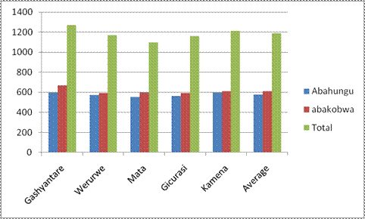
Iki gishushanyo kiragaragaza ubwitabire mu mezi atanu hakurikije ibitsina byombi n’ibitsina byombi.

  - Ibibare y’abo twasanze batitabira ubwo twakoraga isuzuma.
No | Umurenge | Gabo | Gore | Total
1 | Bwishyura | 46 | 55 | 101
2 | Gashari | - | - | -
3 | Gishyita | 10 | 10 | 20
4 | Gitesi | 10 | 6 | 16
5 | Mubuga | 14 | 9 | 23
6 | Murambi | 14 | 25 | 39
7 | Murundi | 8 | 19 | 27
8 | Mutuntu | 9 | 9 | 18
9 | Rubengera | 74 | 67 | 141
10 | Rugabano | 20 | 10 | 30
11 | Ruganda | 6 | 6 | 12
12 | Rwankuba | 44 | 23 | 67
13 | Twumba | 11 | 15 | 26
 | Total | 266 | 254 | 520
NB: imibare y’umurenge wa Gashari ntitwayishyizemo kuko tutayizeye kuko ukurikirana ibikorwa by’Itorero muri uwo murenge ataboneka muri iki gihe.
Iyi mibare kandi iragaragaza abataba mu Karere bagiye ahandi muri gahunda zihariye zitandukanye harimo, abasubiye kwiga kubera babuze diploma, abgiye mu mashuri makuru na kaminuza , abagiye mu tundi turere bimutse cyangwa mu miryango, abagiye gushaka akazi ahindi n’ibindi.
Ikindi ni uko agaciro k’ibyakozwe kangana n’amafaranga y’u Rwanda 57 900 020 nk’uko byagaragajwe mu mbonerahamwe igaragaza ubwitabire.
  - Impamvu hagaragaye ubwitabire buke

- Ihuzabikorwa mu Tugari ritakozwe neza kubera uruhare ruto abayobozi b’Utugari babigiramo kuko aho bita ku rugerero bigenda neza.
- Abo mu Nkambi ya Kiziba baza mu Itorero tukabatoza ariko ntibitabire Urugerero,
- Abajya kwiga muri Kaminuza cyangwa mu mashuri makuru bavuga ko bazakorera Urugerero muri kaminuza nko mu mirenge ya Rubengera na Bwishyura,
- Abandi nyuma y’amanota y’ibizamini bya Leta birangiza amashuri yisumbuye , mu bataratsinze hari abasubiye kwiga, abandi bacika intege bigumira iwabo ntibajya ku rugerero.
- Abitwaza kujya gushaka imibereho ntibajye ku Rugerero kuko banitwaza ko ari nta nkurikizi mu rwego rw’amategeko.
- Nko mu murenge wa Rubengera, Umuyobozi w’ishuri ry’Imyuga rya Rubengera yahaye akazi abarenga 10 bakirangiza amashuri yisumbuye Urugerero rutangiye ntiyabarekura ngo bakore Urugerero. Ibi byatumye Intore zo ku Rugerero muri uwo murenge nazo zitangira kujya zishakisha akazi.

  - Ibikorwa bitandukanye byakozwe
- Ubukangurambaga
- Intore zo ku rugerero zigishije abakuze gusoma, kwandika no kubara;
- Intore zigishije amashuri y’incuke;
- Zakoze ubukangurambaga ku kwitabira amatora;
- Kurwanya malaria n’ibindi byorezo;
- Kwirinda ibiyobyabwenge n’inda zidateganyijwe;
- Gukoresha ifumbire;
- Gusubiza mu ishuri abaritaye;
- Ubukangurambaga ku kwita ku isuku no kuyigenzura mu ngo , ku mubiri n’ahatuwe;
- Kwegeranya imibare fatizo
- Hakozwe igikorwa cyo kubarura Intore zatojwe;
- Babaruye abakorana n’ibigo by’imari;
- Babaruye abatanze MUSA n’abatarayitanga;
- Baburuye abazubakirwa rondeza;
- Babaruye ingo zitujuje ibisabwa muri gahunda za Leta;
- Babaruye ingo zidafite imihigo bazifasha kuyitegura banasuzuma ko yakozwe neza.
- Ibikorwa by’amaboko
- Guharura umuhanda;
- Kubumba amatafari yo kubakira abatishoboye;
- Gutunganya ubusitani bw’Utugari no ku murenge;
- Gutwara amabuye , imicanga, ibiti byo kubakira kbatishoboye ;
- Kubakira abatishoboye ubwiherero;
- Gucukura ingarani no kuzubaka;
- Kubaka uturima tw’Imboga;
- Gufasha mu kubaka akagari,
- Kubaka rondereza,
- Gutera ibiti,
- Gutunganya ikibuga cy’imikino;
- Gusana inzu no kureba nin byeze;
- Gufasha gutanga ishwagara;
- Izindi serivisi
- Gutegura gahunda y’ibikorwa;
- Gukora raporo zitandukanye;
- Gufasha abaturage kunoza imihigo y’Ingo;
- Gusuzuma imihigo y’Ingo mu midugudu;
- Imyitozo ngororamubiri
- Buri wa gatanu bakoraga imyitozo ngororamubiri n’ikarasisi;
- Bitabiriye imyitozo ngororamubiri rusange (sport de masse) .
- Buri wa gatanu kandi nyuma y’imyitozo ngororamuburi, bahabwaga ibiganiro binyuranye bigatangwa n’ababaga batoranyijwe mu murenge kandi ku ngingo zatanzwe na NIC.
Muri rusange imihigo bari bahize bamaze kuyikora ku kigereranyo cya 80% ku buryo ibisigaye ku buryo mu ihererekanyabikorwa bagaragarije Utugari ko byakomeza gukurikiranwa.
  - Imbogamizi
Hari ubwitabire buke twavuze haruguru,
Hari n’ababuzwa n’ababyeyi babo kugira ngo babafashe imirimo muri rusange nk’uko Intore zabitugaragarije mu mbogamizi zagiye zihura nazo ,
Kubura ibikoresho bifashisha mu nshingano baba bahawe,
Nta kibararanga nk’umwenda w’Urugerero,
Hamwe na hamwe bahabwa agaciro gake bikabaca integer.
  - Ingamba zafashwe no gukurikirana Urugerero.
Imbonerahamwe ikurikira iragaragaza ingamba twashyizeho kugira ngo twongere ubwitabire bw’ Urugerero cyane tumaze kubona ko imibare y’ubwitabire yagendaga igabanuka.
No | Igikorwa | Igihe kizakorerw | Uzagikora | Uzagikurikirana | Ibikenewe
1 | Gukora urutonde rw’abataritabiriye n’aho baherereye | Kuva 29/2-4/3/2016 | SEOs imirenge | ES imirenge | -
2 | Inama y’abashinzwe uburezi mu mirenge | 8/3/2016 | Technical meeting/ Umutahira | Umuyobozi w’Akarere | Amatiki, ifunguro rya saa site
3 | Inama ya Komite mpuzabikorwa y’Itorero | 10/3/2016 | Komite Nyobozi y’Akarere | Umuyobozi w’Akarere | Ifunguro rya saa sita
4 | Inama za komite mpuzabikorwa mu mirenge | 11/3/2016 | ES Imirenge | Komite Mpuzabikorwa y’Itorero ku Karere | Imodoka 6 zikurikirana inama zo mu mirenge
5 | Inama z’ababyeyi mu tugari twose | 14/3/2016 | Komite Mpuzabikorwa y’Itorero ku Kagari | Komite mpuzabikorwa y’Itorero mu murenge | Imodoka 1 yo gukurikirana uko bikorwa mu tugari
6 | Gusura Intore zatojwe zititabira urugerero mu ngo zabo | 14-16/3/2016 | Komite mpuzabikorwa y’Itorero mu tugari | Komite mpuzabikorwa y’Itorero ku murenge | -
7 | Gutanga ikiganiro kuri Radio ISANGANO | 14-30/3/2016 | Umuyobozi w’Akarere Umutahira n’Intore zo ku mukondo muri buri murenge | Komite Mpuzabikorwa y’Itorero mu Karere | Amafaranga yo kwishyura ikiganiro hakurikijwe amasezerano n’Akarere n’itiki ku ntore
8 | Inama ya Komite mpuzabikorwa y’Akarere igamije gusuzuma umusaruro wavuye muri iyi gahunda | 30/3/2016 | Komite Nyobozi y’Akarere | Komite mpuzabikorwa y’Itorero ku Karere | Ifunguro rya saa sita
9 | Raporo yo gusoza igihembwe cya mbere cy’Urugerero | 4/4/2016 | Umutahira w’Intore | Umuyobozi w’Akarere | -

NB: iyi gahunda uko iteguye yashyizwe mu bikorwa usibye ko hamwe na hamwe abayobozi batagiye baboneka ngo bayihe imbaraga.
  - Gahunda y’ibiganiro kuri Radio Isangano.
Iyi gahunda yari igamije guha Intore zihagarariye izinda muri buri murenge gusobanurira ababyeyi n’abaturage muri rusange uko bakora Urugerero ariko cyane baniratira bagenzi babo batitabirye ibyiza byo gukora Urugerero.
Hatanzwe ibiganiro incuro enye byahuzaga Intore zo ku mukondo za buri murenge hahuzwa bane cyangwa batatu kuri Radio Isangano bari kumwe n’Umutahira. Byabaye guhera kuwa 17/3/2016 kandi ikiganiro cyamaraga isaha imwe.
  - Urugarero rw’Ubutaha
Dukomeje Uburyo dusanzwe dukoramo Urugerero, bisaba ko hatekerezwa umuntu wihariye ukurikirana Urugerero ku Murenge no mu Tugari Atari ukomatanya inshingano nka SEO uba abazwa byinshi biri mu mihigo. Iyo hari pressure y’umuhigo uyu n’uyu iby’urugerero birahagararara hakabura ubakurikirana. Mu gihe cy’ibanze hatabonetse umusirikare wabikurikirana byahabwa DASSO waba ashinzwe by’umwihariko Urugerero agafatanya n’izo nzego akajya akurikirana buri munsi Urugerero byatanga umusaruro kurushaho.
Ikindi ni uko byaba gukomeza uburyo busanzwe , byaba ko Intore zakora mu buryo buciye ingando, umwenda w’Urugerero urakenewe cyane hashingiwe ku ruhare bagira mu mihigo y’Akarere ndetse n’agaciro ruba rufite ubaze mu mafaranga. Harabura commitment gusa.
Abayobozi, cyane ab’Uturere babigize ibyabo byose byagenda neza umusaruro ukiyongera bidahariwe abatahira gusa.
- Kwimakaza Indangagaciro
Mu buryo bwo kwimakaza Indangagaciro byabaye mu biganiro bitandukanye kuri radio Isangano no mu nama zitandukanye, kubaka ibirango bizimakaza, ariko cyane mu guhugugura inzego z’ibanze zirimo:
- Abagize Komite Nyobozi z’’Imidugudu,
- Biro ya Njyanama z’Utugari,
- Biro ya Njyanama z’Imirenge,
N’abakozi bo ku Kagari bose hamwe bagera kuri 3036 bahuguwe n’abatoza 30 barimo abatoza b’abasivili 20 n’abasirikare 10 ku masite 20 mu Karere. Biciye mu biganiro n’imikorongiro batojwe indangagaciro mu myitwarire ikwiye kubaranga kugira ngo batoze abo bayobora ingeso nziza zikwiye kuranga abanyarwanda muri rusange. Banatojwe kandi ku mikorere n’imikoranire kimwe no ku nshingano zabo basabwa kuzuza. Bahuguwe kuva ku wa 12-13/5/2016 no kuva ku wa 9-10/6/2016 .
Habayeho kandi
- Gutegura Itorero ry’Indemyabigwi n’iry’abakuru b’Imidugudu
Hanateguwe Itorero ry’abarezi bose b’Akarere n’ubwo ritabaye ariko hateguwe abatoza bose bose bagera kuri 270 bari gabanyije mu masite 8 nayo yari yateguwe. Iri Torero riteganyijwe mu gihembwe gitaha.
Twanateguye Itorero ry’abakuru b’Imidugudu naryo riteganyijwe mu gihembwe gitaha aho tuzanatoza inzego z’ibanze zose.
Habayeho nanone gutanga ibiganiro kui Radio Isangano incuro 5. Incuro enye umutahira yabaga ari kumwe n’Intore zo ku mukondo , indi ncuro yatanze ikiganiro kuri gahunda ya Ndi Umunyarwanda.
Mu Bigo by’amashuri hateguwe hanashyirwaho ibirango byimakaza Indangagaciro duhereye ku mashuri makuru ari mu Karere IPRC West na CMHS Nyamishaba. Ahandi ni ku bigo by’Amashuri yisumbuye bitandukanye. Ubu turi gushishikariza Imirenge ku buryo uyu mwaka wa 2016-2017 bizaba bihari.

- Gutoza Intagamburuzwa zo muri IPRC/West na CMHS Nyamishaba muri gahunda ya Induction week
Ni gahunda igamije kubaka umuco myiza wo kwakira nea abanyeshuri bashya bamenyerezwa imiterere y’ikigo na serivisi zihatangirwa ndetse no kumenya ubuyobozi bw’Ikigo , inshingano haba ku bayobozi ndetse n’abanyeshuri.
- Kuri CMHS abatojwe ni abanyeshuri bashya bagera kuri 299 barimo abakobwa 111 n’abahungu 188; abanyeshuri basanzwe 18 barimo abahungu 12 n’abakobwa 6 ndetse n’abakozi 11 barimo abagabo 9 n’abagore 2. Bose hamwe hatojwe 328 igitsina gabo ni 209 naho igitsina gore ni 119 .
- Kuri IPRC West hatojwe abagera kuri 123 barimo abahungu 102 n’abakobwa 21.
Bahize imihigo itandukanye irimo:
1/ Ko bazatoza Intore gukunda umurimo umurimo no kuwunoza cyane cyane uwo bashinzwe wo kwiga;
2/ Gushyiraho umunsi wa buri cyumweru wo gutoza Intore umuco w’Ubutore, indangagaciro na kirazira z’umunyarwanda mu rwego rwo kubaka umunyarwanda nyawe,
3/Gutoza umuco wo kwizigamira , gukunda iby’iwacu no guhanga ibishya buri wese mu byo yakurikiye.
4/ Gutoza abo ku ishuri no hanze yaryo kwitabira gukoresha ikoranabuhanga ndetse no gushyiraho television y’Agaciro;
5/ Gukumira bikomeye icuruzwa ry’abantu, inda zidateganyijwe, gukuramo inda ku bushake, uburaya n’ubwomanzi, imyambarire idahwitse no kugambanira igihugu mu ishuri turimo no hanze yaryo.
- Gutoza Ingamburuzabukene
Ni Itorero ry’abashinzwe ubuhinzi, abashinzwe ubworozi , n’abashinzwe amakoperative mu Turere n’imirenge mu gihugu. Mu karere ka Karongi, hatojwe 27 kuva 26/6-5/7/2016. Nyuma yo gutozwa bahize imihigo igamije kuzamura ibipimo byo mu buhinzi n’ubworozi no ku byoherezwa mu mahanga.
- Ubukorerabushake
Hakozwe igikorwa cyo gutoranya indashyikirwa zakoze neza Urugerero zijya gufasha mu bikorwa bya RSSB ku bigo nderabuzima bitandukanye mu Karere. Uburyo bwashingiyeho ni ukuba yarabaye Intore yo ku mukondo cyangwa ku ruhembe akaba yaritabiriye neza Urugerero cyangwa akaba yarabaye indashyikirwa mu kwitabira neza ariko cyane no kugira imyitwarire myiza ku Rugerero. Aba bari mu mbonerahamwe ikurikira:
No | Amazina | Akagari | Ishami azakoreraho | Icyitonderwa
1 | Bwishyura | 3+20 | CS Kibuye | 20 bandi bafashije mu bukangurambaga mu gukoresha IBM
2 | Gashari | 1 | CS Kirambo
3 | Gishyita | 3 | CS Mugonero
4 | Gitesi | 2 | CS Kirambo
5 | Mubuga | 2 | CS Karongi  CS Karora
6 | Murambi | 3 | CS Kirinda
7 | Murundi | 2 | CS Munzanga
8 | Mutuntu | 0 | -
9 | Rubengera | 4 | CS Bubazi  CS Gatare
10 | Rugabano | 2 | CS Rugabano
11 | Ruganda | 1 | CS Biguhu
12 | Rwankuba | 3 | CS Musango
13 | Twumba | 4 | Gisovu Poste na CS Mukungu
 | Total | 50

- Gutanga no gukurikirana ibiganiro kuri gahunda y Ndi Umunyarwanda no gutegura icyumweru cy’Ubumwe n’Ubwiyunge.
Mu iki cyumweru hakozwe ibikorwa bitandukanye birimo gutanga ibiganiro kuri gahunda ya Ndi Umunyarwanda , gusura amashyirahamwe yimakaza Ubumwe n’Ubwiyunge kimwe no gutoranya abarinzi b’Igihango. Muri iki cyumweru kandi Abakozi b’Akarere bahawe ikiganiro kuri Gahunda ya Ndi Umunyarwanda cyatanzwe na Hon POLISI Denis. Iki Kiganiro cyatanzwe mbere y’Umuhango wo gusoza Icyumweru witabiriwe na Komiseri muri Komisiyo y’Ubumwe n’Ubwiyunge, Madamu UMUBYEYI Marie Meadiatrice.
Mu biganiro kandi hatanzwe ibiganiro 4 ku mudugudu, 2 ku Kagari, kimwe ku Murenge na Kimwe ku byiro byihariye mu buryo bwo gukomeza kwimakaza iyo ndangagaciro no gushimangira ubunyarwanda mbere y’ibindi byose.
Muri rusange ibikorwa byari biteganyijwe byakozwe neza byose.
- Ibikorwa by’Ingenzi biteganyijwe mu muwaka wa 2016-2017

- Gutegura no gutoza Itorero ry’Indemyabigwi ry’abarezi bose b’Akarere ka Karongi;
- Gutegura no gutoza Itorero ry’Imbonezamihigo ry’Inzego z’ibanze;
- Gutegura , gutoza no gukurikirana Urugerero mu Itorero ry’Inkomezabigwi icyiciro cya gatanu;
- Gutoza Intagamburuzwa mu mashuri makuru ya IPRC/West na CMHS Nyamishaba;
- Kwimakaza Indangagaciro hubakwa ibirango bizimakaza ku rwego rw’Akarere n’Umurenge;
- Kukora amarushanwa yimakaza Indangagaciro arimo Imbyino, ibyivugo, imivugo, n’Ibindi bihangano byimakaza Indangagaciro na kirazira by’Umuco nyarwanda bivuye ku rwego rw’Umudugudu kugera ku Karere;
- Gutanga no gukurikirana ibiganiro kuri gahunda ya Ndi Umunyarwanda ku ihuriro no kuri Komite z’abana ku rwego rw’Akarere, Umurenge n’Akagari ndetse no gutegura icyumweru cy’Ubumwe n’Ubwiyunge;
- Gutanga ibiganiro kuri Radio Isangano nibura bitandantu by’Ubukangurambaga byimakaza Indangagaciro no kwitabira gahunda za Leta;
- N’ibindi
Bikorewe I Karongi kuwa 22/07/2016

NDAGIJIMANA Jean Damascène
Ushinzwe Itorero ry’Igihugu mu Karere ka Karongi

AMWE MU MAFOTO YARANZE IBIKORWA BY’ITORERO MU KARERE KA KARONGI 2015-2016
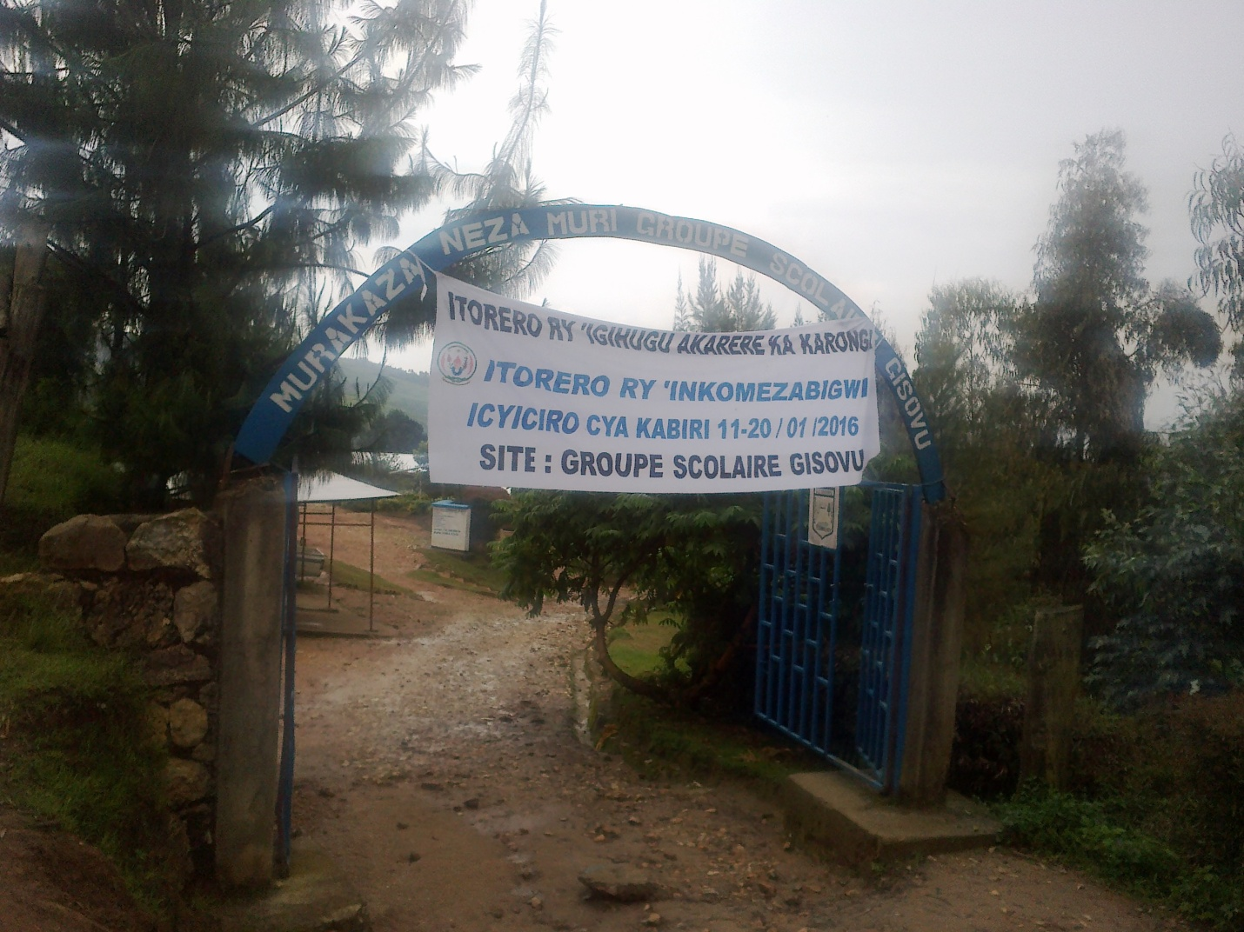
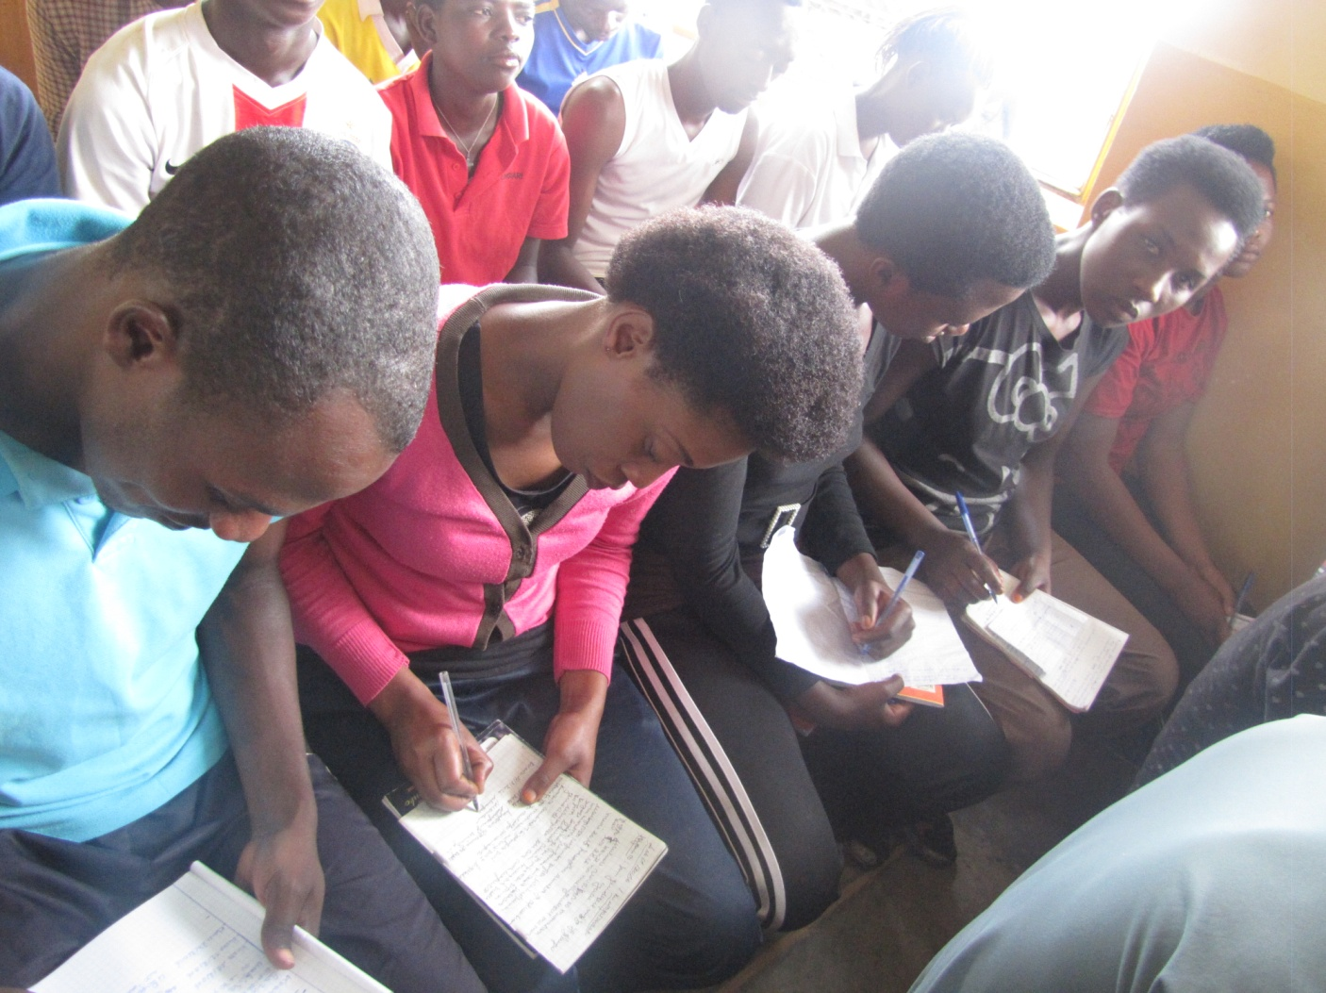
Hejuru ni site ya GS Gisovu , hasi Intore zirakora ikizamini cy’isuzumabumenyi ku wa 11/01/2016

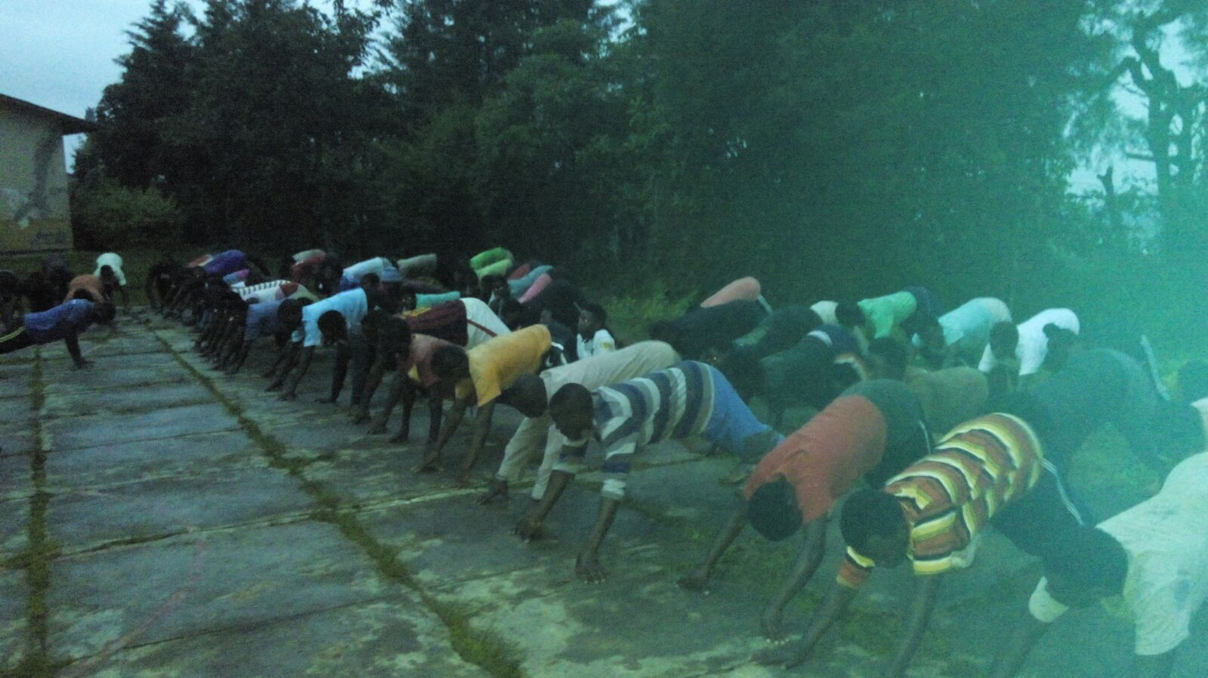
Hejuru abatozwa bari mu myitozo ngororamubiri kuri site ESAPAN Mugonero. Hasi ni kuri site ya ES Kirinda aho bari muri morale ibimburira ikiganiro
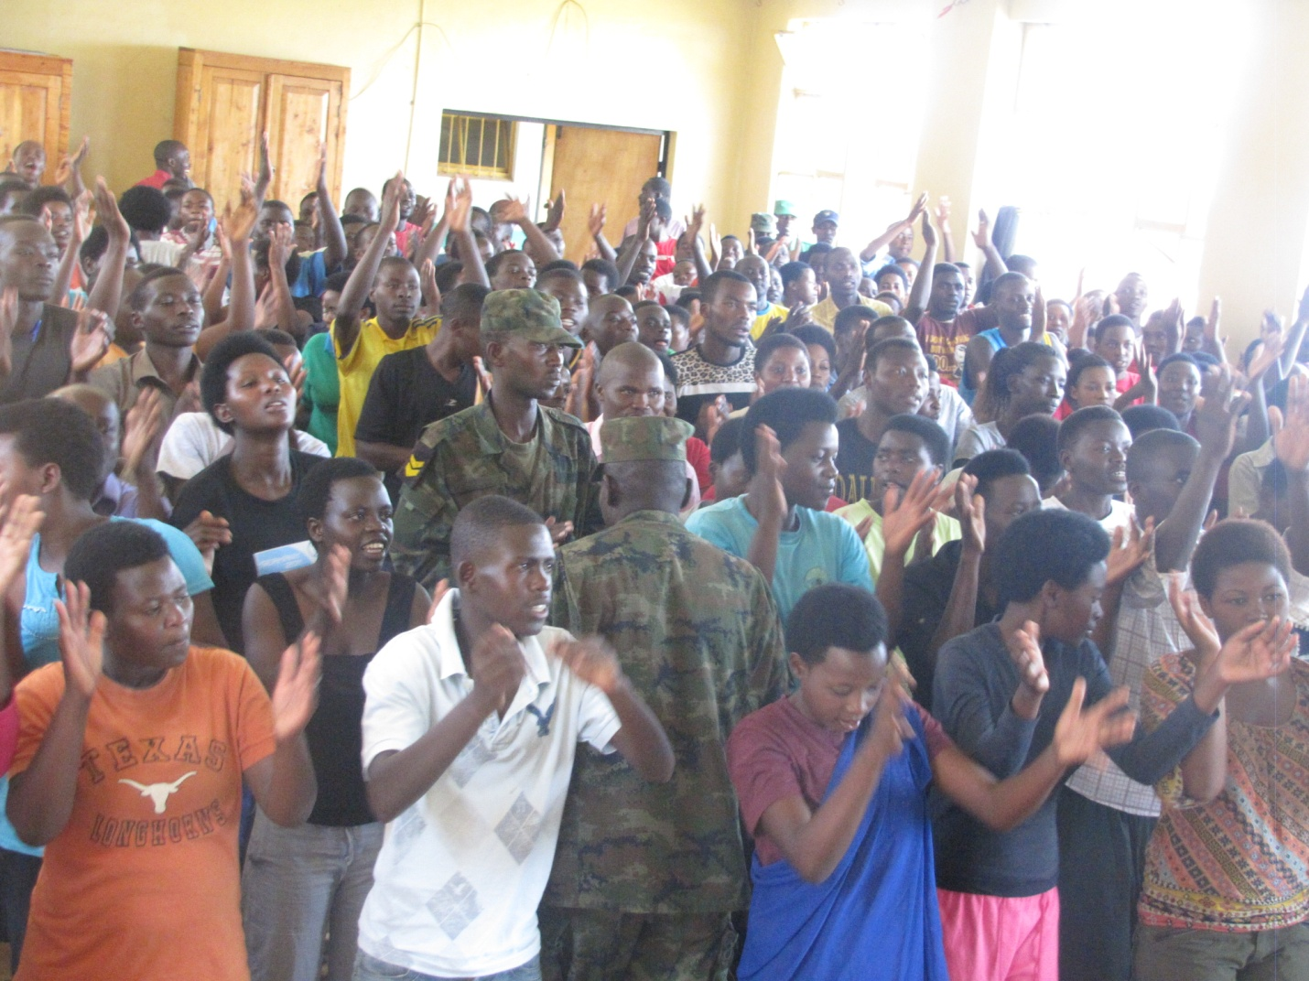

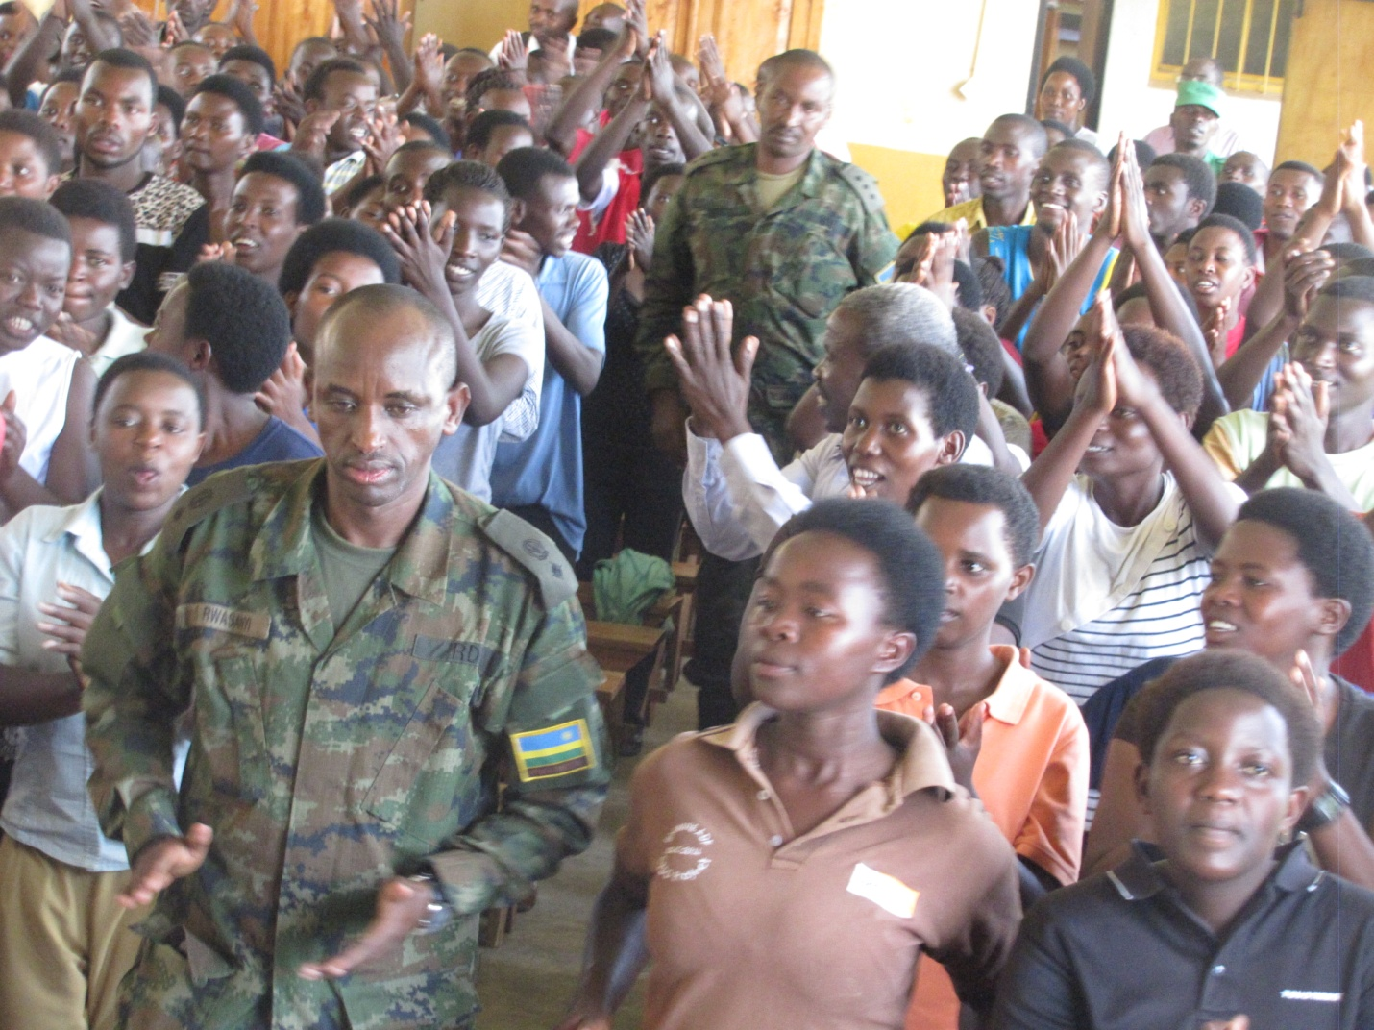
Aha Maj Sam RWASANYI atanga ikiganiro kuri site ya Kirinda , hasi ni kuri Site ya TTC Rubengera abatozwa bari mu mukorongiro wo guca mu nzitane.
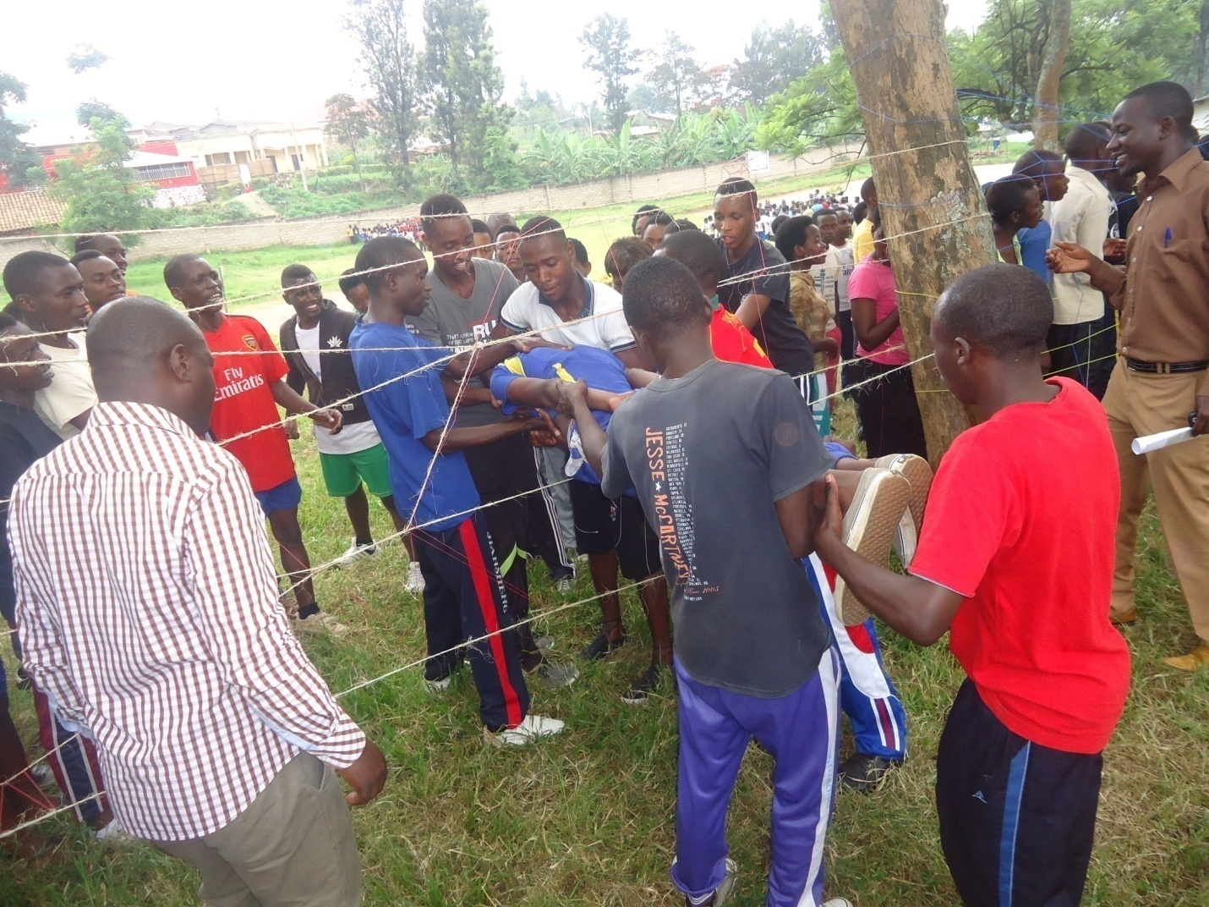

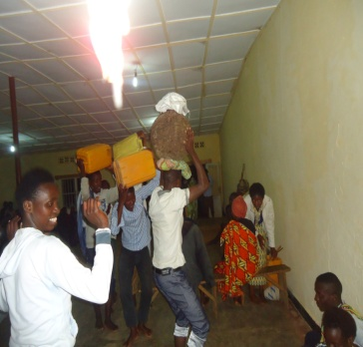
Hejuru Abatozwa bari mu gitaramo cy’umuganura kuri site ya ES Gasenyi.
Hasi Intore zirakurwa ku karubanda zinjira mu rubuga rw’Intore zinahabwa izina kuri site ya ES Gasenyi
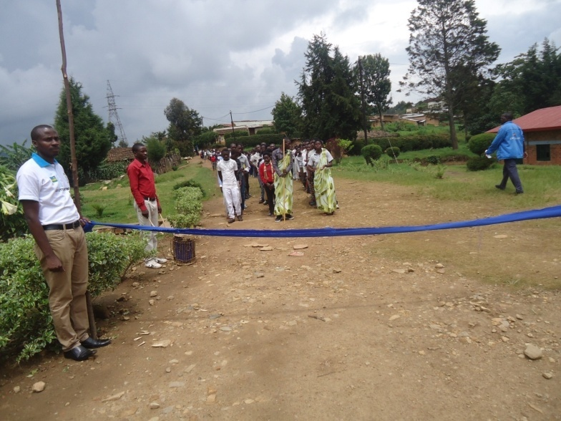

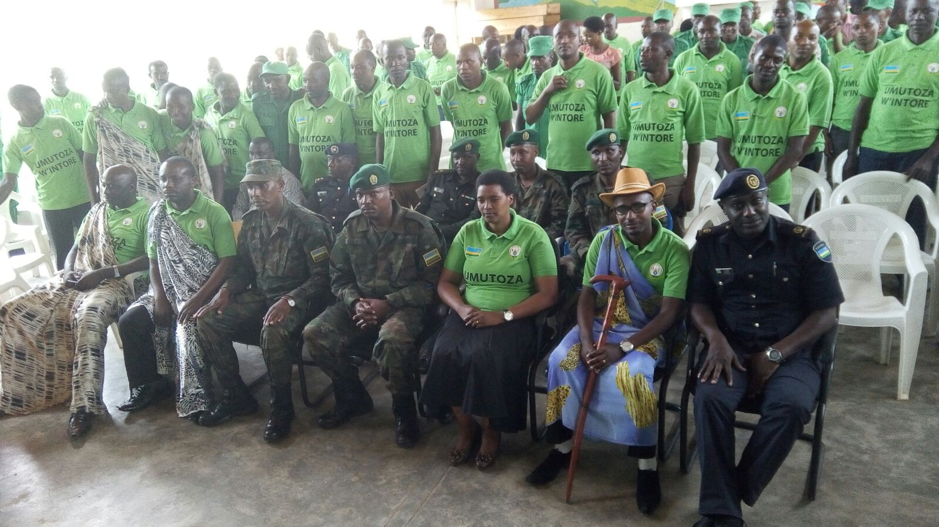
Hejuru ni Umuhango wo kuvuga amacumu kuri DUDC ( TTC Rubengera) ku batoza b’Intore z’Inkomezabigwi ku wa 26/01/2016
Hasi , Umuvuzi w’Amacumu ku Karere, Bwana Muhire Emmanuel arakira imihigo y’abatahira mu mirenge aho biyemeje kuzashyigikira Intore ziri mu bikorwa by’Urugerero.

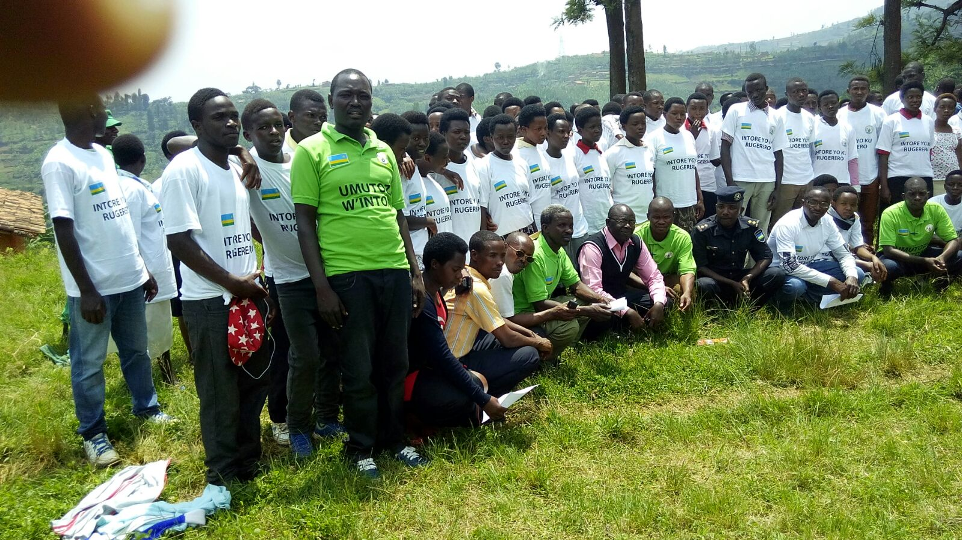
Hejuru ni mu murenge wa Murundi ni Ifoto nyuma y’Umuhango w’Intore mu zindi ku wa 27/01/2016
Hasi Intore zatangiye Urugerero ziri kumwe n’abagize Inteko ishinga amategeko bari mu Karere kuwa 30/01/2016
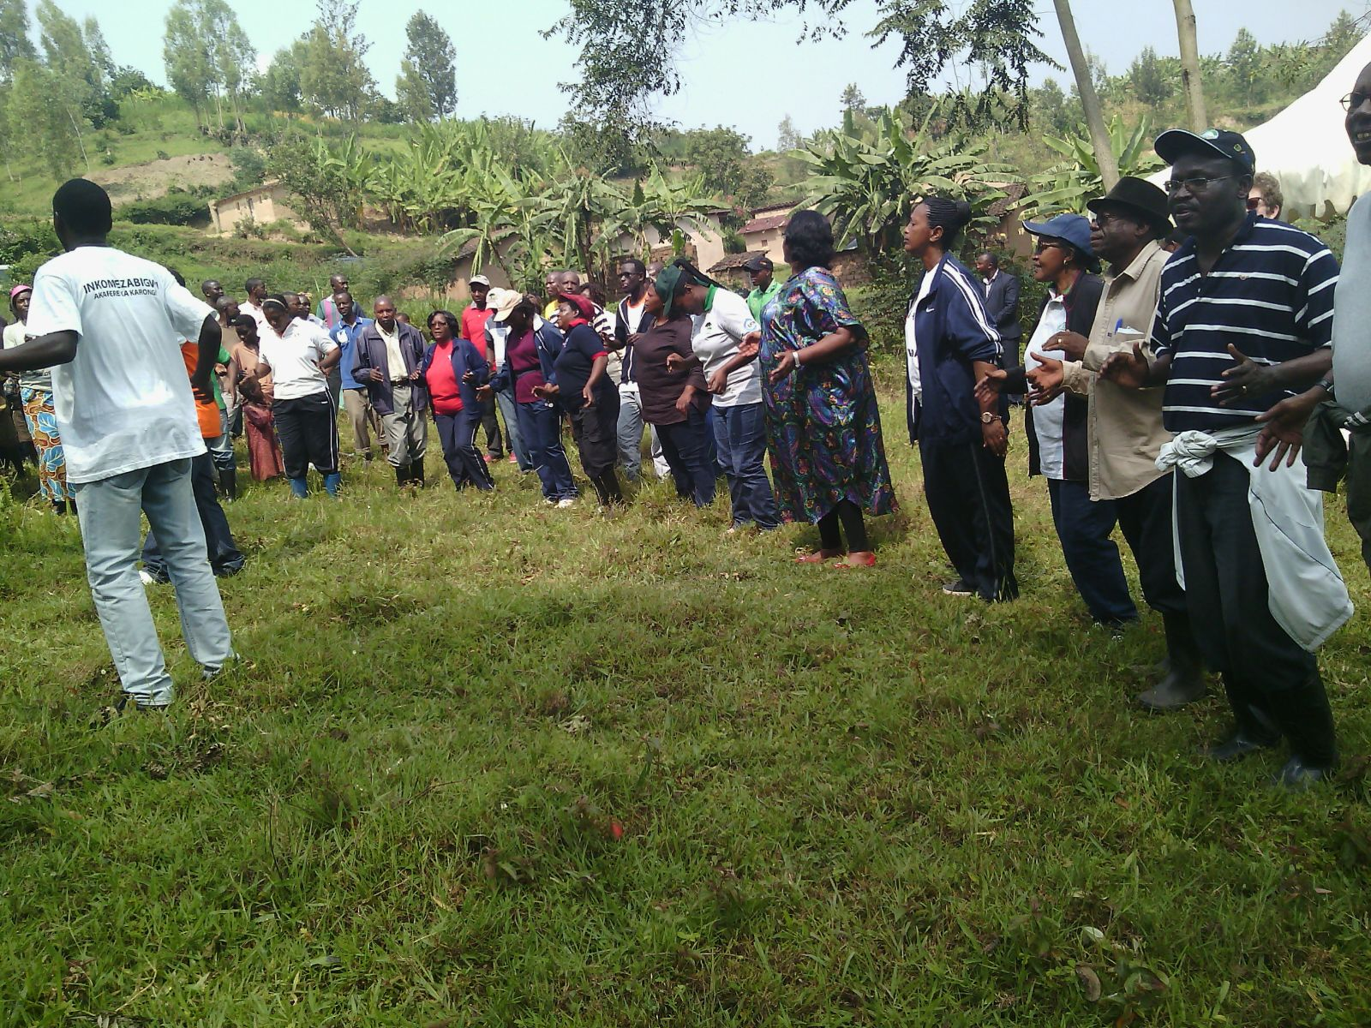

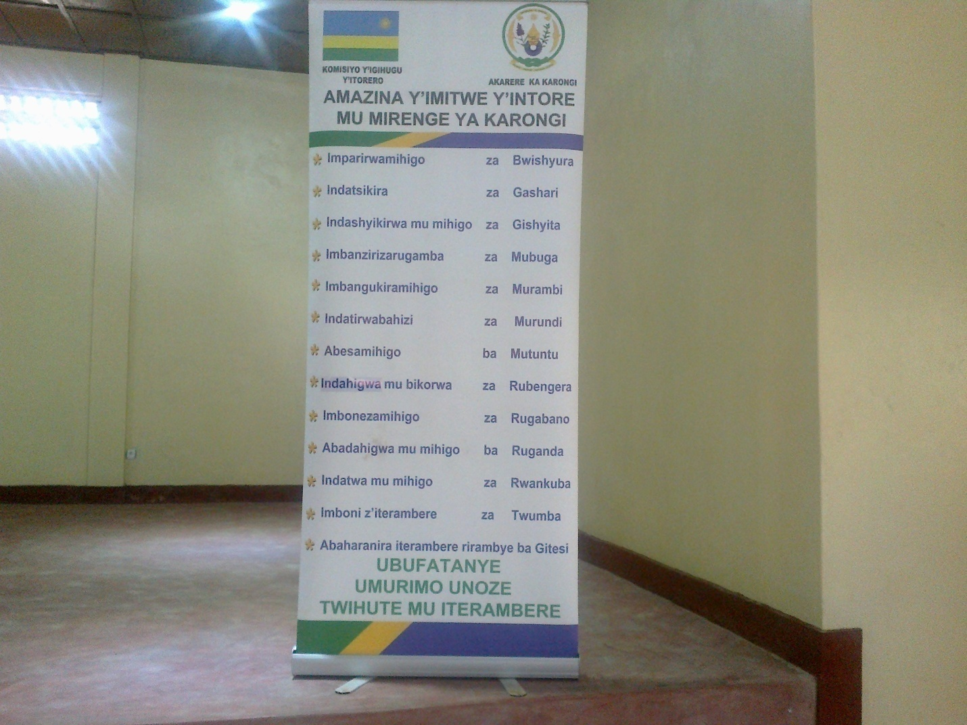
Hejuru ni amazina y’imitwe y’Intore mu mirenge igize Akarere, hasi ni ifoto y’Urwibutso mu muhango wo gusoza igihembwe cya mbere cy’Urugerero ku wa 01/04/2016. Umushyitsi mukuru yari Umunyamabanga Nshingwabikorwa w’Intara y’I Burengerazuba Bwana Jabo Paul ari kumwe n’Umuyobozi w’Ingabo Gen Murenzi. Hari n’Intumwa za NIC, Madamu, Thacienne na Bwana Kamili.
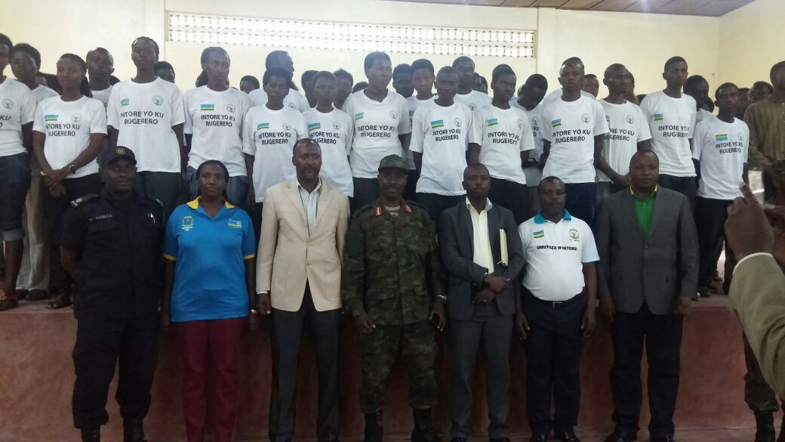
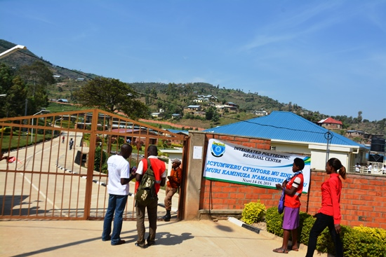
Aha ni mu cyumweru cyiswe INDUCTION WEEK kuri IPRC West baraha ikaze abatozwa bagiye kuhiga. Hasi batangiye morale mu cyumba cy’inama cya IPRC West
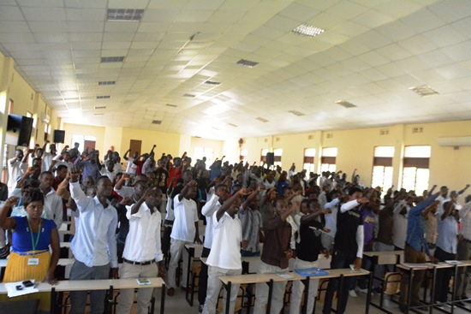

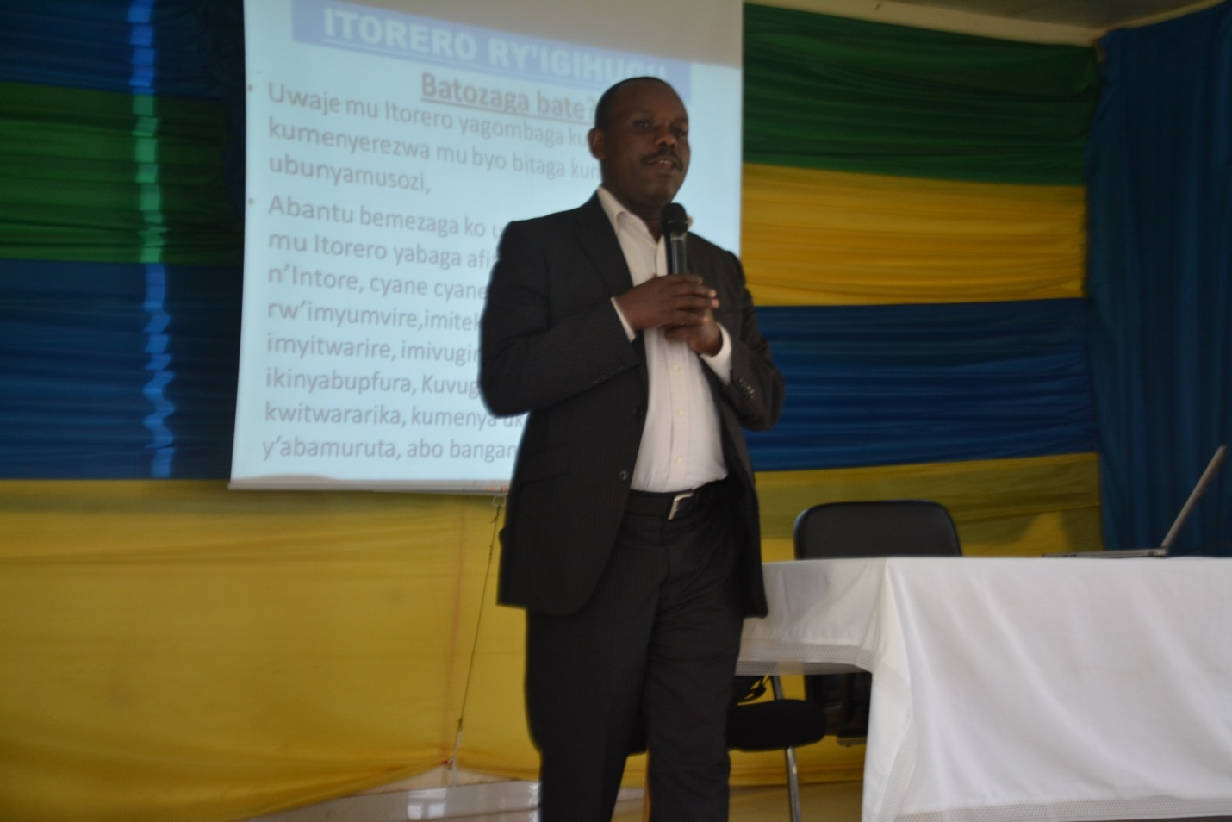
Aha Umutahira w’Intore mu Karere, aratanga Ikiganiro ku batozwa kuri IPRC West naho hasi bari mu mukorongiro wo gusigasira igisenge.
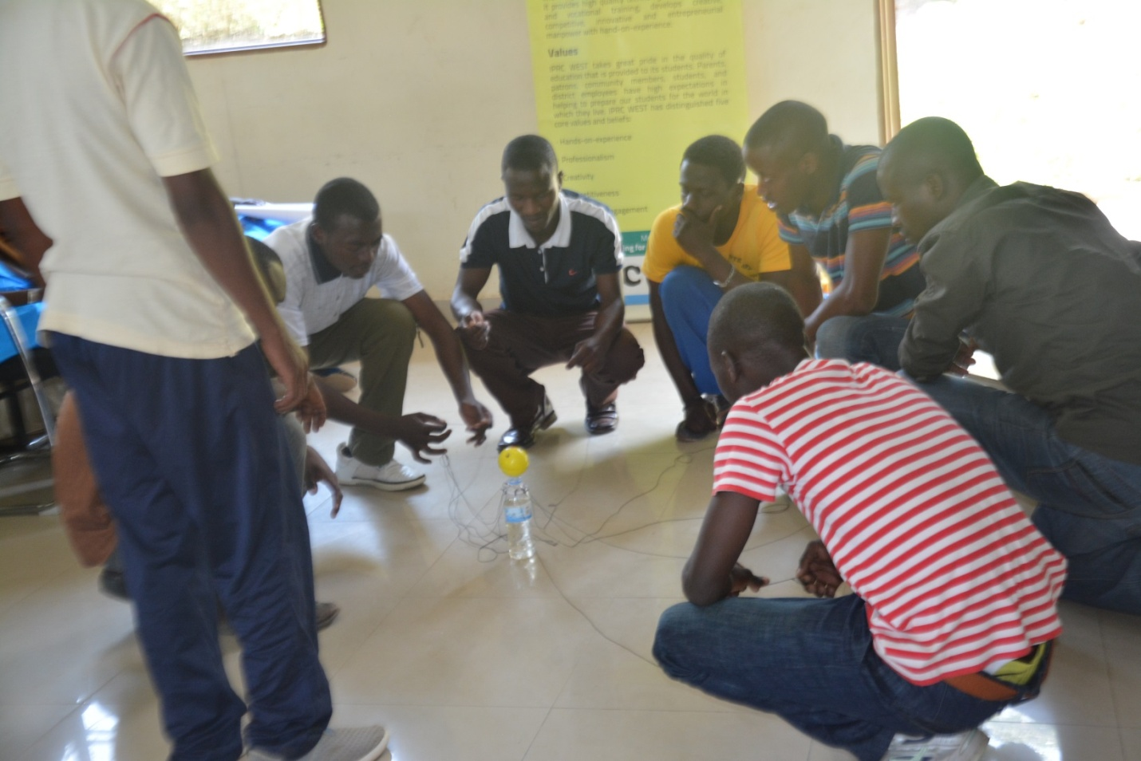

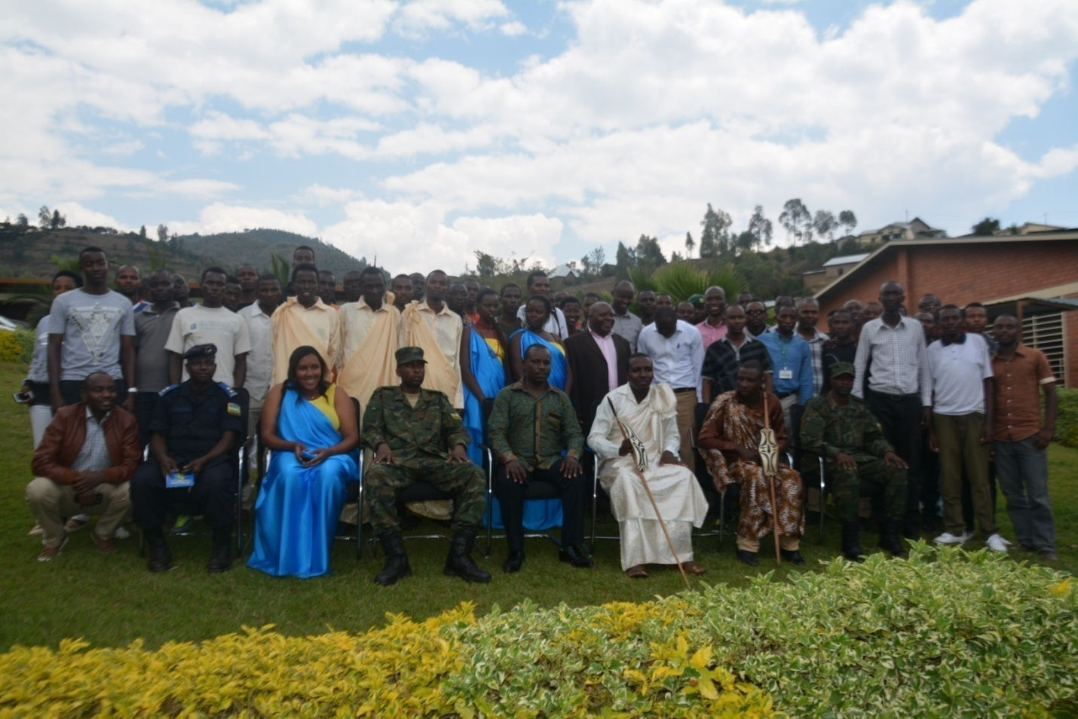
Hejuru Ni Ifoto y’urwibitso kuri IPRC West nyuma y’igitaramo cy’imihigo naho hasi Uhagarariye Ingabo aratanga ikiganiro kuri CMHC Nyamishaba.
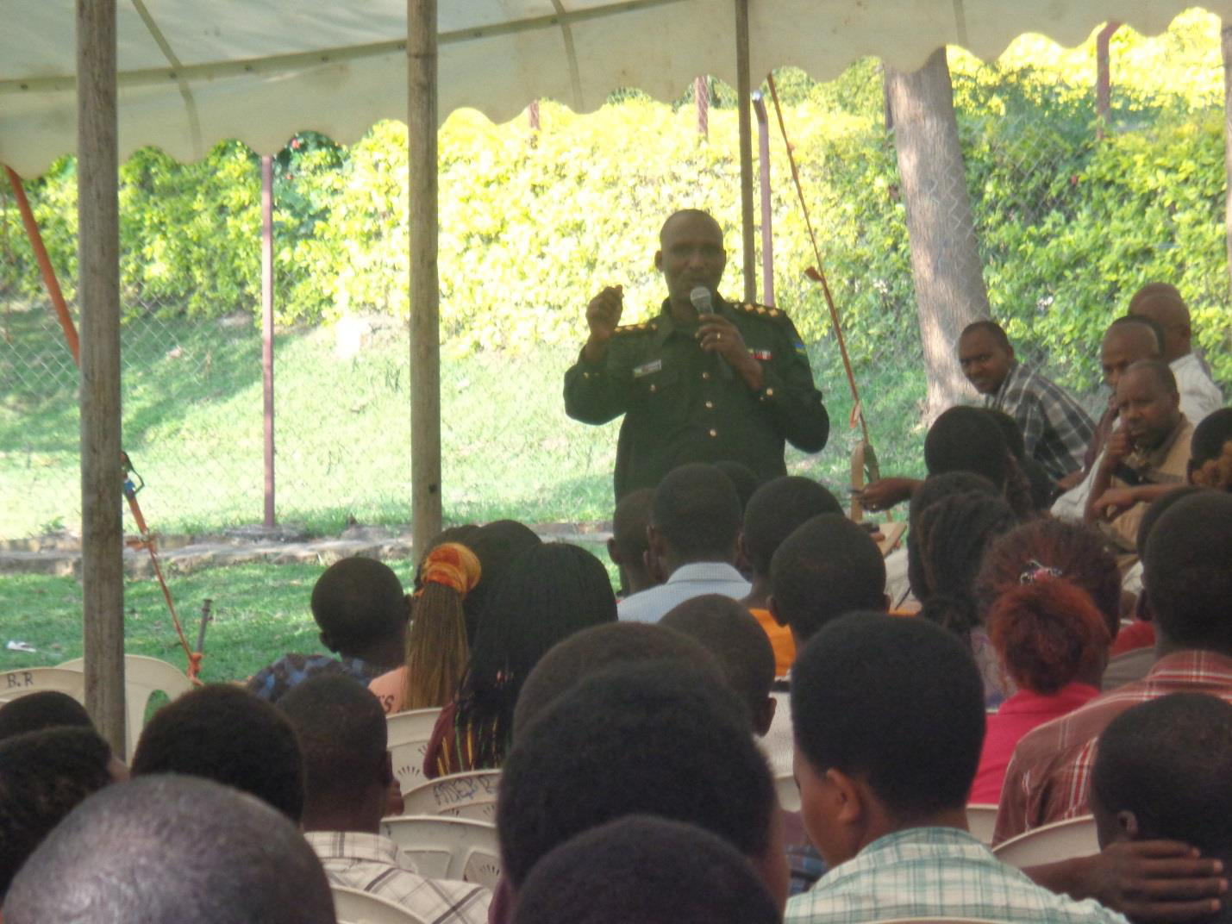

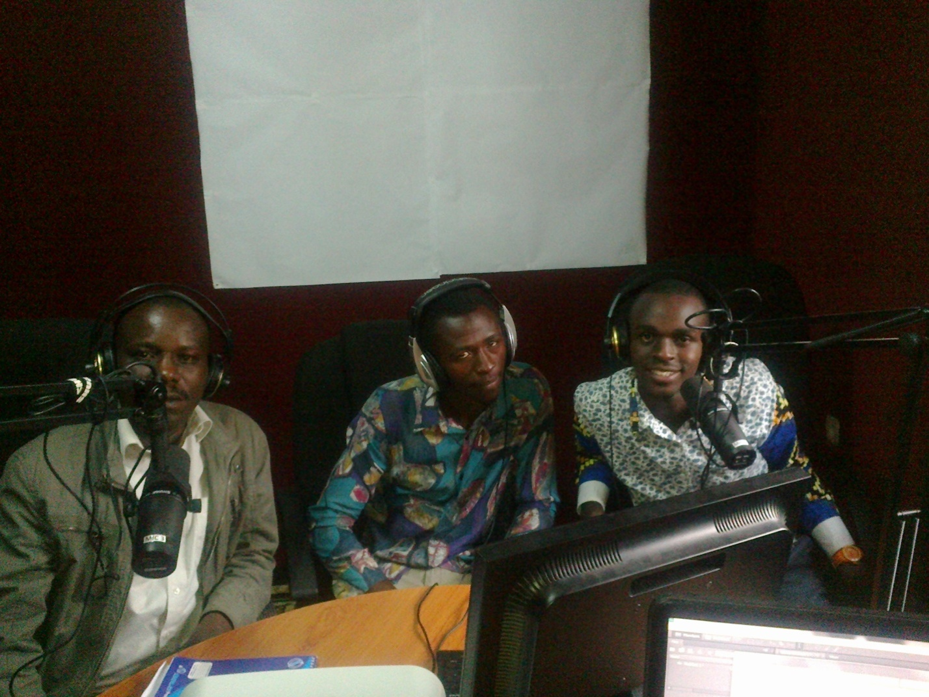
Hejuru Umutahira w’Intore mu Karere hamwe n’Intore zo ku mukondo baratanga ikiganiro ku bikorwa by’Urugerero, hasi Intore zo ku mukondo mu muhango wo gusoza igihembwe cya kabiri cy’Urugerero mu Murenge wa Twumba kuwa 24/06/2016.
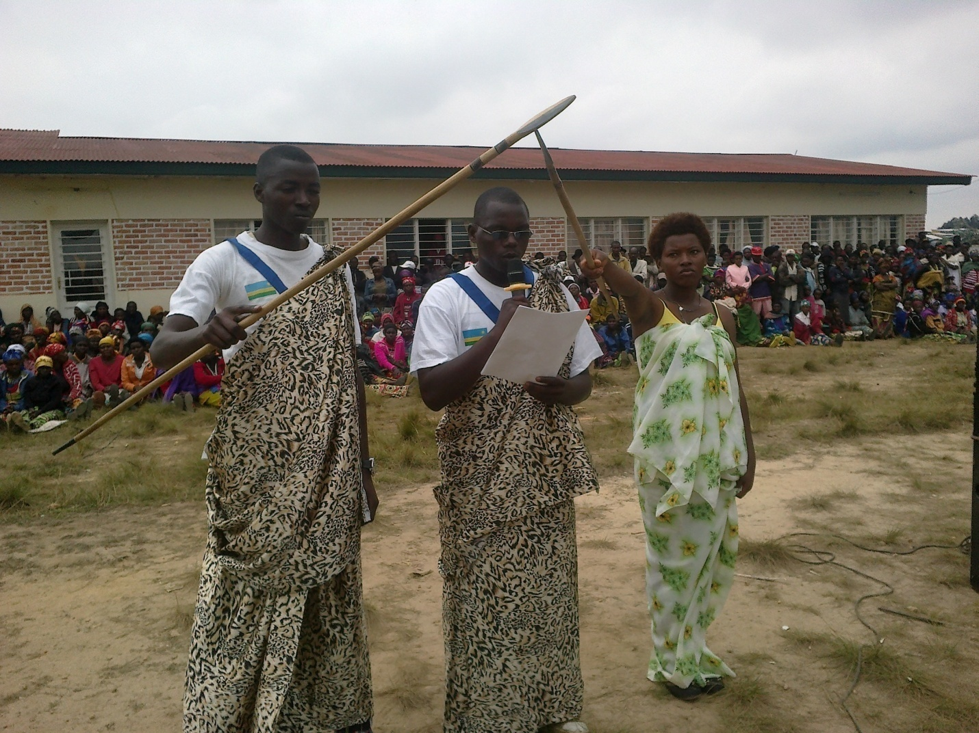

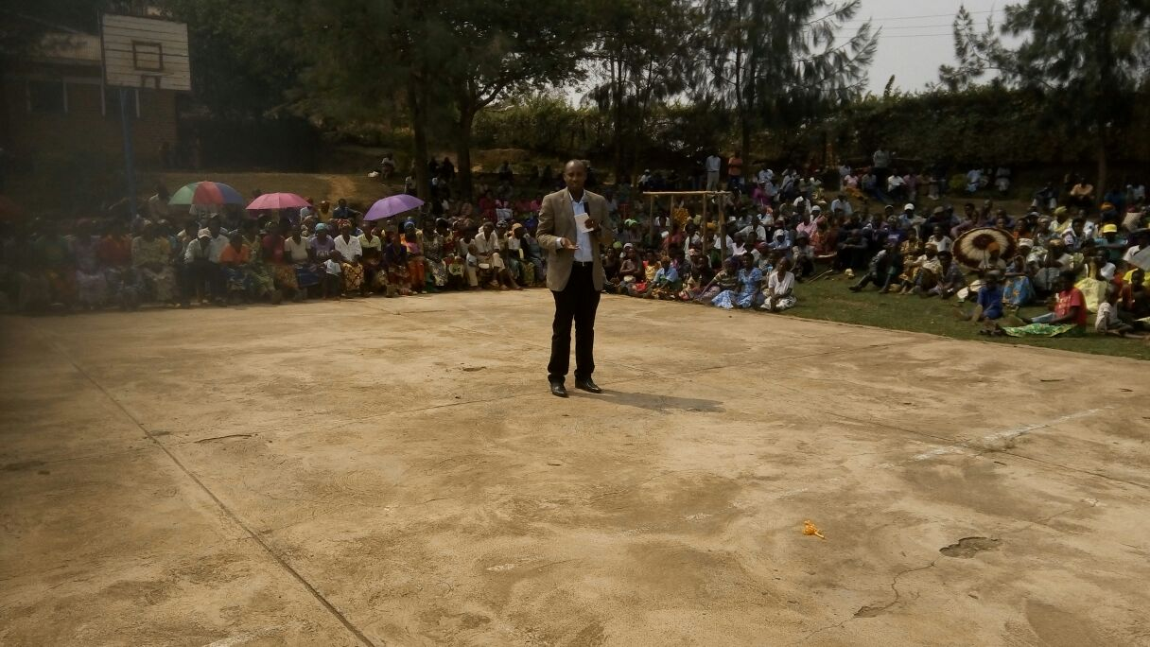
Aka Umuyobozi w’Akarere ka Karongi Bwana NDAYISABA François, arashima Intore zo ku rugerero ibikorwa byiza by’ubwitange zakoze anasaba Intore muri rusange ko wese yashyira imbaraga mu kugera ku byo aba yiyemereye ubwe mu mihigo aba yahize. Asaba buri wese kwitabira umurimo kugira ngo yiteze imbere.

Itorero mu Karere ka Karongi

