C:\Dropbox (ECA)\A1Files\Projects\Worldwide WSP PSP in small towns 504\Docs\Docs\2. Case Study\Best Practice Report\ECA Best Practice Report v1.docx 13/02/2015
Strengthening Public Institutions in Engaging and Regulating Domestic Private Sector for the Provision of Water and Sanitation Services in Rural Growth Areas and Small Towns
Best Practice Report
February 2015
Submitted to the World Bank – Water and Sanitation Program by:
Economic Consulting Associates

Economic Consulting Associates Limited
41 Lonsdale Road, London NW6 6RA, UK
tel: +44 20 7604 4546, fax: +44 20 7604 4547
www.eca-uk.com

Contents
Abbreviations and acronyms iii
Executive summary v
1 Introduction 1
1.1 Overview of the Study 1
1.2 Objective and structure of this Report 2
2 Analysis of Key Issues 3
2.1 Evolution and challenges faced by small towns 3
2.2 Examples of DPSP in WSS service provision 8
2.3 Public initiatives to promote DPSP 12
3 Best Practices, Key Conclusion and Lessons Learnt 15
3.1 Overview of the key activities to encourage DPSP 15
3.2 Demand factors influencing growth in DPSP 16
3.3 Market making or market development 17
3.4 Institutional support 20
3.5 Access to finance 22
3.6 Legal and regulatory framework 23
A1 Global Desk Review Update 25
A2 Country Reports 26
A2.1 Bangladesh Country Report 26
A2.2 Colombia Country Report 26
A2.3 The Philippines Country Report 26
A2.4 Uganda Country Report 26

Tables and figures
Tables
Table 1 Definition of small towns in case study and questionnaire countries 4
Table 2 Urban and rural growth in case study and questionnaire countries 5
Table 3 Economic and human development indicators 7
Table 4 Access to improved water and sanitation 8
Table 5 DPSP in supply of WSS services in small towns 10
Table 6 Distinctive public initiatives to promote DPSP for WSS in small towns 13

Figures
Figure 1 Summary of study objective, activities and deliverables 1
Figure 2 Summary of report objective and structure 2
Figure 3 Key factors to encourage DPSP in WSS sector 15
Figure 4 Market making elements 18
Figure 5 Elements of institutional support 20
Figure 6 Elements of access to finance 22

Abbreviations and acronyms
ADB | Asian Development Bank
AFD | African Development Bank
APWO | Association of Private Water Operators (Uganda)
BOT | Build Operate Transfer
BOTT | Build Operate Train Transfer (South Africa)
BWSI | Balibago Waterworks System Inc (Philippines)
BWSPP | Bangladesh Water Supply Program Project
BWUI | Bohol Water Utilities Inc (Philippines)
CBO | Community Based Organisation
CLTS | Community-Led Total Sanitation (Bangladesh)
CRA | Colombian Water Regulator
DBL | Design Build Lease
DBO | Design Build Operate
DIH | Department of Industry and Handicraft (Cambodia)
DILG | Department of Interior and Local Government (Philippines)
DNH | National Water Supply Directorate (Mali)
DPHE | Department of Public Health and Engineering (Bangladesh)
DPSP | Domestic Private Sector Participation
DWAF | Department for Water Affairs and Forestry (South Africa)
ECA | Economic Consulting Associates
ESP | Public Service Company (Colombia)
HUC | Highly Urbanised City (Philippines)
IFC | International Finance Corporation
JV | Joint Venture
LGD | Local Government Department (Bangladesh)
LGED | Local Government Engineering Department (LGED)
LGI | Local Government Institution
LGU | Local Government Unit
LWUA | Local Water Utilities Administration (Philippines)
MHCP | Ministry of Finance and Public Credit (Colombia)
MIH | Ministry of Industry and Handicraft (Cambodia)
MLGRD&C | Ministry of Local Government, Rural Development and Corporation (Bangladesh)
MWE | Ministry of Water and Environment (Uganda)
MWSS-RO | Metropolitan Waterworks and Sewerage Services – Regulatory Office (Philippines)
NDP | National Development Plan (Colombia)
NEDA | National Economic Development Authority (Philippines)
NGO | Non-Governmental Organisation
NWRB | National Water Regulatory Board (Philippines)
NWSC | National Water and Sewerage Corporation (Uganda)
OBA | Output Based Aid
PO | Private Operator (Cambodia)
PPP | Public Private Partnership
PSSP | Philippine Sustainable Sanitation Plan
PSSR | Philippine Sustainable Sanitation Roadmap
PSU | Policy Support Unit
PWO | Private Water Operator (Uganda)
PWSSR | Philippine Water Supply Sector Roadmap
RURA | Rwanda Utility Regulation Agency
SDE | Senegalese water private operator
SDP | Sector Development Plan (Bangladesh)
SONES | Senegalese water asset holding company
SOP | Standard Operating Procedures
SPI | Strengthening Public Institutions
SSPD | Supervisory Agency for Public Services (Colombia)
TOR | Terms of Reference
UK | United Kingdom
UN | United Nation
VAS | Ministry of Water and Sanitation (Colombia)
WASA | Water and Sanitation Authority (Bangladesh)
WBG | World Bank Group
WSP | Water and Sanitation Program
WSS | Water supply and sanitation
WSSA | Water Supply and Sewerage Authority (Uganda)
WUA | Water User Association (Mali and Malawi)

Executive summary
This report is the Best Practice Report, which is one of the main deliverables for the Study to Strengthening Public Institutions in Engaging and Regulating Domestic Private Sector for the Provision of Water and Sanitation Services in Rural Growth Areas and Small Towns. This report brings together best practices, key conclusions and lessons learnt from the Global Desk Review Update and Country Reports from Bangladesh, Colombia, the Philippines and Uganda.

Methodology and report structure
The Global Desk Review Update presents the analytical framework used in the study, and provides and overview of world-wide experience in domestic private sector participation (DPSP) in water supply and sanitation service provision in small towns and rural areas.
The Country Reports from Bangladesh, Colombia, the Philippines and Uganda provide a more in-depth analysis of each of the country’s efforts in encouraging and promoting DPSP in small town water supply and sanitation services.
The lessons learn from global experience, as well as from the Country Reports, on what works in terms of encouraging and promoting DPSP in water supply and sanitation were taken into account in developing the best practices, key conclusion and lessons learnt presented in this report. The diagram below illustrates the methodology and how this report is structured.
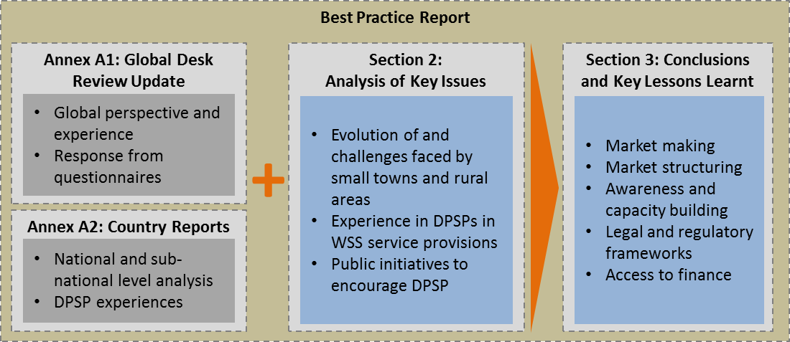

Key conclusion and lessons learnt
The literature review from the Global Desk Review Update and detailed country analysis has shown that there are some key factors that contribute to the growth and development of DPSP in WSS service provision in small towns and rural areas. We have identified four main factors – market making, institutional support and access to finance – with these being strengthened if there is a coherent legal and regulatory framework for DPSP. The inter-relationships between these factors are relatively complex, however, as illustrated in the diagram below.
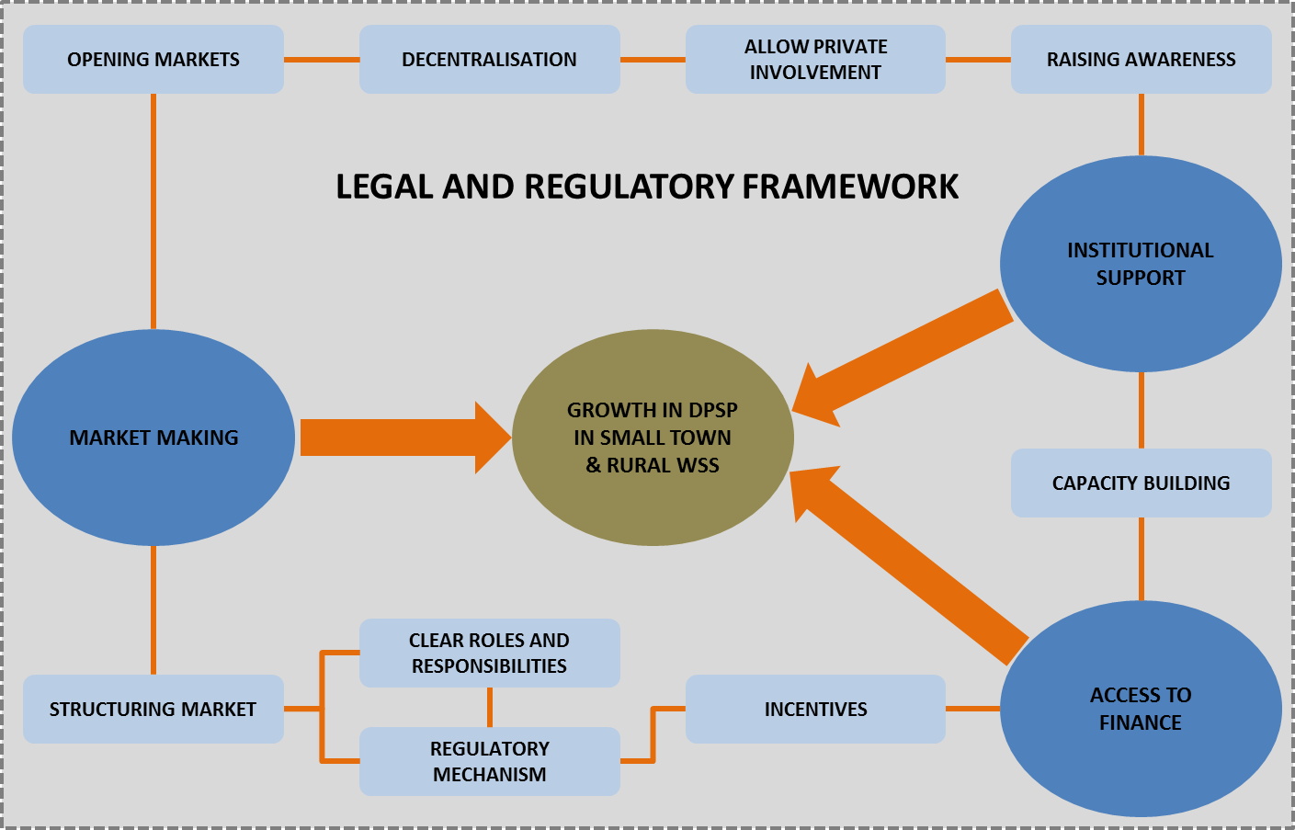
In general, there is no magic bullet, or one prescription that can be applied to every country to encourage DPSP in WSS sector. Through the development of the case studies, it is obvious that every country must take into account existing legal and regulatory conditions, capacity and capability of the public institutions, and readiness of the private sector and also community and public perception of private sector provision of public services when deciding to invite and encourage DPSP in WSS sector.
However, the study has found that there are three key action areas for public institutions to encourage DPSP in WSS service provision:
- Market making or market development – Market making efforts to encourage DPSP can include two complementary elements, one is opening the WSS market to private sector involvement, and the other is structuring the market in such a way that the private sector clearly understands their functions, roles and responsibilities in the WSS sector.
  - Opening markets – through decentralisation, national governments delegate responsibility to provide public service provision to local governments, and by allowing, or in some cases prescribing, the local government to contract with private entities to provide the public service, the government opens the market to private sector participation.
  - Structuring the market – clear roles and responsibilities of each actor in the sector, including clear roles and functions of the private sector are needed, as well as sound regulatory mechanisms that provides incentives for the private sector to participate in the sector.
- Providing institutional support – in addition to providing financial incentives, public institutions can provide other forms of support which can encourage DPSP, including:
  - Awareness raising – the benefits of having private sector participation in the WSS sector must be understood by the local governments as well as the community. The perception that private entities are not appropriate to provide public services can otherwise be a major constraint to DPSP.
  - Capacity building – for the local governments on how to structure projects to involved private partners, how to select the private partner and how to implement the projects is very important. In addition, it is also important to build the capacity of the private entities in terms of providing good services at a reasonable cost.
- Assisting in developing and improving access to finance – this is another form of capacity building, aimed at the financial institutions. Financial institutions need to understand the WSS business in order to be able to offer financial products that are suitable for the WSS sector, such as long term loans with slow payback period. In addition, public finance may also be needed to address affordability issues and to accompany any private investment.
For all three activities above, a coherent and clear legal and regulatory framework can provide the necessary background and be conducive to the growth of DPSP. This constitutes the fourth main public sector support factor.

Introduction
Economic Consulting Associates Limited (ECA) has been engaged by the Water and Sanitation Program (WSP) of the World Bank to conduct the Study to Strengthening Public Institutions in Engaging and Regulating Domestic Private Sector for the Provision of Water and Sanitation Services in Rural Growth Areas and Small Towns.

Overview of the Study
As stated in the Terms of Reference (TOR), the objective of this study is “to consolidate knowledge so far gained by the World Bank Group and its partners at global level and provide operating procedures and guidance to developing countries and WBG task teams on how to support public institutions in effectively engaging the local private sector to deliver better water and sanitation services specially to the poor in rural growth centres and small towns”.
This study is being conducted in three phases: a desk review phase, field-diagnostic phase and knowledge dissemination phase. The specific objectives, activities and tasks for each phase and the resulting deliverables are summarised in Figure 1.
Figure 1 Summary of study objective, activities and deliverables
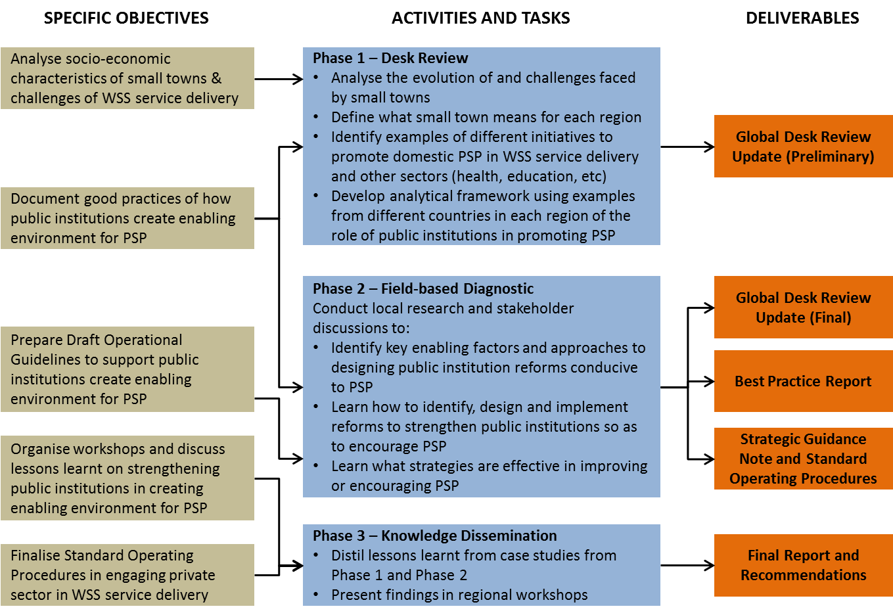
The study focuses on piped water schemes in rural and small towns where local private actors increasingly represent a significant group of stakeholders, using lessons learnt and experiences from the selected countries: Bangladesh, Colombia, the Philippines and Uganda.

Objective and structure of this Report
This report is the Best Practice Report being delivered at the end of Phase 2. The objective of this report is to bring together best practices, key conclusions and lessons learnt from the Global Desk Review Update and Country Reports from Bangladesh, Colombia, the Philippines and Uganda.
The Global Desk Review Update was submitted in early December 2014, and includes the results from the questionnaire responses from Cambodia, Niger and Senegal. Comments were received since, and have been taken into account in the final version, which forms Annex A1 of this report.
Four separate Country Reports were submitted at the end of November 2014 for Bangladesh, Colombia, the Philippines and Uganda. Comments from each of the country representatives have been received and taken into account in the final versions, presented as Annex A2 of this report.
The rest of this report is structured as follows (and illustrated in Figure 2):
- Section 2 provides comparative analysis of key issues highlighted in the study based on the Country Reports (Bangladesh, Colombia, the Philippines and Uganda), supplemented by the questionnaire countries (Senegal, Niger and Cambodia) and other global experience.
- Section 3 concludes this report by summarising key lessons learnt based on the results of the desk review and the work conducted in Phase 2.
Figure 2 Summary of report objective and structure

Analysis of Key Issues
This section provides perspectives on and analysis of key issues pertaining to the experience with domestic private service providers (DPSP) in water supply and sanitation (WSS) services in the four selected countries: Bangladesh, Colombia, the Philippines and Uganda, with additional information from the questionnaire countries: Cambodia, Niger and Senegal.
A comparative approach is adopted here to contrast different experience around the world and see to what extent common lessons emerge. The details of national experience in each of the case study countries are to be found in the individual Country Reports.

Evolution and challenges faced by small towns

The definition of small towns
It was noted that there is no universal definition of a small town, and that population size definitions are very problematic. The four case study countries, as well as the responses from questionnaires capture these issues well:
- Some countries have government-mandated definition of the size of small towns, and have specific local government structures for small towns – Uganda is a case in point where a “small town” is defined as having a population between 5,000 and 20,000 inhabitants and the responsible authority is a Town Board or a Municipality for a larger centre. The process of declaring new towns is also formalised in Uganda - in accordance with the Local Governments Act, the Minister of Local Government, in consultation with district authorities and Cabinet, may declare an area to be an urban council (a town, municipality, town board) after satisfying him or herself that the requirements stipulated in the Law have been met. In situations where new districts are created, their headquarters are automatically declared to be towns.
- Other countries do not find it necessary or useful to define a small town in terms of population limits. Bangladesh provides a good example, where the main distinction is between rural and urban. Local government structures for the urban areas are precisely defined – City Corporations for the 10 cities with more than 6 million people, and 308 smaller centres in 3 classes of Pourashavas (municipalities). Centres move between these government classifications when the size of the centre and the average municipal income changes. It is the World Bank and other donors that have required a population-based definition of “small town” and a range of 10,000 to 100,000 has become accepted for this.
- A similar situation prevails in the Philippines, where the government classification systems are more concerned with income measures than head counts. The population-range definition of a small town we have adopted in the study for the Philippines comes from an ADB small town water project and the views of private operators, who consider the same population range as Bangladesh (10,000 to 100,000) to be characteristic of small towns in the Philippines.
- In Colombia, different government agencies have different definitions of urban settlements. In the absence of an agreed national definition, the operational value adopted for this study is the National Planning range of 5,000 to 12,000 people. This definition covers most of 557 municipalities in Colombia which vary in size between 2,500 and 12,000 people.
- In Cambodia, according to Government officials, there is no formal definition of small towns, but the term ‘Growth Centres’ is used to describe an area with around 5,000 inhabitants. In terms of the size limit for small towns, in Cambodia the range of 5,000 to 10,000 is accepted.
- The lower limit for small towns in Niger is 2,000 according to a World Bank report. The bottom population range is in line with Niger’s very low population density (14 persons/km²) and relatively low urbanisation rate. However, it was reported through the response to the questionnaire that there is no formal definition of small towns, and a range of 10,000-20,000 is used for WSS services
- In Senegal, the government specifies small towns (or ‘semi-urban’ areas) as having a population of 5,000 to 10,000, compared to the large towns and cities (urban areas) with populations of more than 10,000 people. Rural growth centres are areas with a population size of between 2,500 and 5,000.
Table 4 illustrates the different definition of small towns in the different countries.
Table 1 Definition of small towns in case study and questionnaire countries
Country | Total population  (million) | Density  (pop/km2) | Proportion urban | Small town  definition | Local government structure
Bangladesh | 156 | 1,033 | 30% | 10,000 to 100,000 | Class III Pourashavas and Upazila headquarters
Colombia | 48 | 41 | 76% | 5,000 to 12,000 | Municipalities
Philippines | 100 | 335 | 49% | 10,000 to 100,000 | Municipalities
Uganda | 35 | 137 | 16% | 5,000-20,000 | Town Boards, Town Councils, Municipalities
Cambodia | 15 | 86 | 20% | 5,000 to 10,000 | Commune
Niger | 18 | 14 | 18% | 10,000 to 20,000 | Municipalities
Senegal | 14 | 73 | 43% | 5,000 to 10,000 | Municipalities
Sources: Case Study Reports and World Development Indicators 2013

Dynamics of the urban hierarchy
While acknowledging that what is considered ‘urban’ is not the same in the different countries, Table 1 shows that the countries differ considerably in the degree of urbanisation, from only 16% in Uganda to 76% in Colombia. In all countries, the urban population is growing more rapidly than the rural population.
Over the long-run period up to 2050, against modest overall population growth (0.7% pa), the rural populations of Bangladesh and Colombia are expected to decline (see Table 5). In Cambodia and the Philippines, national population growth is 1.1% to 1.3%, with rural growth at very low levels (0.5% to 0.6% pa) and urban growth significantly higher (2.7% and 1.9% pa respectively). In the African countries, overall rates of population growth are projected to be significantly higher (Senegal 2.3% pa, Uganda 2.8% pa and Niger 3.7% pa) and the rural populations will continue to grow, though not nearly as fast as the urban populations.
Table 2 Urban and rural growth in case study and questionnaire countries
Country | Overall  pop  growth | Urban  pop  2014 (m) | Urban  pop  2050 (m) | Urban  ave  growth | Rural  pop  2014 (m) | Rural  pop  2050 (m) | Rural  ave  growth | Total  pop  2050 (m)
Bangladesh | 0.7% | 53 | 112 | 2.1% | 105 | 90 | -0.5% | 202
Colombia | 0.7% | 37 | 53 | 1.0% | 12 | 10 | -0.5% | 63
Philippines | 1.3% | 45 | 88 | 1.9% | 56 | 69 | 0.6% | 157
Uganda | 2.8% | 6 | 33 | 4.8% | 33 | 71 | 2.2% | 104
Cambodia | 1.1% | 3 | 8 | 2.7% | 12 | 14 | 0.5% | 23
Niger | 3.7% | 3 | 25 | 5.6% | 15 | 45 | 3.1% | 69
Senegal | 2.3% | 6 | 29 | 3.2% | 8 | 13 | 1.3% | 33
Source: UN World Urbanisation Prospects 2014. Some 2014 values differ from the national
sources used in the Case Study reports.
The structure of the urban hierarchies is also quite different across the countries. In most countries, the pattern is a pyramidal one - the capital is a mega-city, followed by a number of large cities, and larger number of small cities, and then progressively larger numbers of large towns, small towns, villages and rural centres. The Philippines is a case in point, where there are many large urban areas with those being declared as ‘cities’ increasing quite rapidly. For example, in 2000, 16 new cities were declared and in the first half of 2001, 15 more were declared. As of September 2013, there are 143 cities, 32 of which are so-called ‘highly urbanised cities (HUC)’ with populations of more than 200,000.
The urban hierarchy in Uganda is quite different. It has a single large city which is the capital, Kampala, with a population of 1.4 million. The next largest urban centres are one tenth or less the size of capital: Gulu (147,000), Lira (119,300), Mbarara (97,500), Jinja (94,000), Bwizibwera (79,200), Mbale (76,500) and five more centres in the 60,000-70,000 range. Below these centres, there are some large towns, and then the small towns which are the focus of this study (centres with populations between 5,000 and 20,000).
Cambodia is quite similar to Uganda in terms of urban hierarchy. Phnom Penh, the capital of Cambodia, has a population of around 1.4 million, while the next largest urban areas being much smaller in size. However, urbanization is taking place at considerable speed and is expected to further accelerate over time, with more than a third of Cambodians living in towns and urban centres by 2050. Average population density in Cambodia is quite low, around 86 inhabitants per km² in 2013.
Despite the relatively rapid urban growth rate projections by the World Bank (see Table 5), the UN-Habitat data indicated a reduction in the urbanisation level of Niger and Senegal between 2001 and 2010. It is interesting to note that in Senegal, counter-urbanization has occurred at the top of Senegal’s urban hierarchy, with its ten largest towns (with the exception of Dakar) reducing their share of Senegal’s population since 1988. Only two of the nine largest urban settlements below Dakar grew faster than the national growth rate.
In Niger the population growth in rural areas has been much higher than in urban areas. According to the African Research Institute,, the increase in population share of the 38 main towns rose by just 1%, from 15% to 16% of the population. Although the capital, Niamey, attracted many migrants between 1988 and 2001, some large towns experienced net out-migration.

Impact on WSS service provision
In countries like Bangladesh and Colombia, where the rural populations are projected to decline and urban growth is relatively modest, the provision of water and sanitation in small towns is a contained problem in the sense that any satisfactory solutions that are found now can be expected to last. In other words, WSS systems build now will be able to serve the population in rural areas and small towns in the medium to long term, so there will not be a need for upgrade in the foreseeable future. However, as the rate of urbanisation in Bangladesh is still significant, the local governments in the small towns and/or even in Cities are struggling to meet the WSS needs of its population, especially those living in peri-urban areas.
By contrast, in Senegal, Uganda and Niger, and to a lesser extent in the Philippines, there is to be a ‘moving target’ of growing numbers of small towns and rapid population growth within those towns. WSS systems build now will most likely need to be upgraded in the short to medium term to cope with the increase of population.
In the Philippines, WSS services in rural areas are typically provided by CBOs in the form of public standposts (level I) or piped water system to a communal connection (level II). As the rural area grows, more sophisticated systems are needed, and the local community will ultimately request a level III supply system (piped water with private connection) to be provided by the local governments. In some cases, the CBO continues to operate the level III system (once built and financed by the local government). In other cases, the local government may build and operate the system themselves or find a private partner to build and operate the level III system.
Amongst the case study countries, the challenge of growing urban demand is greatest in Uganda, where the growth in the number and size of small towns needs to be met with an adequate response in terms of WSS service provision. The government and the National Water and Sewerage Company (NWSC) do not have anywhere near the financial and other resources to meet the requirements and the private sector therefore has a critical role to play in filling the gap in small town water supplies. The Government of Uganda presently seems unwilling to recognise the scale of the small town WSS challenge and regards the private sector interventions as a stop-gap until NWSC can take over responsibility. This study recommends that this position be reviewed and active steps taken to allow the private sector to play a more significant and sustained role in providing WSS services in small towns.
Another aspect of Uganda’s challenge that is shared by Niger is that income levels are lower than in other countries (see Table 3), so affordability of WSS services is more of an issue. This also makes it more difficult for the private sector to provide WSS services. The Philippines and Colombia represent the other end of this spectrum.
Table 3 Economic and human development indicators
Country | Current GDP (USD billion) | GDP per capita (USD PPP) | Adult literacy rate | Life expectancy at birth (years) | HDI  2013 | HDI  rank
Bangladesh | 130 | 2,557 | 58% | 71 | 0.558 | 142
Colombia | 378 | 12,371 | 94% | 74 | 0.711 | 98
Philippines | 272 | 6,533 | 95% | 69 | 0.660 | 117
Uganda | 21 | 1,410 | 73% | 59 | 0.484 | 164
Cambodia | 15 | 3,042 | 42% | 72 | 0.584 | 136
Niger | 7 | 913 | 15% | 58 | 0.191 | 187
Senegal | 15 | 2,269 | 50% | 64 | 0.485 | 163
Source: World Development Indicators 2013 and Human Development Report statistics 2014.
PPP = purchasing power parity

Access levels
Table 4 gives data for access to improved water and improved sanitation. Access levels differ significantly across the different case study and questionnaire countries, although this is clearly not just due to substantive national differences, but to different data collection methodologies and access definitions, which may be related to different technologies. This is evident in Bangladesh, for example, where rural sanitation coverage (58%) is reportedly higher than in urban areas (55%). In rural areas, there are many on-site sanitation services, such as latrine suppliers that also install and provide after sale services to households, while in urban areas, sanitation or sewerage services are supposedly the responsibility of the local government and these have been rather neglected. Sewerage coverage in Dhaka is very low compared to the water supply coverage.
In the table, the range in national water coverage is from 52% in Niger to 92% in the Philippines, but it is interesting to note that Niger claims the highest urban access rate (99%) of all 7 countries. The national average is pulled down by low rural levels (42%), the lowest in the sample. In sanitation, Niger is again the country with the lowest coverage (9%) especially in the rural areas (4%), while Colombia (80%) and the Philippines (74%) are highest.
Table 4 Access to improved water and sanitation
Country | Urban  water | Rural  water | National  water | Urban  sanitation | Rural sanitation | National  sanitation
Bangladesh | 86% | 84% | 85% | 55% | 58% | 57%
Colombia | 97% | 74% | 91% | 85% | 66% | 80%
Philippines | 93% | 91% | 92% | 79% | 69% | 74%
Uganda | 95% | 71% | 75% | 33% | 34% | 34%
Cambodia | 94% | 66% | 71% | 82% | 26% | 37%
Niger | 99% | 42% | 52% | 33% | 4% | 9%
Senegal | 93% | 60% | 74% | 67% | 41% | 52%
Source: World Development Indicators 2013

Examples of DPSP in WSS service provision
The extent of domestic private sector participation in water and sanitation service provision in small towns varies considerably across the 4 case study countries – see summary in Table 5. It is only in the Philippines that the private sector is providing investment capital to any significant extent, albeit with the proviso that assets are relinquished at the end of the contract period. In other countries, investment in water is considered to be a public responsibility, with financing being provided by donors and the government. Water assets are owned by central or local government, and investments are made by public authorities. By and large, the role of the private sector is to operate the assets. This is not quite the case in Colombia, where private operators do invest in, to a limited extent, the supply systems, but the major investments are financed via capital subsidies from the government. Lease contracts are increasingly preferred over concession contracts which have not, in practice, resulted in private capital financing investment projects.
From several viewpoints besides private investment contribution, the Philippines stands out as the most successful of the case study countries in encouraging DPSP in small town water supply, in that there is now a vibrant and active market for DPSP in WSS services in small towns. A major aspect of this seems to be the widespread acceptance within the country, from central and local government through to the consumers that the private sector has a useful role to play. Cost recovery tariffs are permitted, with a cap on the rate of return that the private sector can earn clearly stated in the BOT Law for unsolicited projects, and there is sufficient confidence in the regulators (the National Water Resources Board in the case of regulating private operators) for this to work. One important aspect in the Philippines is that DPSP involvement in WSS services is market driven. Public initiatives are mostly targeted at large national PPP projects, rather than the water supply of small towns.
Colombia has developed some mechanisms for DPSP in city and large town water supplies, and the most successful small town DPSP examples are those where the large city utilities have extended services to nearby small towns. Steps are being taken by the government in Colombia and the private sector to create a more conducive framework for direct small town private WSS provision, on the one hand through introducing a simplified tariff formula for small systems, and on the other through the proposal to allow “regional tariffs”. This latter provision will permit an operator to charge a uniform tariff across WSS systems that are not physically interconnected, effectively enabling large urban centres to cross-subsidise small towns, such that provision to the small towns would then be profitable for the operator. In this respect, the main driver for DPSP in Colombia is the government’s initiative/program to encourage private sector involvement in infrastructure.
In Uganda, where the need for improvements in WSS in small towns is so pressing, the private water operators (PWOs) have played an important role, but this is regarded by the authorities as a stop-gap measure. As discussed in the previous section, however, Uganda is chasing a rapidly moving target and, by creating a more positive environment for DPSP, the PWOs could play an increasingly important and useful role in small town water supply in the future. The National Water and Sewerage Company (NWSC) does not have the capacity to take over responsibility for all the small towns now, and the gap between NWSC capacity and the needs of small towns is set to grow in the years to come. The involvement of PWOs in Uganda was driven by the government’s policy position encouraging small towns water authorities to enter into a contract with a PWO, as is provided for in the law.
If anything, there is in Bangladesh an even more sceptical attitude than in Uganda about the participation of the profit-oriented private sector in the water sector. Whereas in the other countries, DPSP in the WSS sector is currently limited almost exclusively to water, in Bangladesh the WSS DPSP success stories are in sanitation. In particular, the sanitation marketing pioneered in a WSP project has given rise to a cohort of local entrepreneurs who construct latrines and provide other sanitation services for the communities they serve. Local marketing of sanitation materials and kits has also made it easier for households to provide their own improved sanitation facilities. Most DPSP experience in Bangladesh is either driven by government initiatives or through donor funded projects.
Table 5 DPSP in supply of WSS services in small towns
Country | Form of DPSP in WSS in small towns
Bangladesh | In Bangladesh, there are very few private sector WSS operators. NGO and CBO run schemes are common – these are regarded as 'private' because they are not public. The profit-making private sector is not welcomed for the WSS sector. Main driver of DPSPS is government and/or donor initiatives.  The private sector success story that is to be told relates to the marketing of sanitation services by local entrepreneurs. They build latrines and provide other sanitation services. The local availability of sanitations materials and kits also facilitates self-provision of improved sanitation by households.
Colombia | Colombia has been committed to private provision of water services in urban areas since 1990. A flexible legal form – the public services enterprise (ESP) – makes it possible for municipalities to establish commercialised water utilities which attract private capital and skills. The full-scale national PPP procedures can thereby be avoided. Main driver of DPSP is government initiatives.  For DPSP in small town WSS, the success stories relate to private sector operators in large urban areas extending their services to nearby small towns. The private sector is pushing for a system of regional tariffs, which would allow for cross-subsidisation between urban areas: this would result in many more small towns being served by private operators.
Philippines | Amongst the case study countries, the Philippines has the most successful programme of DPSP in small town water supply. There is now a vibrant and active market for DPSP in WSS services in small towns. Key performance outcomes have been positive in terms of water service availability, drinking water quality, water pressure, per capita water availability, and operational efficiency. DPSPs are mainly market driven, in that private sector actively seeks opportunities to invest.  The Philippines has an established national PPP framework that is supported at the highest political level. Many different institutional forms have emerged in the water sector, flexibility being one of the hallmarks of successful penetration of DPSP. Private companies make proposals to governments or local utilities to provide WSS services, on a joint venture or some form of PPP. Unsolicited proposals are subject to a Swiss Challenge, but once signed the contracts run for 25 years or longer.
Uganda | In Uganda, private water operators (PWO) have played an important role in operating piped water schemes in a number of small towns. As of mid-2014, the leading 20 PWOs were managing 48 town water supply systems, with a total of around 28,000 connections (including water kiosks and public standposts) and a total population served of over 1 million people. Main driver of DPSP is government initiative, this being anchored in the legal framework.  The PWO interventions are, however, regarded by the authorities as a stop-gap until the water supply systems can be taken over by the National Water and Sewerage Company (NWSC). The PWO management contracts are short (typically 3 years) and investment by PWOs is precluded.
Cambodia | Small private operators play a key role providing water supply services to small towns and rural areas in Cambodia, filling the gap between the demand for WSS services and the absence of government supported systems. The private sector is the main driver in Cambodia.  Many of the small private operators are not licenced however. To operate in areas not provided by government public utility, private operators must get commune and provincial approvals before obtaining a licence from Ministry of Industry and Handicraft (MIH).
Niger | Government policy prescribes PPP arrangements to manage WSS assets both in urban and rural areas. In urban area, one private operator, SPEN (the asset holding company), has lease-affermage contracts with a private operator who operates the assets. In rural areas, the communes are asset owners, responsible for leasing the assets to various small private operators. Main driver for DPSP is government reforms and initiative.
Senegal | Senegal has promoted PPP in WSS sector since 1996, starting with the large PPP contract between Senegalaise des Eaux (SDE) and Société Nationale des Eaux du Senegal (SONES). Since then rural water PPP has also been promoted and supported by the Government. A new institutional framework for rural water PPP has recently been established, where ASUFOR (the institution responsible for rural WSS) can contract private distribution companies to provide WSS to the communities. Main driver for DPSP is government reforms and initiative.
Sources: Case Study Reports, questionnaire responses and public documents
In Cambodia, there are only 12 government public utilities that are mandated to provide WSS services. To fill the gap between demand for WSS services and an absence of government supported services, the domestic private sector has stepped in. A total of 300 domestic private operators have been identified, although only 147 are licenced. According to a recent WSP report, domestic private operators were found to supply about 17% of the population that live in urban area. Domestic private operators in Cambodia have invested substantial amounts in water supply sector in small towns, often taking significant financial risks. Their potential for expansion is quite large and private operators will continue to play a prominent role in providing WSS services in small towns.
In Niger, due to the weak performance of community based management of WSS systems, the government has since 1996 tested PPP arrangements through delegated affermage lease contract with local private sector operators. With the decentralization in 2005, many types of service provision, including WSS services, were allocated to communes. In 2009, the Government decided to manage rural WSS assets through a PPP arrangement, where communes are asset holders with responsibility to delegate the management of rural systems to private sector. For urban WSS services, the asset holding company (SPEN) can contract with private operators to operate the assets, also through lease-affermage contracts.
Senegal has a long history of private sector participation in the WSS sector, including a large scale reform to introduce private operators in rural water supply. A user association called Associations d’usagers de forages ruraux (ASUFOR) manage water systems in rural areas. The Government obliges ASUFOR to sign maintenance contracts with private distribution companies, who then provide water to the rural communities. In addition, ASUFOR can outsource maintenance to licensed private providers and can subcontract, or delegate, the management of water supply system to a private entity.

Public initiatives to promote DPSP
A major lesson from all the case studies is that if a developing country wants to encourage DPSP in WSS for small towns, there is much the public sector can do to create a conducive environment. Common components of this are:
- Opening WSS service provision to private participation, providing strong policy backing for this
- Structuring the market to manage competition so as to encourage the nascent market to grow, and making adjustments as the market evolves
- Raising awareness amongst stakeholders (particularly local government entities, existing public water providers and most importantly consumers themselves) about the beneficial public service role that the private sector can play.
- Providing a legal and regulatory framework to balance and protect the interests of both consumers and private sector providers.
- Establishing support structures to provide training and technical assistance to both the local governments and private sector operators in small towns
- Ensuring access to finance for private providers.
These elements are present to a greater or lesser extent in each of the case study countries, which tell a rich story of the interplay of the different factors, with different strengths and weaknesses being evident across the world. At the top end of the scale is the Philippines, where many elements are in place to facilitate DPSP in small town water and at the bottom Cambodia, where DPSP has become important without government support in response to deficiencies in government service delivery.
The more general framework issues are synthesized and discussed in Section 5. What is highlighted in this sub-section of the report is the distinctive or unusual elements in the case study and questionnaire countries, which provide special examples for other countries to emulate. These are summarised in Table 9 below. The distinctive elements cover a spectrum of initiatives which other countries seeking to promote DPSP would do well to adapt and emulate:
- Bangladesh stands out internationally in WSS for its innovative approaches to rural sanitation, including pioneering the Community-Led Total Sanitation (CLTS) approach, which has become a cornerstone of national sanitation strategies throughout the developing world. The related achievement that is highlighted in the country case study is the successful sanitation marketing. This is the outcome of a WSP program which embraced demand creation, product development, market development, inclusivity, innovative financing and quality control. From 5 villages in 2009, the program is on track to cover 5,000 villages by 2017.
- In Colombia, while being wholeheartedly committed to DPSP, the government has recognised the unique characteristics of the water sector and has created institutional and regulatory frameworks that are flexible and tailored to encourage participation of private water providers. One key aspect of this is that municipalities are able to form “public service companies (ESPs)” to provide water services on a commercial basis. The ESPs provide an attractive entry point for the private sector, as an ESP may be publicly owned, privately owned, or owned by both public and private entities in a joint venture type arrangement. The provisions of the relevant legislation (Law 142) are explained in the Country Report.
- A key feature in the Philippines is the high level political support for PPPs. One of the practical ways in which this plays out is in having strong supportive institutions for PPPs. The national one-stop PPP centre is becoming a strong institution that has various ways in which it assists local government units to enter into PPPs. One important aspect is the internship programme for LGU officials, which provides general PPP understanding. The Department of Interior and Local Government (the central government institution responsible for supporting local government units, LGUs) complements this by providing water-specific capacity building programs to prepare LGUs to either establish water districts (local water utilities) or contract private partners for WSS service provision.
- In Uganda, a notable feature of the support environment for DPSP is the establishment by the government of so-called Umbrella Organisations. These are funded by the state, but allowed to operate like responsive private sector entities. They provide training and back-up support for domestic WSS providers. They are able, for example, to rapidly buy spare parts or a new pump to rescue a supply system that has suffered an unexpected breakdown. Procuring such items through standard public sector procurement procedures would be very time consuming and would defeat the objective of helping small, new operators keep the water flowing in the small towns for which they are responsible.
Table 6 Distinctive public initiatives to promote DPSP for WSS in small towns
Country | Notable public initiative
Bangladesh | Sanitation marketing – successful WSP program that combines social and commercial marketing approaches to stimulate supply and demand for hygienic sanitation facilities for the benefit of poor consumers.
Colombia | Commercialising water services as a precursor to DPSP – municipalities are able to form “public service companies (ESPs)” to provide water services on a commercial basis. The ESPs provide an attractive entry point for the private sector. The formal PPP route, as required in other sectors in Colombia, would be far more cumbersome and inflexible.
Philippines | PPP education and institutional support - internship program in the PPP centre to educate local government officials from small towns on PPP structuring and negotiation; the Department of Interior and Local Government (the central government institution responsible for supporting local government units, LGUs) provides water-specific capacity- building programs to prepare LGUs to either establish water districts or contract private partners for WSS service provision.
Uganda | Support to small WSS operators – Umbrella Organisations funded by the state but allowed to operate like responsive private sector entities providing training and back-up support for domestic WSS providers.
Cambodia | Demand driven – lack of government WSS service provision has led the private sector to step in and provide the much needed WSS services in small towns. The Government requires private operators to obtain licences from the relevant ministry, however, this practice has not been followed, and almost 50% of existing private operators do not have licences.
Niger | Government reform and requirements on local government structures – in the WSS reform process, the Government mandated the communes to be WSS asset owners, and to contract the operation of the assets to private operators.
Senegal | Supportive institutional framework – in Senegal, the institutional framework has been progressively restructured in order to provide clearer allocation of responsibilities between the institutions involved in the provision of WSS services. This in turn is expected to provide the stability and enhanced private sector confidence needed for greater DPSP in WSS service provision
Sources: Case Study Reports and questionnaire responses
- Cambodia presents an interesting story, in that domestic private operators exist not just in spite of but also because of the lack of public sector support in the WSS sector. The decentralisation process in Cambodia delegates the responsibility to provide WSS services to local governments. However, the decentralisation process also creates a form of confusion, which results in local governments being unable to provide basic public services, such as water and sanitation. The local private sector came to fill this gap. To operate assets and provide WSS service, private operators are supposed to obtain licences from the Ministry of Industry and Handicrafts, following approvals being given by the commune and the provincial government. However, the licencing process and the regulatory regime has not been properly implemented, and many private entities are operating without a licence, and hence are not regulated.
- In both Niger and Senegal, the Governments have made efforts to reform the WSS sector and have clearly delegated responsibilities to local government structures. The WSS assets are owned by government institutions (local and/or national levels), and encouragement is given to the operation of those assets being contracted out to the private sector through lease-affermage types of contract.

Best Practices, Key Conclusion and Lessons Learnt
This section presents our findings and summarises the key lessons learnt from the study so far. Further comments, contributions, and suggestions from WSP personnel involved in this sector will be very much welcomed. Discussions during the regional knowledge dissemination workshops, as well as comments and suggestions received, will be included in the Final Report of this study.

Overview of the key activities to encourage DPSP
The literature review and detailed country analysis has shown that there are some key factors that contributes to the growth and development of DPSP in WSS service provision in small towns and rural areas. We have identified just four main factors – market making, institutional support and access to finance – with these being strengthened if there is a coherent legal and regulatory framework for DPSP. The inter-relationships between these factors are relatively complex, however, as illustrated in Figure 3.
Figure 3 Key factors to encourage DPSP in WSS sector
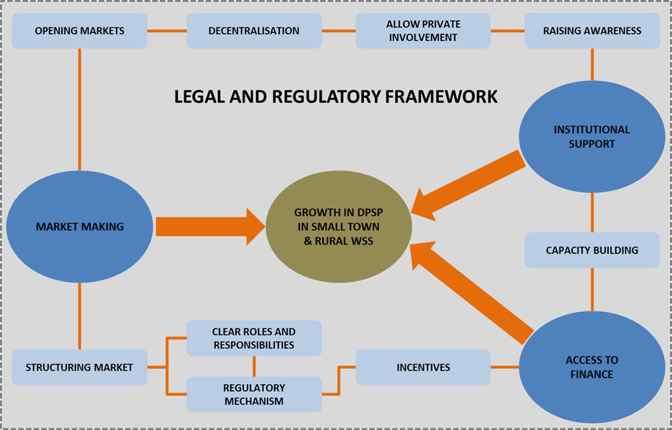
In general, there is no magic bullet, or one prescription that can be applied to every country to encourage DPSP in WSS sector. Through the development of the case studies, it is obvious that every country must take into account existing legal and regulatory conditions, capacity and capability of the public institutions, and readiness of the private sector and also community and public perceptions of private sector provision of public services when deciding to invite and encourage DPSP in WSS sector.
However, the study has found that there are three key action areas for public institutions to encourage DPSP in WSS service provision:
- Market making or market development
- Providing institutional support
- Assisting in developing and improving access to finance.
For all three activities above, a coherent, clear legal and regulatory framework can provide the necessary background and be conducive to the growth of DPSP. This constitutes the fourth main public sector support factor.
The subsections below discuss each of the key activities above and how they inter-relate and support each other in encouraging DPSP in WSS sector. First, however, we note that the basic market conditions for DPSP have to exist – the public interventions can bolster investor intentions, but the private operator must first feel confident that it can cover their costs and make a reasonable return on their investments.

Demand factors influencing growth in DPSP
In general, the private sector is motivated by the financial rewards and profits. Therefore, factors that increase the potential for profits will be a positive incentive for private sector involvement. These factors include:
- Population density and average income of residents – high population density decreases costs to connect households to the water supply network, and higher average household income improves household’s willingness and ability to pay. Both of these factors improve the financial performance of the private operator and hence their ability to make profit. Private operators in the Philippines have identified these as prerequisites for investing in WSS in small towns. The high risks and low profits associated with more spread out and less well off rural areas discourage private service providers.
- Economies of scale – small rural systems far from water source require high investment costs with small potential for cost recovery. If the rural area is close to another village, and it is possible for the private operator to provide both areas using one network, the potential for economies of scale will be an attractive attribute to the private sector. In Uganda, this was one of the constraints for the private operators, and the government is currently looking into the clustering of small towns in order to achieve economies of scale attractive to the private operators.
- Potential for growth – similar to the above point, successful private operators would like to expand their business to other locations. This is occurring in the Philippines, Uganda and Colombia.
- Availability of alternative sources – in the case of Bangladesh, the availability of private boreholes and other sources of water becomes a serious competition and has deterred private sector from providing WSS services in those areas with alternative sources. Awareness of communities of the importance and benefit of safe water supply needs to be improved to support the private operators.
The first three factors are related to the patterns of urbanisation discussed in Section 2.1. How urbanisation occurs in the country can determine whether or not it is feasible to have DPSP in providing WSS services. Identifying growth areas where population as well as economic activities are increasing would be propitious to promoting DPSP in the area. Economies of scale can be achieved when relatively large urban utilities expand to provide services to neighbouring towns, as is evident in Colombia. Combining small towns into regions which can be tendered as a single contract to the private sector (as is contemplated in Uganda) or having regional tariffs which would allow the private operator to cross-subsidies between towns (as is proposed in Colombia) are two further approaches to this issue.
The final point – the availability of alternative sources – is an important issue. In localities where there are readily available alternative supplies, extra care has to be taken to design a contractual and regulatory framework that ensures that clean water provided by a private operator will be affordable by low income households. If not, poor people will often resort to using unsafe water, which would defeat the objective of expanding access. From a business viewpoint, the existence of alternate supplies applies to all customers, making demand for water from the private operator much more elastic than overall demand for water. Private operators therefore need to be more than ever efficient and customer-oriented when alternative water supplies can easily be accessed.

Market making or market development
Returning to the main theme of this final section of the report – the role that that public sector can play in encouraging DPSP in WSS for small towns, Figure 4 shows the elements of the first main factor identified - market making.
Market making efforts to encourage DPSP includes two complementary elements, one is opening the WSS market to private sector involvement, the other is structuring the market in such a way that private sector clearly understand their functions, roles and responsibilities in the WSS sector.

Figure 4 Market making elements
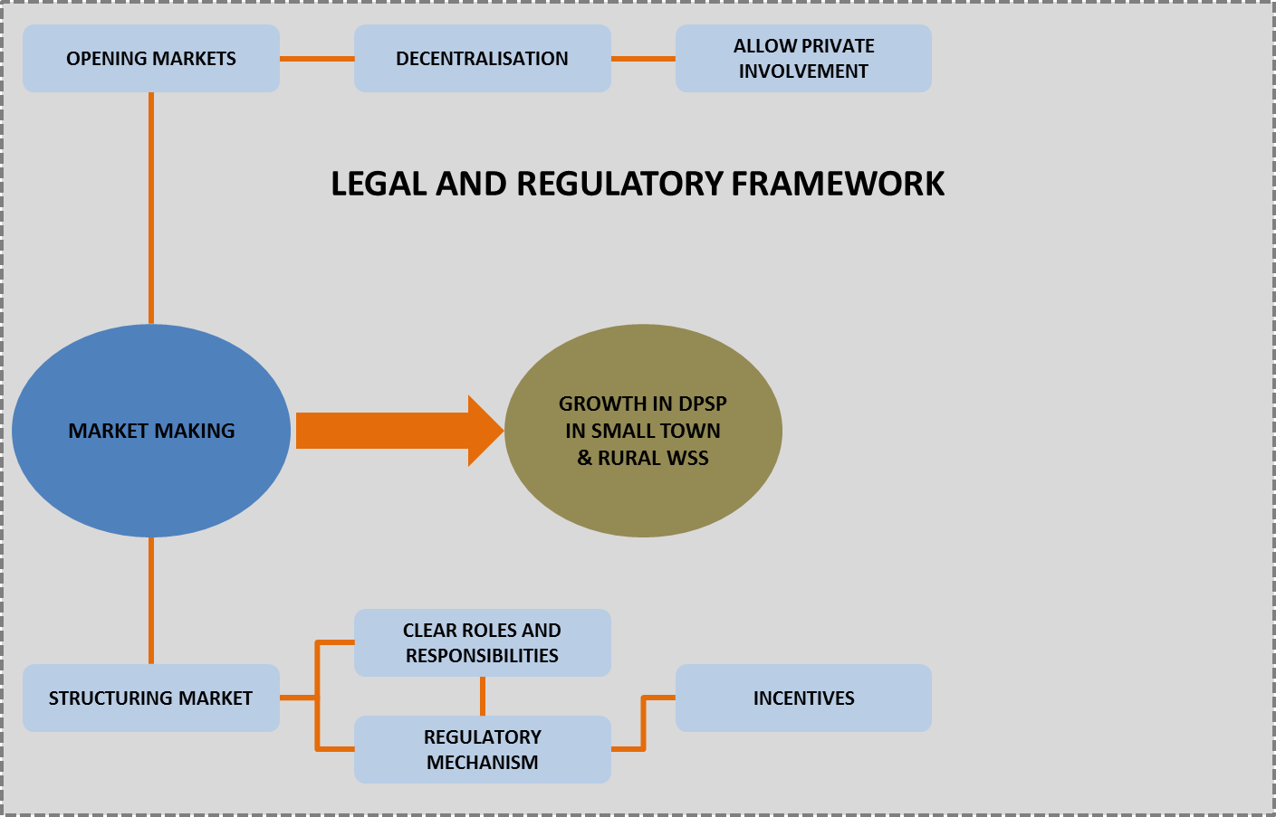

Opening the market to DPSP
In all of the case study and questionnaire countries, public service provision has been decentralised and delegated to local government institutions. This has directly or indirectly opened the market for and influenced the degree of private sector involvement in providing WSS services.
In the case of the Philippines, the local government institutions are allowed to choose how to provide the services, through the establishment of a separate local water utility (called water districts), through the local government’s own department, or through partnering or contracting with private partners. In Colombia, the local governments can choose to establish an ESP, which is a separate public utility that can be publicly owned, privately owned, or both. In both the Philippines and Colombia, this devolution of public service provision and the authority to choose the service delivery model is clearly stated in the legal framework.
The African countries included in this study, Uganda, Senegal and Niger, the decentralisation of WSS service provision was part of or included in reform of the WSS sector. In Niger and Senegal, the local government institutions are strongly encouraged to contract private operators to operate and maintain the WSS system and provide the WSS services to the communities. This is less strongly the case in Uganda, but in all three countries, the legal framework clearly supports this arrangement, and the regulatory framework allows for regulation by contract.
In all cases, there are common factors that led to local government institutions choosing to contract private operators to provide WSS services, including:
- Lack of capacity and ability of the local government institution to provide WSS services themselves
- Poor performance of community based organisation in providing WSS services
- Lack of availability of public sources of finance, which encouraged local governments to seek private sector investments.
However, decentralisation of public services can also create issues, such as the lack of experience and ability of local government institutions to procure suitable private sector partners, to design an appropriate PPP contract and to monitor the performance of the private operator. These skills and knowledge about PPPs are usually pooled at the national or central government level.
This is illustrated by the experience in Bangladesh. Although the responsibility of public service provision has been delegated to local government institutions, and the legal framework allows the local governments to partner with private sector, the lack of capacity and/or experience of the local government institutions have prevented the WSS market being opened for private involvement. The local government institutions still have the view that private sector is purely for profit and is unsuitable for public service provision, and therefore they are very reluctant to partner with private sector entities.

Structuring the market
Allowing the public sector to participate in the WSS sector opens the WSS market. However, DPSP will not flourish without clear understanding of the roles and responsibilities of the actors involved in the WSS sector, a stable and conducive regulatory framework that is not too restrictive, and incentives that allows the private sector to earn returns on its investments.
The roles and responsibilities of the private sector have been made clear in Uganda, Senegal and Niger, in that they are operators responsible for operation and maintenance of the system, and not asset owners. This clearly give signals to private operators that they are unlikely to be expected to invest in major construction of new assets, and therefore do not need to find large financing sources.
In the Philippines, the PPP framework and Joint Venture Guidelines provide guidance to both government institutions and private companies on the types of partnership legally accepted. In general, private companies are encouraged to invest in the WSS system. However, at the end of the contract period, the assets will be returned to the government. To allow for returns on their investments, the contracts are usually long term, at least 25 years.
Having a regulatory framework that is not too restrictive and allows the private companies to earn returns on their investment is also key to attracting DPSP. In the Philippines, tariff setting procedures are not restrictive, in that in most cases tariff adjustment clauses are included in the PPP contracts, monitored by the regulator.
In terms of incentives, most countries provide some form of financial incentives to attract DPSP. In Bangladesh and the Philippines, the PPP legal framework clearly prescribed the types of financial incentive the governments are willing to provide. This includes capital investments, guarantees, subsidies and tax breaks, amongst others. In Colombia, there is an indirect incentive, also anchored in the legal framework, in that local governments that have corporatized their public service provision through the establishment of the ESP may receive higher national budget allocations for WSS investments.
The examples above show that market making is very important in developing DPSP in WSS sector. In most cases, the opening of the market started with decentralisation of public service provision, followed by allowing private sector involvement and structuring of the market, where all actors have clear understanding of their roles and responsibility, sound regulatory mechanisms and good incentives, have contributed to factors leading to the growth of DPSP in WSS service provision.
However, as shown by the Bangladesh example, market making efforts from the government will need to be complemented by other factors, such as institutional support and access to finance.

Institutional support
Figure 5 illustrates the elements of the institutional support activities that encourage DPSP in WSS service provision.
Figure 5 Elements of institutional support
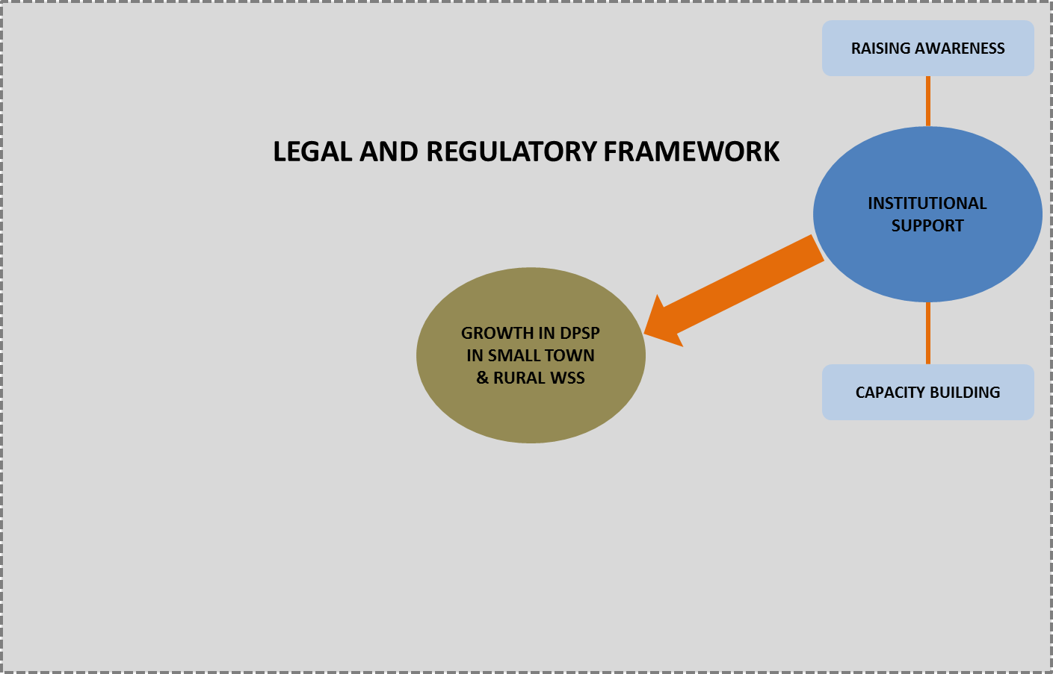
Public institutions can provide the much needed support to encourage growth. One type of support that has in a way been mostly neglected by most countries in their efforts to promote DPSPs is in raising the awareness of all stakeholders, including local government institutions and the community/consumers, of the benefits of having private sector involvement in the sector.
The lack of this type of support can be detrimental to the efforts to promote DPSP, especially in sectors that have traditionally been served by government institutions. This is shown by the example from Bangladesh. As mentioned earlier, the local government institutions do not fully understand the benefits of having private partners in providing WSS services. In addition, the community in general share the local government’s view that the private sector will only be interested in earning profits and not in providing public services such as WSS.
In contrast, DPSP in WSS sector is a well-accepted concept in the Philippines. The Government of the Philippines has made great efforts in promoting PPPs in all infrastructure sectors, and have created a PPP framework that includes the establishment of a PPP Centre, which acts as a knowledge centre of PPPs. The PPP Centre provides various capacity building programs for local government institutions in terms of understanding the concept of PPPs, how to structure, develop and prepare PPP projects, and how to implement and monitor PPP projects. This drive to disseminate knowledge about PPPs has resulted in the acceptance of the concept by local government institutions. Coupling this with several success pilot projects, has greatly improved community understanding and belief in the benefits of DPSP.
Many local government institutions are interested in having private partners as they understand that private sector can provide better and more efficient service to the community, as well as bringing in the capital needed to improve the system and increase coverage. The community also understands the benefits of having good WSS services, for example one community noted that economic activities, especially tourism, improved significantly and became more remunerative once the community had piped water supplies.
In most cases, central or national government institutions have good understanding of PPPs and the benefits that PPP arrangements can bring to infrastructure sectors. This knowledge and experience needs to be passed down to local governments and the community. Capacity building and training programs for local government institutions are needed, coupled with public awareness raising campaign for the community.
Capacity building programs and training should also include capacity building and training for the private sector and financial institutions. It is important that the private sector also understand how they can contribute to public service provision, and how they can earn returns from their investments. In terms of financial institutions, it is important that financial institutions understand the nature of the WSS business, in that it is capital intensive and has a slow return period, but market demand is secure and risks are low if there is good tariff regulation. This will allow them to provide tailored financial products that can assist and support private sector investment in the WSS sector.
The success of the sanitation marketing program in Bangladesh illustrates this point. Through the capacity building component of the program, and through understanding the need and financial ability of the community, local financial institutions now provide tailored loans to local entrepreneurs, who in turn offer flexible financing options to low income households.

Access to finance
Figure 6 shows the elements of the access to finance activities that encourage DPSP in WSS service provision.
It is well known and accepted that access to finance is a crucial factor in the development and growth of DPSP in any country. As mentioned above, it is beneficial for public institutions to provide support to private financial institutions in terms of capacity building and training, so that local financial institutions can provide tailored products to support the local private sector.
In addition, public finance may also be needed to address affordability issues and to accompany any private investment. For example, for small towns or rural areas where the community is not able to pay cost recovery tariffs to cover the full investment costs, the government may need to provide the capital investment, while the private operator provides funds for initial operation of the system.
Another way financial institutions can be useful in supporting DPSP in WSS is by channelling financial incentives provided by central or national government institutions and/or by donors or development partners to the private sector. For example, a soft loan from the donor agencies to improve WSS service provisions can be channelled through local financial institutions to the private companies involved in the provision of WSS services. Grants can also be channelled through local banks: these may, for example, take the form of output-based grants to encourage expansion of distribution networks to enhance access of poor households to clean water and improved sanitation.
Figure 6 Elements of access to finance
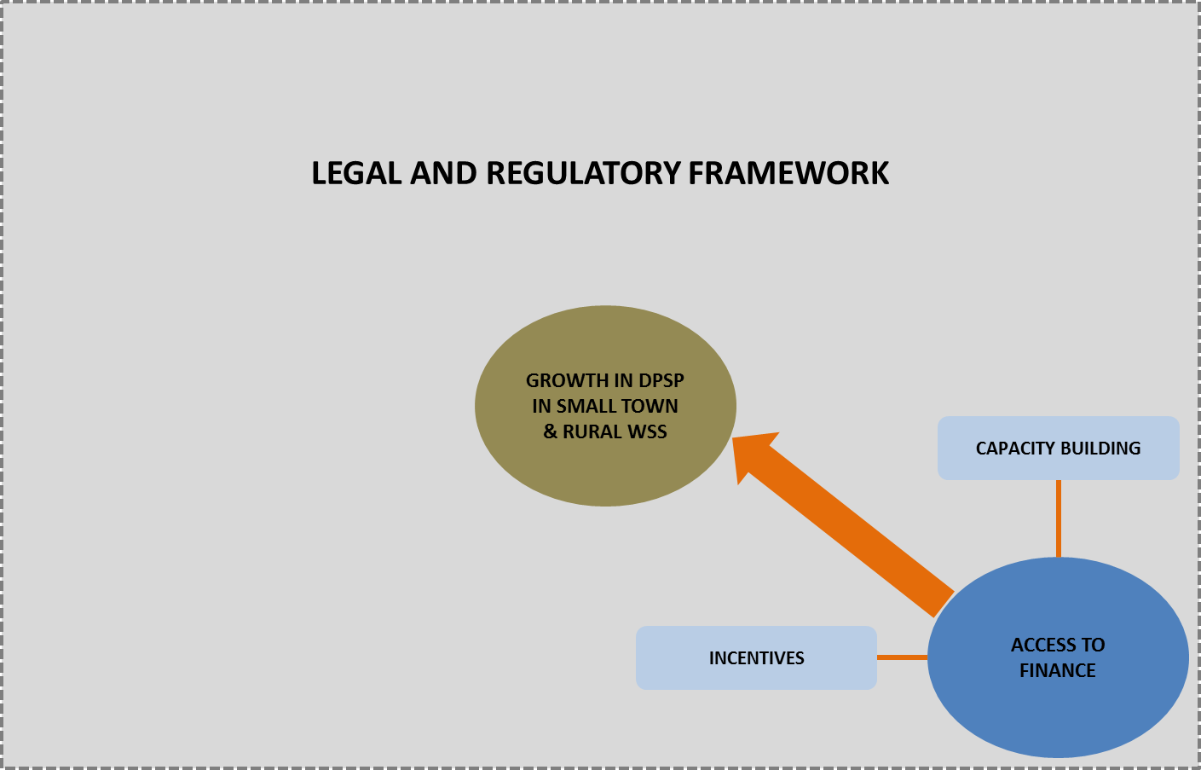

Legal and regulatory framework
As shown in all the diagrams, a good legal and regulatory framework is needed to support all the activities described above. The legal framework surrounding decentralisation provides the mandate for local governments to provide public service provision, whilst the sector-related legal framework clarifies roles and responsibilities of institutions involved in WSS, and defines the regulatory framework for WSS. In addition, some countries have a separate PPP legal framework that governs how PPPs are to be understood and implemented in the country.
There are, however, exceptions to this rule. For example, in Cambodia the private sector stepped in to invest in WSS systems and provide the services without any government technical or financial support. The lack of clear legal and regulatory framework has created opportunities for private entities to enter and develop their own market to provide WSS services to unserved community.
This has also occurs in the Philippines, albeit to a lesser degree. The comprehensive PPP framework that has been developed over time has overcome and compensated for the lack of regulatory framework in the WSS sector.
Nevertheless, there are clear benefits to having sound legal and regulatory framework:
- Clear legal and institutional framework – having a solid foundation in the legal framework gives private sector the confidence that their operation is protected by law. The legal framework also provides clear definition of the responsibilities of the public institutions involved in the WSS sector and can reduce complicated bureaucracy for the private sector.
- Clear regulatory framework – Good regulatory framework will also ensure the private sector that their interest will also be protected. This is especially important in terms of tariff setting. It is important that the private operator be allowed to charge tariffs that can cover their costs. Having a clear tariff approval process that are not political is key.

ANNEXES

- Global Desk Review Update
This Annex was submitted as a separate file.

- Country Reports
The Country Reports are provided as separate files, one for each case study countries.
  - Bangladesh Country Report
  - Colombia Country Report
  - The Philippines Country Report
  - Uganda Country Report

World Bank, 2011, Africa’s water and sanitation infrastructure
Africa Research Institute, 2012, Whatever happened to Africa’s rapid urbanisation, http://africaresearchinstitute.org/files/counterpoints/docs/Whatever-happened-to-Africas-rapid-urbanisation-6PZXYPRMW7.pdf
Africa Research Institute, 2012, Whatever happened to Africa’s rapid urbanisation, http://africaresearchinstitute.org/files/counterpoints/docs/Whatever-happened-to-Africas-rapid-urbanisation-6PZXYPRMW7.pdf
These incentives are included in the PPP legal framework, which could encourage private involvement in the infrastructure and public services. How effective these incentives are depends on various other factors and will require more detailed and focused evaluation.

