C:\Dropbox (ECA)\A1Files\Projects\Worldwide WSP PSP in small towns 504\Docs\Docs\1. Global Desk Review Update\Finals\ECA Global Desk Review Update (Final) v10.docx 13/02/2015
Strengthening Public Institutions in Engaging and Regulating Domestic Private Sector for the Provision of Water and Sanitation Services in Rural Growth Areas and Small Towns
Global Desk Review Update
February 2015
Submitted to the World Bank – Water and Sanitation Program by:
Economic Consulting Associates

Economic Consulting Associates Limited
41 Lonsdale Road, London NW6 6RA, UK
tel: +44 20 7604 4546, fax: +44 20 7604 4547
www.eca-uk.com

Contents
Abbreviations and acronyms iv
Executive summary vi
1 Introduction 1
1.1 Overview of the Study 1
1.2 Objective of this Report 2
1.3 Structure of this Report 2
2 Analytical Framework 3
2.1 Overview 3
2.2 Country diagnostic and questionnaires 4
2.3 International experience of DPSP 13
2.4 Integration with PPP framework 13
3 Analysis of Urban Development 16
3.1 The urban hierarchy and definition of small towns 16
3.2 Proximity of small towns to cities 17
3.3 Small towns and rural-urban migration 18
3.4 Urban hierarchies 18
4 International Experience of DPSP 20
4.1 Factors influencing private involvement 20
4.2 Enabling environment for private participation 25
4.3 Types of private operators in WSS sector 29
4.4 Main challenges faced by DPSPs 34
5 Preliminary Hypotheses 37
5.1 What encourages the growth of DPSPs? 37
5.2 What support can be provided? 40
A1 Detailed Analytical Framework 43
A1.1 National level analysis 43
A1.2 Sub-national level analysis 46
A1.3 Small town WSS analysis 47
A2 Summary of Questionnaire Responses 50
A2.1 Water supply and sanitation sector information 50
A2.2 Government Structure and Public Service Provision 55
A2.3 Private Sector Existence and Level of Involvement 57
A2.4 Conclusions and Key Lessons Learnt 61

Tables and figures
Tables
Table 1 Summary and comparisons of country diagnostic results 6
Table 2 Profiles of Rural and Small Town Private Operators in Mauritania 31
Table 3 Profiles of WSS private operators 31
Table 4 National level analysis – topics and questions for each phase 43
Table 5 Sub-national level analysis – topics and questions for each phase 46
Table 6 Small towns WSS analysis – topic and questions for each phase 48
Table 7 Water Supply and Sanitation Sector Information 50
Table 8 Government Structure and Public Service Provision 55
Table 9 Private Sector Existence and Level of Involvement 57
Table 10 Conclusions and Key Lessons Learnt 61

Figures
Figure 1 Summary of study objective, activities and deliverables 1
Figure 2 Methodology and analytical framework of this study 3
Figure 3 Integration and relation with PPP framework 15
Figure 4 Categorisation of piped schemes for domestic water supply 33
Figure 5 Rural private operator initiatives by technology 33
Figure 6 Preliminary hypotheses 37

Boxes
Box 1 Private operators provides WSS services where governments cannot 22
Box 2 Lessons learnt from water sector reforms in Senegal 26
Box 3 Experience with water sector reform in Niger 27
Box 4 Variations of contractual arrangements 30

Abbreviations and acronyms
ADB | Asian Development Bank
AFD | African Development Bank
APWO | Association of Private Water Operators (Uganda)
BOT | Build Operate Transfer
BOTT | Build Operate Train Transfer (South Africa)
BWSI | Balibago Waterworks System Inc (Philippines)
BWSPP | Bangladesh Water Supply Program Project
BWUI | Bohol Water Utilities Inc (Philippines)
CBO | Community Based Organisation
CLTS | Community-Led Total Sanitation (Bangladesh)
CRA | Colombian Water Regulator
DBL | Design Build Lease
DBO | Design Build Operate
DIH | Department of Industry and Handicraft (Cambodia)
DILG | Department of Interior and Local Government (Philippines)
DNH | National Water Supply Directorate (Mali)
DPHE | Department of Public Health and Engineering (Bangladesh)
DPSP | Domestic Private Sector Participation
DWAF | Department for Water Affairs and Forestry (South Africa)
ECA | Economic Consulting Associates
ESP | Public Service Company (Colombia)
HUC | Highly Urbanised City (Philippines)
IFC | International Finance Corporation
JV | Joint Venture
LGD | Local Government Department (Bangladesh)
LGED | Local Government Engineering Department (LGED)
LGI | Local Government Institution
LGU | Local Government Unit
LWUA | Local Water Utilities Administration (Philippines)
MHCP | Ministry of Finance and Public Credit (Colombia)
MIH | Ministry of Industry and Handicraft (Cambodia)
MLGRD&C | Ministry of Local Government, Rural Development and Corporation (Bangladesh)
MWE | Ministry of Water and Environment (Uganda)
MWSS-RO | Metropolitan Waterworks and Sewerage Services – Regulatory Office (Philippines)
NDP | National Development Plan (Colombia)
NEDA | National Economic Development Authority (Philippines)
NGO | Non-Governmental Organisation
NWRB | National Water Regulatory Board (Philippines)
NWSC | National Water and Sewerage Corporation (Uganda)
OBA | Output Based Aid
PO | Private Operator (Cambodia)
PPP | Public Private Partnership
PSSP | Philippine Sustainable Sanitation Plan
PSSR | Philippine Sustainable Sanitation Roadmap
PSU | Policy Support Unit
PWO | Private Water Operator (Uganda)
PWSSR | Philippine Water Supply Sector Roadmap
RURA | Rwanda Utility Regulation Agency
SDE | Senegalese water private operator
SDP | Sector Development Plan (Bangladesh)
SONES | Senegalese water asset holding company
SOP | Standard Operating Procedures
SPI | Strengthening Public Institutions
SSPD | Supervisory Agency for Public Services (Colombia)
TOR | Terms of Reference
UK | United Kingdom
UN | United Nation
VAS | Ministry of Water and Sanitation (Colombia)
WASA | Water and Sanitation Authority (Bangladesh)
WBG | World Bank Group
WSP | Water and Sanitation Program
WSS | Water supply and sanitation
WSSA | Water Supply and Sewerage Authority (Uganda)
WUA | Water User Association (Mali and Malawi)

Executive summary
This report is the Global Desk Review Update, which is one of the main deliverables for the Study to Strengthening Public Institutions in Engaging and Regulating Domestic Private Sector for the Provision of Water and Sanitation Services in Rural Growth Areas and Small Towns. This report is an updated version of the Preliminary Report submitted in August 2014, and takes into accounts the response from the detailed questionnaires circulated in October 2014.
The objective of this report is to present the analytical framework used in the study, provide an overview of world-wide experience in domestic private sector participation (DPSP) in water supply and sanitation (WSS) service provision for small towns and rural areas, and to address specific issues related to the dynamics of urban hierarchy and what the impact is on WSS service provision.

Analytical framework
The analytical framework developed in Phase 1 (Desk Review) of this study, which was used in Phase 2 (Field-diagnostic), includes analysis of the WSS sector at the national level, and at the sub-national level, focusing on the levels of government and dynamics of urban hierarchy, and the last part of the analysis presents details of the experience of DPSP in the WSS sector. This analytical framework was also used to develop the questionnaire that was circulated in October 2014.
The diagram below illustrates the cross cutting nature of the analytical framework developed and used in this study, as discussed in Section 2.
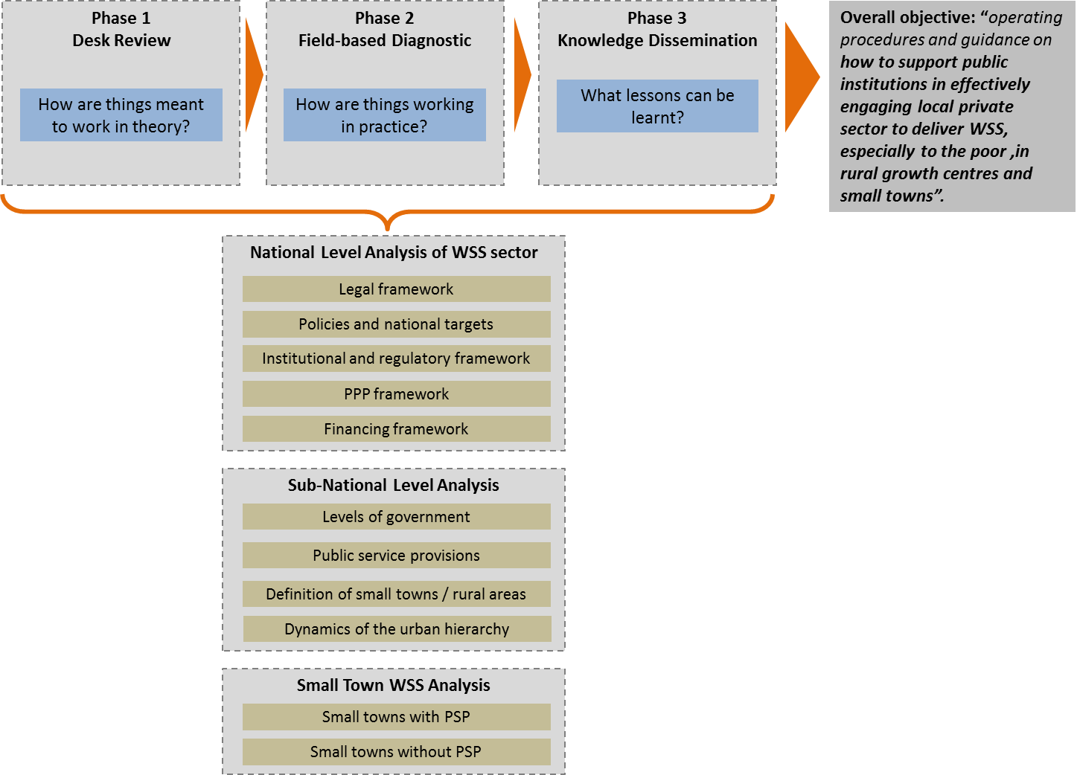

Analysis of urban development
An important component of the analytic framework for the study relates to the growth in the number and size of small towns. Section 3 of this report presents definitions and current thinking on the process of urbanization and how this relates to WSS service provision. From the viewpoint of a private operator, the immediate importance of urban development is in creating a market for WSS services. Private operator market incentives are driven by:
- Population density and average income of residents
- Potential for economies of scale
- Potential for growth
- Availability of alternative sources of water
The first three factors are related to the patterns of urbanisation: where these create sufficient population and income density, the provision of WSS by the private sector makes sense, and the more so in a context of rapid demographic and economic growth. Economies of scale can be achieved when relatively large urban utilities expand to provide services to neighbouring towns, as is evident in Colombia, or through different regionalisation models.
This analysis of urban development is discussed further in Section 3.

International experience in DPSP
This report provides a literature review aimed at a broad global overview of international experience in DPSP in WSS sector was conducted, focusing on these key questions:
- What are the reasons for private sector involvements in the WSS sector?
- What kind of enabling environment encourages more DPSP?
- What types of arrangements and contracts are there, especially in small towns?
- What are the challenges faced by DPSP in both water and sanitation services provision?
This international experience is discussed in detail in Section 4.

Preliminary hypotheses
Diagram below summarises the preliminary hypotheses, showing the main factors that influences and encourages the growth of DPSPs in the WSS sector:
- Decentralisation – the delegation of the responsibility for providing WSS services to local governments has led to and allow local governments to find the best way to provide these services, including by contracting private operators
- Market making – several factors contribute to market making activities that encourage DPSP in WSS sector:
  - Central government support – in terms of providing stable and clear legal and regulatory framework for DPSP, offering financial support to private partners, and providing capacity building to local governments, private operators and community
  - Economies of scale and potential for growth – these are important incentives for private operators, which are essentially a profit making entity (in most cases, depending on the definition of private sector)
  - Availability of financial products – access to financing is crucial for private sector participation, especially if it includes capital investments.
These hypotheses are taken into account during the field-based diagnostics and in forming our key conclusions and lessons learnt in presented in the Best Practice Report. These are discussed in Section 5.
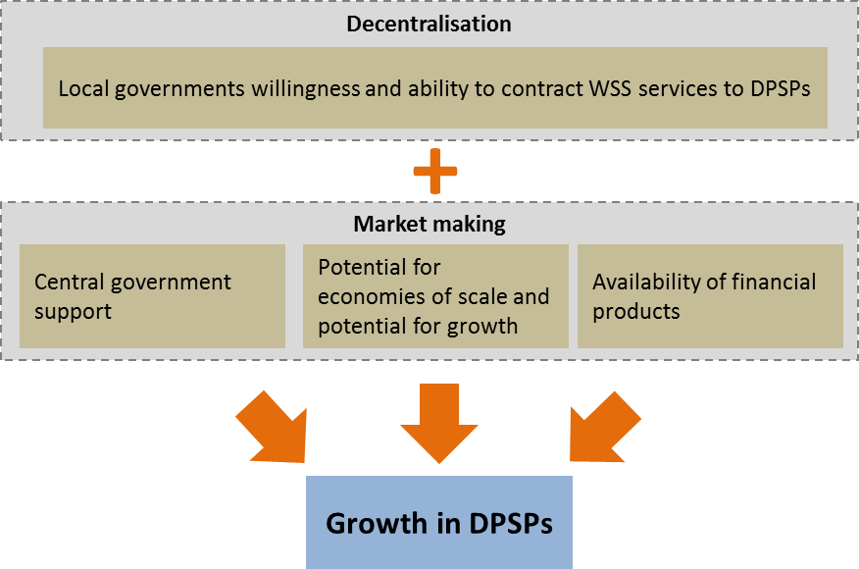

Introduction
Economic Consulting Associates Limited (ECA) has been engaged by the Water and Sanitation Program (WSP) of the World Bank to conduct the Study to Strengthening Public Institutions in Engaging and Regulating Domestic Private Sector for the Provision of Water and Sanitation Services in Rural Growth Areas and Small Towns.

Overview of the Study
As stated in the Terms of Reference (TOR), the objective of this study is “to consolidate knowledge so far gained by the World Bank Group and its partners at global level and provide operating procedures and guidance to developing countries and WBG task teams on how to support public institutions in effectively engaging the local private sector to deliver better water and sanitation services specially to the poor in rural growth centres and small towns”.
This study is being conducted in three phases: a desk review phase, field-diagnostic phase and knowledge dissemination phase. The specific objectives, activities and tasks for each phase and the resulting deliverables are summarised in Figure 1.
Figure 1 Summary of study objective, activities and deliverables
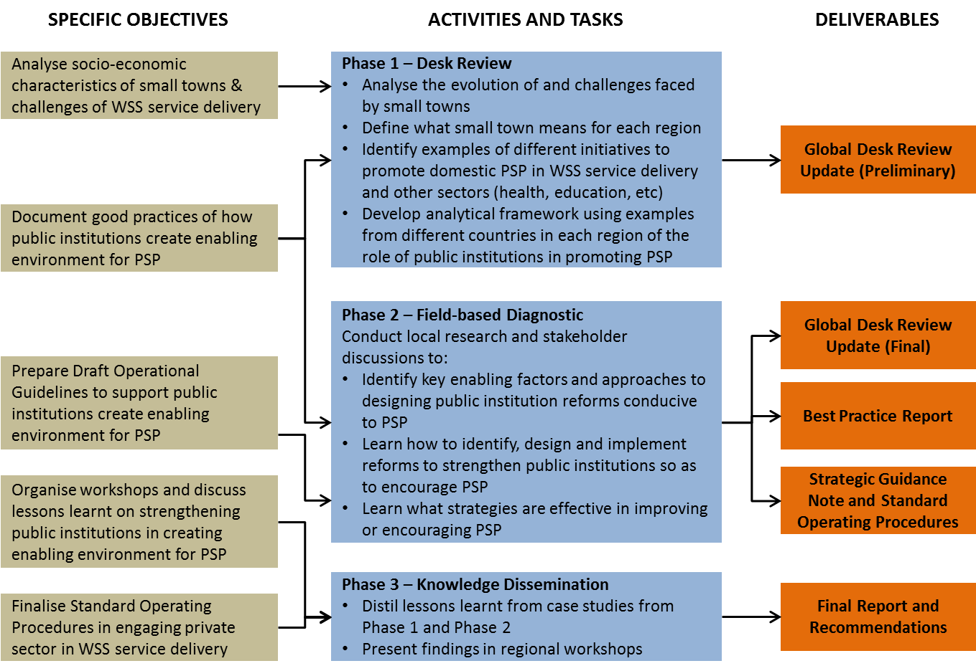
The study focuses on piped water schemes in rural and small towns where local private actors increasingly represent a significant group of stakeholders, using lessons learnt and experiences from the selected countries: Bangladesh, Colombia, the Philippines and Uganda.

Objective of this Report
This report is the Global Desk Review Update being delivered at the end of Phase 2. It is an update and expansion of the preliminary Global Desk Review presented in Phase 1. The objective of this report is to present the analytical framework developed and used in the study, provide an overview of world-wide experience in domestic private sector participation (DPSP) in water supply and sanitation service provision for small towns.
It was agreed during the launch workshop for this study in Kampala in July 2014 that a questionnaire be developed and circulated to other countries to add experience from other countries in encouraging domestic private sector participation (DPSP) in WSS service provision. ECA developed the questionnaire, and this was circulated by WSP to other countries. Three countries responded to the questionnaire: Senegal, Niger and Cambodia.
This report is based on information and publications available in the public domain, and also incorporates the response to the questionnaire from Senegal, Niger and Cambodia.

Structure of this Report
The rest of this report is structured as follows:
- Section 2 presents the analytical framework used in this study.
- Section 3 outlines the current thinking and analysis of urban development
- Section 4 includes the result of the literature review on wider international experience in domestic private sector participation in the water supply and sanitation sector
- Section 5 presents our preliminary hypotheses based on the literature review and questionnaire responses.
In addition, Annex A1 provides a detailed analytical framework questions, and the summary of the response from the questionnaire is included in Annex A2.

Analytical Framework

Overview
This section presents and explains the analytical framework developed for and used in this study. The analytical framework illustrated in Figure 2 is used first and foremost for the detailed survey and field-based diagnostics of the selected four countries: Bangladesh, Colombia, the Philippines, and Uganda, and also for the development of the questionnaire.
Figure 2 Methodology and analytical framework of this study
The three phases in this study build in turn on knowledge and information gained from the previous phases:
- Phase 1 – Desk Review: How things are meant to work in theory
The analysis in this phase relies on publicly available information and publications. The literature review conducted in this phase includes not only the four main countries selected for this study, but also other countries based on the answers from the questionnaires and on additional global research. In addition, the literature review of the four selected countries provides a theoretical picture of how the WSS sector works at national and sub-national levels, and what definition of small town is used in each country, which is used as the basis of the field diagnostic in Phase 2.
- Phase 2 – Field-based Diagnostic: How things are really working in practice
This phase investigates how the WSS sector is performing in real life in the four selected countries, through field visits for discussions with key stakeholders. The results from this phase are captured in the Best Practice Report and the Country Reports. The key conclusions and lessons learnt have been supplemented by information from the questionnaire countries. Through this phase, the preliminary study hypotheses have been tested and refined. The results will be the basis for the Strategic Guidance Note and Standard Operating Procedures, which are due in the next round of deliverables.
- Phase 3 – Knowledge Dissemination: What lessons can be learnt
This phase will bring together experiences and lessons learnt from all countries on how to support public institutions in encouraging domestic private sector participation in the WSS sector. The consolidated knowledge from the study will be presented in the four regions during Regional Workshops. The final perspectives from the research work and the workshop discussions will be drawn together in the Final Report.
This report, the Global Desk Review Update, is an updated version of the Preliminary Report submitted in August 2014, and takes into accounts response from the detailed questionnaires circulated in October 2014.
The analytical framework is also broadly used to systematise the issues and topics that the study focusses on, to guide the global perspective based on previous studies, and how this study will culminate in the development of Standard Operating Procedures (SOP) for strengthening public institutions to support to domestic private sector participation in WSS in small towns.

Country diagnostic and questionnaires
The analytical framework uses different levels of analysis that can be applied to each country in the study, and was also used to develop the questionnaire:
- National level analysis – focuses on the water supply and sanitation sector and how it is organised at the national level. The objective is to gain good understanding of the WSS sector in each country, what the governing laws, regulations, national policies and targets are, who the key players are at the national level, how the WSS sectors are being financed, and whether or not there is a specific PPP framework that the government is promoting
- Sub-national level analysis – seeks to understand the definition of small towns (expected to be different in each country), the dynamics of rural and urban areas, and the way the different levels of governments and public institutions provide public services. The objective is to see if there are certain factors that influence the way public services are provided by the different levels of governments
- Experience with small town DPSP – the focus is on WSS service provision in small towns. The objective is to further understand why in some small towns WSS services are provided by domestic private service providers and in others the local government or other public institutions choose to provide the services themselves. This level of analysis relied mostly on discussions with key players, such as the private operators, local governments and other local level institutions, with the key information most likely being gathered during the field diagnostic phase.
Table 1 summarises the results of the analysis of the selected countries in Phase 1 and updated through the field diagnostic in Phase 2. Annex A1 provides a more detailed description of how each level of analysis was applied to each phase.
The topics of analysis used in the field-based diagnostics are also used for the questionnaire. As mentioned, the responses from three countries were received, Senegal, Niger and Cambodia. Annex A2 provides a summary of the response received.

Table 1 Summary and comparisons of country diagnostic results
Topics of analysis | Bangladesh | The Philippines | Uganda | Colombia
National level analysis
Legal framework of WSS sector | - Main legal document is the Bangladesh Water Act of 2013, mostly governing water resources management  - Local Government Acts was reframed in 2009, define function of local institutions, including to provide WSS services  - A National Water Supply and Sanitation Strategy paper to streamline WSS strategies is due in 2014  - Limited reforms in the WSS sector | - Main legal document is the Water Code of 1976, mostly about water allocation  - The Local Government Code of 1991 governs the provision of WSS services by LGUs and water districts and allows the LGUs to choose how to provide WSS services, i.e., through creation of water districts, direct provision from LGU or by contracting private entities  - Presidential Decree 198 introduce a new management model for urban water supply by encouraging LGUs to form water utilities called “Water Districts”, which operate with a certain degree of autonomy from LGUs | - Key document for WSS sector is the Water Act of 1998, provides for the use, protection and management of water resources and supply  - Water Act aims to promote rational use of water and supply of sufficient water of safe quality  - Reforms are desired as performance of WSS sector has been poor  - Policy and legal revisions to accommodate reforms are lacking | - 1991 Colombian Constitution decentralised public services  - Law 142 of 1994 sets out the WSS institutional arrangement and establishes the economic regulator CRA  - SSPD is created by the 1991 Constitution as the entity responsibly for monitoring and oversight of public service providers
WSS sector policies and national targets | - Sector Development Plan (SDP) for WSS sector specifies targets  - SDP valid from 2011 to 2025, addresses existing problems and future challenges  - SDP calls for universal WSS services of basic nature by 2016  - Introduction of a Sector Wide Approach (SWAp) is a priority | - NEDA formulates WSS national targets based on medium term national development plan  - Have water supply sector roadmap (PWSSR) and specific roadmap for sanitation (PSSR and PSSP)  - Universal access to safe water provision by 2025  - Universal access to safe sanitation services by 2028 | - Targets for WSS sector have been established in Ugandan WSS Sector Reform Strategy, include improved coverage, sustainability and affordability  - National Water Policy outlines efforts to reach targets  - Main target is 100% access to water for urban population by 2015 | - WSS policy making is at national level by Vice-Ministry of Water and Sanitation (VAS)  - National Planning Department (NPD) also involved in planning sector priorities. Most recently, focus on rural WSS service access according to MDGs
Institutional and regulatory framework of WSS sector | - LDG under MLGRD&C, specifically the Policy Support Unit (PSU) responsible for developing WSS policies and strategies  - LGED under MLGRD&C responsible for implementing infrastructure projects  - DPHE responsible for WSS projects in rural areas  - An Independent Regulatory Commission is planned for the sector  - Service provision by WASA in large urban areas, LGIs and CBOs / NGOs in small urban and rural areas | - No specific ministry responsible for WSS  - DILG provides support to LGUs in all aspects including WSS service provision  - LWUA regulates and provide financing for water districts  - NWRB regulates private service providers  - MWSS-RO regulates concessionaires in Metro Manila  - WSS service provisions are decentralised to LGUs, water districts or private operators  - In rural areas, WSS services are provides by CBOs | - The Ministry of Water and Environment (MWE) sets policies and standards, manages water resources and determines development priorities  - Ministry of Health also plays a role in the WSS sector  - No independent regulator  - Independent regulation authority is currently designed for urban areas, next step is for the legislation to be passed  - Independent regulator will replace regulation unit within the MWE | - NPD responsible for broad policy direction  - VAS is responsible for sector-specific policy making  - Economic regulator CRA is independent from Ministry  - SSPD is the monitoring & enforcement agency  - The responsibility for WSS service provision lies with the municipalities. Provision can be by specialised providers (public, private, mixed), authorised organisations, including CBOs, or private individuals
Public Private Partnership (PPP) framework | - National PPP framework exists  - Main document is the Policy and Strategy for Public-Private Partnership  - Incentives of fiscal and non-fiscal nature available  - Public Private Partnership Act of 2013 awaits approval to complete Bangladesh's PPP framework from legal perspective | - Comprehensive and politically supported PPPO Framework  - Two legal documents provided the national PPP framework: BOT Law and the Guideline for Joint Venture 2013  - PPP Centre provides institutional support for all PPP projects | - A policy on PPP was adopted in 2010  - Specific PPP legislation or regulation is still missing  - Ministry of Finance Planning and Economic Development is currently strengthening the PPP framework  - PPP has been implemented in relatively few projects, outside the water sector | - PPP Law (Law 1508) governs the PPP framework, guides the procurement process  - However, all public services (incl. WSS) explicitly fall outside the scope of the PPP Law  - Specialised providers (ESPs) of mixed ownership are governed by Law 142 instead
Financing framework of WSS sector | - The Finance Division of the Ministry of Finance allocates the government budget  - WSS sector is not a distinctive sector for allocation purposes  - WSS sector has a strong donor base it receives funds from  - WSS sector funding more project based rather than long term planning | - NEDA reviews and allocates budget to various sectors based on development plan  - WSS sector receives financing from donors and development partners | - Allocations of government budget are made based on National Development Plan  - A significant portion of the investments in the WSS sector are financed by donors and NGOs  - The bulk of urban water investment resources are channelled through NWSC | - WSS sector funded through the national budget, royalties, tariffs and a specialised credit line through FINDETER  - MHCP allocates national budget to sectors  - A small share of the national budget is allocated to the WSS sector
Sub-national level analysis
Levels of government | - Two levels of government, central and local  - Local government institutions (LGIs) vary for urban and rural areas  - In urban areas the LGIs are city corporations for metropolitan cities and Paurashavas for large-to-medium sized towns  - In rural areas there are Zila Parishads (District), Upazila Parishad (subdistrict) and Union Parishad | - Two levels of government, central and local  - Elected local government units (LGUs) include:  - Provincial government  - Independent cities (same level as provincial)  - Cities and municipalities (under provinces)  - Barangays (under cities or municipalities) | - Two levels of government, central and local  - In rural areas, there are local governments at district, county, sub-county, parish and village level  - In urban areas, there are local governments at city, municipality, town council and town board level  - District Water and Sanitation Coordination Committees play a key role in implementation of WSS policies | - Two levels of sub-national government: departments and municipalities  - Both are elected  - Neither have legislative power, only executive and judicial representation
Public service provision in sub-national levels | - Four large cities have Water Supply and Sewerage Authorities (WASAs) in charge of WSS services  - Otherwise City Corporations are in charge of WSS services and other public service provisions  - Paurashavas comparable to City Corporations in their tasks  - Union Parishads raise awareness of WSS benefits | - All levels of LGUs are responsible for providing public services, including WSS  - All levels of LGUs are allowed to contract with private sector to provide these services | - National Water and Sewerage Corporation (NWSC) is in charge of WSS services in 30 large towns  - Directorate of Water Development, also under the MWE, provides small towns with WSS services  - Local governments contract private service providers. As of 2013, 132 small towns were supplied by private operators. | - Responsibility for provision lies with municipality  - If municipality of department cannot deliver it is the National Government's direct responsibility  - Municipalities may contract with private or other organisations for WSS service provision
Definition of small towns and rural areas | - No formal definition of small towns, use WB project’s definition, between 10,000 and 100,000 population  - An area is classified as urban if 75% of the population do not work in agriculture, 33% of land is not used for agriculture, population density per square kilometer is 1,500 or more and total population is 50,000 or more | - No formal definition of small towns, use ADB definition of between 10,000 and 100,000 population  - Has definition of urban areas and classification of cities and municipalities based on LGUs income  - In WSS services context, small towns have up to 2,000 connections | - Small towns have a population of between 5,000 and 20,000 people, rural growth centres (RGCs) have a population of 500 to 5,000 people and rural areas have a population of less than 500 people  - Small towns are typically found close to major roads; many towns are the administrative headquarters of local governments | - Small towns: 5,000-12,000 inhabitants  - Rural areas: disperse disposition of house; streets, roads or avenues are not named or marked.
Dynamics of the urban hierarchy | - Annual urban population growth has declined from 3.5% in 2000 to 2.9% today  - Job opportunities and poverty in rural areas drive migration to urban areas  - Urban centres struggle with provision of public services and infrastructure due to influx of migrants  - Urban centres developing around metropolitan cities | - Urbanisation due to migration but also from rural areas becoming growth centres  - Remittance from overseas worker played a big role in the development of rural areas to become more trading centres  - Growth centres forming around large metropolitan cities | - The minister of Local Government can declare a rural area to be urban upon fulfilment of relevant criteria  - Job opportunities and land shortage in rural areas caused by high population growth motivates people to migrate to urban areas  - Public services and infrastructure in urban areas are adversely affected by migration  - Rapid growth in small towns, consistent with a long-term urban growth rate of 4.8% per year, is expected | - Migration to urban areas leads to growth of small towns near big cities  - Overtime the small towns becomes part of the big cities  - At present, urban population growth stands just above 1% per year
Small town WSS analysis
Small towns with private service providers | - The World Bank funded Bangladesh Water Supply Program Project (BWSPP) from 2005 to 2010 meant to increase private service providers in small towns  - BWSPP's goal was to implement privately owned and operated piped water supply schemes  - BWSPP failed partly due to poor financing opportunities for private sector.  - Sanitation marketing program from WSP has successfully create market for DPSP in sanitation  - Sanitary equipment supplier also provide installation and after sale services, and offer tailored financing to poor customers | - Vibrant market for DPSP in small towns  - Small local private companies actively seek opportunities to partner up with LGUs to provide WSS services  - Examples from field trip:  - Balibago Waterworks System Inc (BWSI) – started providing WSS service in Angeles City for 7000 connections, now has 15,000, also provide WSS services to other small towns with max population of 100,000  - Bohol Water Utilities Inc (BWUI) – JV company with provincial government  - SIG Construction – won the DBL contract in Santa Cruz  - ALV (SAVS) Water – small local company seeking opportunity for JV with Tuburan LGU | - MWE can appoint any public bodies to become Water Supply and Sewerage Authority (WSSA)  - WSSAs can sign management contracts with private water operators (PWOs)  - In 2013, out of 187 centres, WSS was supplied in 30 by NWSC, 1 by a sugar company and 24 by Water Authorities. The remaining 132 centres by private water operators (58 belonging to APWO, 53 by other operators) and by individuals (21 centres).  - Water tariffs in small towns are proposed by operators, but there are long delays in getting approvals from MWE  - The performance in delivering WSS services of the different districts is compared using a monitoring and evaluation mechanism | - Triple-A is a specialised provider of mixed ownership operating in the large city of Barranquilla. It also supplies neighbouring municipalities (small towns) out of own initiative (not profitable)  - Acuavalle S.A. ESP is a regional company that provides drinking water and sewerage services to a population of 582,000 people in 33 municipalities of Valle del Cauca.  - The Aqueduct La Sirena in Valle del Cauca in the Southwestern edge of the city of Cali, manages 778 residential connections with continuous service to 4,200 users. The system includes a sewer, a plant of slow filter.  - The Black River Aqueduct Association in Popayan, formed 10 years ago, includes 10 villages with 7,000 household connections.
Small towns without private service providers | - WSS service provisions provided by NGOs or community organisations | - Water districts are essentially water utilities owned by the government and provides WSS services for urban towns  - Water districts operates on a commercial basis and are regulated by the LWUA  - LGUs can also provide WSS services through their own departments  - LGU-operated systems are reportedly less efficient than water districts or private operators  - CBOs provide level I (shared water wells) and level II (piped water to shared connections) in rural areas | - Characterized by very low populations – less than 500 people  - Economic activities of these places mostly limited to subsistence agriculture  - Private service providers are missing from all sectors and not only WSS services  - WSS services often provided by NGOs and CBOs | - WSS service provision provided mostly by CBOs  - Alternatively, municipality has to provide service

International experience of DPSP
To strengthen the four country diagnostic analysis described above, a literature review aimed at a broad global overview of international experience in DPSP in WSS sector is included in this study. This draw on various previous studies on DPSP in the WSS sector internationally, as well as responses from the questionnaire, providing insights into what works and what does not work in reality across a wide spectrum of countries.
This literature review focuses on the following questions:
- What are the reasons for private sector involvements in the WSS sector?
- What kind of enabling environment encourages more DPSP?
- What types of arrangements and contracts are there, especially in small towns?
- What are the challenges faced by DPSP in both water and sanitation services provision?
The international experience, as discussed in detail in Section 4, is taken into account in the analysis of key issues and lessons learnt in the Best Practice Report.

Integration with PPP framework
During the Launch Workshop in Kampala in July, we were made aware that in parallel to this study, there is an on-going project to develop Standard Operating Procedures for Public Private Partnership in the WSS sector. It is envisaged that this study will collaborate and support the PPP SOP work, not least through the major complementary deliverable of this study, the SPI SOP. To this effect, contact has been made with Iain Menzies and Shin Keu Ryu from WSP on how to create synergies between the two studies. This section describes our understanding of how the two studies are related.
The PPP SOP aims to assist World Bank Group Task Team Leaders (TTLs) to implement PPP projects in the relevant country, and will focus on the following topics:
- Why choose PPP rather than conventional public procurement?
- How ready are the government and the private sector in entering into a PPP type contract?
- How to choose the most suitable type of PPP?
- How to allocate the risks and responsibilities between the government and the private sector?
- How to implement the PPP transaction?
- How to monitor PPP contracts?
In our understanding, this study will support the PPP SOP work especially in terms of the second bullet point question in the above list: how ready are the government and the private sector in entering into a PPP type contract.
It is relevant here to re-iterate the objective of this study: “to consolidate knowledge and provide operating procedures and guidance to developing countries and WBG task teams on how to support public institutions in effectively engaging local private sector to deliver better water and sanitation services especially to the poor in rural growth centres and small towns”.
The three levels of analysis discussed in previous sections will provide this study with a better understanding of institutional arrangements that are conducive to promoting DPSP in WSS service provisions in small towns, as it will look in each country at:
- The level of decentralisation and how this affects public service provisions including WSS.
- The types of support that central governments provide to local governments in terms of budgetary, technical support and capacity building.
The results of the analysis will provide insights on the most conducive institutional arrangement for DPSP in WSS sector. It will also highlight weaknesses in institutional and regulatory frameworks that constrain further private sector participation.
The Strengthening of Public Institutions (SPI) Standard Operating Procedures (SOP) to be developed as part of this study will encapsulate the findings from the analysis, and provide guidance to assist TTLs in providing support to public institutions. The SPI SOP will focus on the following topics:
- How to identify the strength and weaknesses of the public institutions and/or of the institutional arrangements?
- What types of support will be most suitable to strengthen the identified weaknesses?
- How to further support public institutions in promoting and encouraging further private sector participation in WSS?
Figure 3 illustrates how the two studies relate to one another and how the SPI SOP can be used in a complementary manner in the PPP framework.
Figure 3 Integration and relation with PPP framework
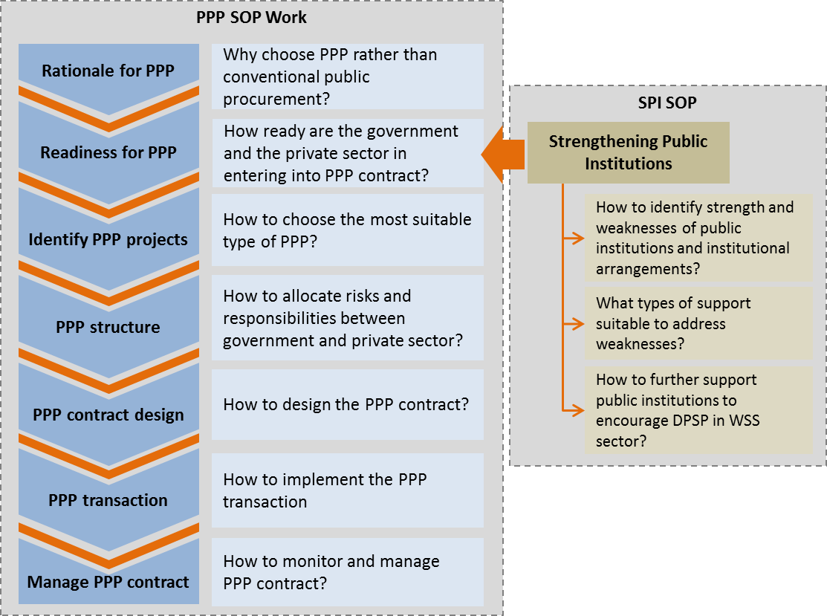
This integration with the PPP framework will be further discussed with various personnel from WSP and with Iain Menzies and Shin Keu Ryu from WSP. A more detailed description of how the SPI SOP will be included in the Strategic Guidance Note.

Analysis of Urban Development
This section presents definitions and current thinking on the process of urbanization and how this relates to WSS service provision. This theoretical framework is used to analyse the country experience in the Country Reports as well as in the Best Practice Report.

The urban hierarchy and definition of small towns
Rapid demographic change is characteristic of developing countries, with the shift from the population being predominantly rural to being increasingly located in urban areas being one of the most pronounced and important aspects. Increasing urbanisation is invariably associated with a reduction in fertility and hence a lowering of the population growth rate. As countries develop, this demographic transition to lower growth occurs in the context of changes in the structure of different categories of urban centres, which is referred to as the “urban hierarchy”.
The urban hierarchy and the way it is structured and evolves are very different in different countries. One aspect of this is that the concept of a “small town” is different across countries and regions, with consequent differences for WSS options. In many countries, towns are defined by their political and/or economic status. So a local government headquarters is almost always defined as urban even though in many African countries, for example, it might be little more than a village staging post. It is the World Bank and other donors that have required a population-based definition of “small town” and a range of 10,000 to 100,000 has become accepted for this.
In March 2000, a global e-conference on small town water supply discussed the differences in small town definition and attempted to arrive at a WSS-specific universal definition of a small town:
Small towns are settlements that are sufficiently large and dense to benefit from the economies of scale offered by piped water supply systems, but too small and dispersed to be efficiently managed by a conventional urban water utility. They require formal management arrangements, a legal basis for ownership and management, and the ability to expand services to meet the growing demand for water. Small towns usually have populations between 5,000 and 50,000 inhabitants, but can be larger or smaller.
The upper limit is half of the earlier figure cited above, but all population-based definition are problematic for several reasons, including that small towns cannot be interpreted purely statistically, classification criteria vary, statistical units are often not well defined and/or defined differently in almost every case, and because the official statistical units do not correspond to a delimited area of a particular density to suit the requirements of potential private operators.
No two countries have the same definition of what is urban. This is appropriate because of the different character of urban settlements in different localities. In this regard, the following is to be noted:
- There is often a vast difference in urban character between a market town of 5-10,000 and a large town of 50-100,000 people, or even between a town of 10,000 and one of 20-30,000.
- In many countries, a town of 50,000 or more would be regarded as a small city, because such centres are large enough to have differentiated commercial areas and middle class neighbourhoods, which might be favoured for exclusive provision by a network utility, whilst rapidly growing low income peri-urban areas would be neglected and represent an increasing social problem. On the other hand, with an appropriate regulatory and municipal planning framework, such areas might be linked up and form the nucleus of a network extending to adjacent poorer neighbourhoods, though separate provision may need to be made for more isolated peri-urban areas.
- In many developing countries, the statistical units used for measuring population are not small enough to give a tight definition of urban as relating to a specific built up area and a district, LGA or municipal population figures may be quoted that contain large low density rural populations. However, it is important that areas of appropriate density are defined to create a working basis of which to assess the feasibility of different types of water provision. Population figures on their own may not give sufficient indication of the situation on the ground.
From a WSS supply perspective, a small town might be more manageable in terms of reaching a larger proportion of the population within a relatively small area, although income levels might be too low to support a more sophisticated network. Thus, as well as defining the working boundaries of small towns by reference to population density characteristics, those planning water supply need to think in terms of the income density characteristics. Urban areas are on average invariably wealthier than rural areas and larger cities richer than smaller towns. The larger an urban area, the more it can be subdivided into neighbourhoods characterised by very different average income levels.

Proximity of small towns to cities
As countries develop and grow, their urban hierarchies change, typically in quite unbalanced ways. The proximity of small towns to one another is relevant, but proximity of small towns and villages to larger cities is almost always a more important factor.
There is a tendency to think of small towns as isolated settlements in sparsely populated rural areas, but statistically they are much more likely to be found in densely populated areas, either heavily cultivated areas and/or in the wider catchment areas of larger cities, sometimes called extended or mega urban regions (where in any case agricultural production is intensive). In terms of commercial economies of scale, municipal service providers are likely to be far more interested in towns that are close to their main area of operations in cities, in clusters of closely spaced small towns (as can happen in mining areas, for example) or affluent rural market centres servicing dense networks of rural settlements.
This opens the DPSP possibility of established private operators in cities and large towns extending their operations to provide services in neighbouring small towns. This allows the advantages of economies of scale of a large utility to be extended, including overcoming the financing constraints which would often be significant for a small operator establishing a water supply operation in a small town. As will be detailed in Section 4, the Colombia case study provides a good example of this model.

Small towns and rural-urban migration
The rural-urban linkages are an extremely important factor and understanding rural development is key to understanding these interrelationships. Normally this is described in terms of migration from poorer rural areas to wealthier urban areas, but this is often an over simplification of a dynamic and complex process. Migration can be driven as much by pull as by push factors. New rural feeder roads open up pathways for migration from rural areas and it is often the young, better off and more mobile that can afford to migrate first.
Evidence suggests that rural areas benefit significantly from the process of urbanisation in terms of increasing income levels. Multiple factors are involved:
- Rural depopulation is often associated with the growth of commercial, mechanised farming supplanting labour intensive subsistence farming
- Remittances can be a major factor
- Urbanisation is economically dependent on linking cities with their wider markets, with each other and with their natural resource and food supply hinterland, all of which implies increasingly dense road networks and wider rural accessibility to markets and farm job opportunities (with towns near cities becoming increasingly commuter towns).
This is a self-reinforcing developmental process. Higher rural incomes allow households to get hold of vehicles or afford informal taxis services to go to town. Services are attracted to larger rural settlements that grow into market towns with banks, vehicle, real estate and professional services. What has just been described is a process of rural urbanisation. This is hugely underestimated in development planning.

Urban hierarchies
Urban hierarchies are known to follow a broadly rank size rule, with small numbers of large cities (frequently one large 'primate' city), larger numbers of middle size settlements and numerous small settlements. These large numbers of smaller towns account for a substantial proportion of the overall urban population, which is being fed from below by villages turning into towns as well as by the existing population in the settlement growing either within their defined borders or by annexation of previously rural areas.
It is often the case that developing (and developed countries, UK and France being cases in point) are dominated by the capital or other large city (Philippines and Bangladesh by their respective mega cities, Colombia by its near mega city Bogota, and Uganda by the large metropolitan area of Kampala). However, while the big urban centres tend to be early magnets for investment and migration, as they get larger, growth tends to slow (as natural growth replaces in-migration as the main growth factor) and spill over into secondary cities and into their extended urban regions as dis-benefits of scale like congestion and very high inner city land prices set in.
Thus while it might be the case that the share of very large and primate cities in the overall population of a country increases over time, it is usually not the case that more and more of the urban population live in those cities and there is a balancing out with the total populations of settlements further down in the urban hierarchy growing as fast or faster. This pattern of urbanisation is a complex interplay of different factors in different locations that unfolds over an extended period of time.
Thus no single, universal conclusion can be given on the way small towns will evolve in numbers and size over time. The applications of the discussions above to the case study countries are discussed in the Country Reports and in the Best Practice Report.

International Experience of DPSP
This section provides insights into what works and what doesn’t in terms of encouraging and promoting DPSP in the WSS sector in small towns through broad international experience. A wide literature review was conducted to summarise the international experience in terms of factors that motivates and influence private participation in the WSS sector, enabling factors necessary for DPSPs, types of private operators exists today in DPSP in small towns, how the existing private operators are performing, and the main challenges which are faced by DPSPs.

Factors influencing private involvement
There is a lot of pressure on water authorities, local authorities and ministries to meet international goals and targets regarding access to clean water and meet water service delivery obligations to remote rural, peri-urban, and small town communities. In an effort to achieve those goals and meet their targets governments and local authorities have recognised the importance of private sector participation in the water supply and sanitation sector.
The private sector involvement in the provision of water and sanitation services in rural and small towns in developing countries has been advocated as a means of improving the development of sustainable water and sanitation systems. The factors that often call for the need of private sector involvement in the provision of such services may include:
- development partners programs to encourage private sector participation
- lack of capacity and inability of local governments to provide WSS services after decentralisation
- poor maintenance of community-managed systems
All these factors are discussed in more detail in the section below.

Encouragement from development partners
International donors and development partners can encourage private sector participation in the WSS sector through providing grants or other funding mechanisms for DPSP projects, and also through providing capacity building to the government institutions and the private sector.

Financial support and incentives
International donors often provide grants to developing countries with the purpose of investing in water and sanitation projects.
In Benin, the World Bank had identified several issues with the management of the pipe networks, and it was subsequently agreed by both the Bank and the Government to promote private operators for the management of water supply in small towns and rural areas. As a result, the Small Towns Water Initiative started in 2006 with funds from a number of international donors. This approach has been very successful over the past decade for piped schemes in small towns with populations between 2,000 and 25,000. Private operators managed schemes increased by one in 2001 to more than 100 in 2010.
In Yemen, the World Bank financed a $130 million project to support ‘the creation of opportunities for increased private sector participation’, through privatisation and public private partnerships (PPP) in water services. The project resulted in improved reliability of water distribution service, reduction in non-revenue water and the establishment of 60,000 new and rehabilitated water and sewer connections.
Another example of a donor led DPSP program is that of the Bangladesh Water Supply Program Project (BWSPP), which is discussed in the country case study. Similarly, Columbia received a lot of help from the World Bank to initiate public-private partnerships for water supply in rural areas and small towns.

Capacity building and technical support
Apart from grants, international donors often fund pilot projects to demonstrate the benefits of private sector involvement in the water and sanitation sector and promote effective capacity building.
In Ghana, until 2000, PPP was unknown in small towns and rural areas. The World Bank funded a pilot project in order to demonstrate to the wider population the benefits of private sector involvement in the provision of water supply services. The project initially started in 4 small towns with population between 5,000 and 25,000 and attracted small local water enterprises.
A review of the pilot project showed that in a regularly changing political environment like that of Ghana, private operators can ensure continuity and consistency in the delivery of services and ensure a more efficient use of resources.
From the perspective of private investors the pilot program also provided concrete evidence that the provision of water services in rural areas and small towns can be profitable despite the low willingness to pay of the people and the scattered population.
In Kenya, K-Rep Bank with funds from the GPOBA and WSP developed the Microfinance for Rural Piped Water Services pilot project to show that microfinance can play a significant role in the provision of water piped schemes in rural areas and small towns.
The idea is that communities that receive a loan from the K-Rep Bank water supply scheme are required to engage a private company to manage the water supply system in order to ensure that funds are managed efficiently. The private company are then responsible for operation and maintenance, marketing and financial management. The private firms are to be selected through a competitive tender and are required to manage the contract until the loan has been repaid. The firms are either paid a fixed management fee or they get a percentage of the revenues.
In practice however, the scheme was piloted in one community that engaged a private operator. In other communities, the operations of the systems are mostly done my community organisations.

Inability of local governments to provide WSS services
Local institutions or organisations often lack the necessary skills and capacity to manage water supplies and sanitation services, which calls for private sector involvement to bridge the capacity gap.
A good example of this is in Cambodia, where the government public utilities could not cope with the demand for water supply service provisions. There are only 12 public utilities serving mostly urban areas, whilst in rural area, the small private operators are filling in the gap and meeting the demand for water supply services. The experience from Cambodia is summarised in Box 1.
Box 1 Private operators provides WSS services where governments cannot
Water supply and sanitation public utilities in Cambodia are struggling to meet the demand for water supply services. One of the major constraint is that they have problems with providing the funds necessary to increase access. This is both due to the tariff regime that are not allowing full cost recovery tariffs, and that it is difficult for public utilities to raise finance from financial institutions.
With the exception of PPWSA who has been able to attract concessional loans from AFD, public utilities are unable to finance expansion schemes to ensure sustainability of the water services sector and to meet increasing demand. Public utilities have to develop business and investment plans in order to secure external financial support. The preparation of such plans and feasibility studies is a bottleneck, which is further compounded by their overall weak financial position and low technical performance.
Another problem, linked to poor regulation, is the fact that the water sector is very centralized at the National level and line ministries that is the Ministry of Industry and Handicraft (MIH) and Provincial Department of Industry and Handicraft (DIH). This organisational structure does not give autonomy to public utilities to make investment decisions that will potentially increase their financial sustainability.
The private operators on the other hand, are not faced with these constraints. The level of full cost recovery by private water operators is adequate, with an around 90% of private operators recovering operational costs and 80% of them reporting full cost recovery including depreciation and debt service.
Source: Response from questionnaires, and Water Supply and Sanitation in Cambodia – Service Delivery Assessment: Turning Finance into Services for the Future, November 2014

Mali also provides a good example. Starting in the 1990s the Government of Mali started a process of transferring the responsibilities in regards to water supply to communes. The assets were also transferred from the Regional Government to the responsible commune. The latter was required to delegate service provision to a service provider, which could be a water user association (WUA) or a private firm. Initially there was scepticism towards private operators, so the provision of water supply was delegated only to WUA.
The Government then decided to introduce PPP for the management of rural piped systems. The National Water Supply Directorate (DNH) then assisted the communes to draft tender documents and award contracts. By 2008, 15 rural piped schemes were operated by private firms, while DNH developed an action plan to promote PPP in an additional 20 communes.
Another example is the Build-Operate-Train-Transfer (BOTT) project in South Africa. In 1997 the Government of South Africa enacted a regulation to transfer the responsibility for water supply and sanitation services to local governments, previously managed by the Department for Water Affairs and Forestry (DWAF).
However, the local governments lacked the skills and capacity to handle the new responsibilities and as a result the Government then developed BOTT. The purpose of this project was to build new infrastructure for water and sanitation services and train local governments in the management of these services. After the BOTT project was complete, the majority of local governments contracted the operation of services to the private sector.
BOTT allowed the water supplies to be transferred effectively to local governments, which were not able to manage their plan their investment and develop them.
In Mauritania, the government established communes in late 1980s which became responsible for the provision of water supply. Communities soon encountered a lot of problems with the management of resources and the government responded by delegating the management of rural piped schemes to private operators. However, the private operators lacked the skills to maintain the pipes and in practice this remained at the hands of the government.
With AFD’s assistance, a non-profit organisation, ANEPA, was established to disengage the government from maintaining the water pipes. ANEPA quickly managed to sign contracts with private operators and as a result almost 90% of small piped schemes were managed by private operators, with ANEPA’s backstopping support, for which it received a volume- based fee from the operators. The private operators are responsible for operating, maintaining and repairing the distribution network. They are also responsible for expanding the distribution network, passing over the cost to the tariff charged for new connections.
Under this system the number of household connection increased by 35,000 in 10 years. This success is mainly attributed to the fact that new customers pay a connection fee that allows the private operator to recover the cost of expanding the network and secondly the construction standards are flexible in order to keep costs to a minimum.

Poor maintenance of community-managed systems
Rural and small town water supplies and sanitation services are poorly managed in most developing countries. The underutilisation of resources has forced Governments to turn to rural private operator models for the provision of water and sanitation services. As a result of the widespread problems with maintenance, and the efforts to address those projects, Africa has the most experience with rural private operator initiatives.
Malawi has implemented a community managed rural piped scheme that had gained a lot of recognition. However, over time due to poor maintenance of the network the program deteriorated and reached a point where only half of the taps were functioning. The government then decided to adopt a new approach to rural piped schemes management, based on WUAs that will contract the maintenance of the piped network to private firms. As a first step, a WUA is established and a private operator is hired together with core operational staff. Subsequently a business plan and an operator performance agreement is prepared.
The Government of Rwanda has decided in late 1980s to decentralise the provision of water and sanitation services and to transfer the assets to communities. Until 2002, the main model used for the provision of such services was community management, when the local community of Byumba Province experimented with private sector management of water and sanitation facilities. A review conducted in 2004 by the World Bank revealed that more than half of the WUAs were no longer operational because of no payment for water services by consumers, mismanagement of funds and technical losses. On the hand, it was found that the three operators from Byumba were efficient and profitable.
The findings of the review increased the popularity of third party operators reflected by the Government’s Poverty Reduction Strategy Paper which highlighted the need to move toward a private operator model and also set the target that 10% of rural water supplies would be managed privately by 2007. The results were very satisfactory since out of 850 rural piped schemes, 140 schemes were managed by third parties, over half of these went to private sector while the rest were awarded to third party organisations, such as cooperatives and associations. The Rwanda Utility Regulation Agency (RURA), which was established in 2001, aims at monitoring the bidding process for hiring private operators and protect consumer rights.
The consensus in Rwanda is that the private sector participation in the provision of water supply and sanitation is an improvement over community management.
In Latin America, Haiti delegated the management of rural schemes to a local private operator. The government decision to seek an alternative management solution with private operators was based on the disappointing performance of the community management of piped water schemes.
In South Asia, the two Indian initiatives to increase private participation in the provision of water and sanitation services are also reactions to poor management of schemes, either by government or communities. The main model that has been replacing community management in South Asia aims to improve the management of multi-village schemes by handing production and transmission to a private operator, while the distribution remains in each village to community management.

Enabling environment for private participation
In many cases, government reforms to encourage more private sector participation in the country have created conducive legal, regulatory and institutional environment for private sectors involvements. In addition to this, other factors such as the availability of financing sources, availability of water sources to meet demand and general government support can create the enabling environment for private sector participation.

Government reforms
The main motive for the private sector to get involved in any sector is the possibility of making a profit. However, in rural communities and small towns the low purchasing power of consumers combined with high input costs and the inability to form economies of scale lower the chances of making a profit. Moreover, the lack of infrastructure, the inaccessibility of certain areas, the lack of education among the rural population and the limited access to affordable funding pose serious barriers to private sector participation in the WSS sector. Due to this, governments need to make efforts and develop policies that provide incentives for the private sector to get involved in the WSS sector.
In Senegal, the first reform in the water sector was introduced in 1984. The reform resulted in transferring the control of water to the local community and allowing the progressive withdrawal of the state from day-to-day involvement in the sector. Water management committees (CdGs) were also established to manage rural water systems. These committees assumed responsibility for the running costs of the motorized wells.
A second reform of the water sector was implemented in 1996, which resulted in the establishment of a new asset-holding company (SONES) and recruiting a private operator (SDE) to operate 66 urban centres. The aim of this reform was to improve key performance indicators and boost investments. Some years later the sector equilibrium was restored and access rate in urban water perimeter increased drastically. Despite its initial success, major difficulties appeared in 2010 which eventually led to a crisis. Box 2 summarises the experience of Senegal and provides lessons learned.
Similarly, government reform in Niger has been conducive to private sector participation in rural water. The experience from Niger is summarised in Box 3.
Box 2 Lessons learnt from water sector reforms in Senegal
A decade after the reform was initiated and sevel years after the creation of SONES and the engagement of a private operator, there have been major improvements in the water supply sector; the volume of water produced for use in the urban water sector has risen each year by on average 19 percent per year, while the number of private water connections increased by 34%. Between 1996 and 2006, 130,000 social connections were built. As a result of the reform, sector equilibrium was restored in 2003 and access rates in urban water reached 98% by 2013.
The primary factors which contributed to the success of the reform process and the strengthening of the urban water sector are:
- the use of a particularly appropriate form of contract;
- strong political will and good leadership within the government;
- a well-designed process;
- flexibility and innovation when necessary
- the tariff levels were reasonably close to cost recovery of operation and maintenance costs
- Clear share of responsibilities; asset holding company focuses on investing, while private operator focuses on improving technical and commercial efficiency.
- Share of commercial risks & share of incentive to make the system work
- Tailor made contractual arrangements
- Massive donors support
The main critism against the reform is that though access rates had increased, the expansion of the network had not greatly benefited the two poorest quintiles of the population.
In 2010 the reform showed signes of weakness. A major contributor to the crisis was the burden of state bills. State arrears amounted to around $48million. This has put a lot of pressures on cash flows. In 2010, the SONES couldn’t fulfill their loan repayment obligations and as a result international donors froze the disbursements. Another problem was that tariff increases froze since 2006 which did not allow for costs to be fully recovered. The financial crisis also led to a confidence crisis. Lack of political engagement and lack of transparency from the SONES contributed to the crisis.
The main lessons learned in Senegal can be summarized as follows:
- There can be no sustainable reform without political commitment
- Tariff should be cost reflective and tariff implementation should be disconnect from the politics and linked to debt repayment.
- Governments must remain committed to sector investments, and implement them in a timely manner.
- Establishing a climate of trust and cooperation among the various key stakeholders will make reform sustainable.
- The state asset-holding company must be institutionally autonomous, professionally competent, and have clear financial targets.
- Mechanisms should be put in place to better anticipate the system failure.
Source: Response from questionnaires, other sources cited in the text, and:
Clarissa Brocklehurst and Jan G. Janssense, Innovative Contracts, Sound Relationships: Urban Water Sector Reform in Senegal, January 2004

Box 3 Experience with water sector reform in Niger
In Niger, WSS services in rural was initially handled by national government and managed by communities before the decentralization took place. Due to the weak performance of community based management, the PPP model was tested through delegated ‘affermage’ lease contract with local private sector since 1996.
With the decentralization in 2005, many service provision including WSS services were allocated to communes. Since then, the central government conducted an assessment of the two types of management in the perspective of smooth handover to communes. Based on this assessment the Government of Niger decided to opt for the management of rural assets through PPP arrangement (affermage lease contract) in 2009 where communes are assets holders with responsibility to delegate the management of rural systems to private sector.
In urban areas, the sector was managed by a State company. Because of poor performance due to Government interference and other factors, the urban water reform was conducted in 1999 and finalized in 2001. In 2001 this reform led to the creation of two entities:
- a Government body responsible of assets, in charge of investment programs and debt service repayments; this is a public company with concession contract with the Government.
- a private company responsible for the operation of infrastructure and marketing of water services; this company has an affermage lease contract with the Government.
Source: Response from questionnaires

Another example of how government reforms encourage private involvements is in Uganda, where the Government decentralised the water sector and require local governments to become water authorities, who then has to contract the service provisions to private operators. The case of Uganda is discussed in more detail in the case study report.

Availability of finance, high demand and other factors
Small private network operators of water supply services generally choose their location strategically based of population densities and average incomes of residents. They prefer areas where households are less dispersed, which would increase connection costs, and also show a preference towards areas where people can afford to pay for piped water services. Other factors that private operators take into consideration when choosing a location to operate are hydro-geological factors with regard to both source water and the existence and availability of substitute supplies for customers.
In Cambodia, for instance, private operators are more prevalent in areas that are close to rivers because of ease of access to raw water sources. In Kenya, network providers are prevalent in areas where it is hard for people to install hand dug wells to extract water and therefore their choices of water supply are limited.
Private investors in rural Cambodia and the Vietnamese province of Tien Giang stepped in the water sector to fill a gap in service provision that the public sector was unable to fill. These owner-operators began to design, construct and operate small piped networks without any external support. Their decision to get involved in this business was a combination of a number of factors, including high population density, easy access to water and the investor’s ability to find financing sources.
The Red River Delta Rural Water Supply and Sanitation Project in Vietnam establishes provincial utility companies to own all rural piped networks in their respective provinces. The purpose of this project is to attract private capital into piped scheme construction and expansion, to bring technical expertise, equipment and business led principles by awarding management contracts to private companies. These schemes attracted private investor because the infrastructure of the rural pipeline network resembles urban water supplies, in that it provides room for economies of scale.
In contrast, the availability of alternative sources of water can be a deterrent for private sector participation. This is the case in Bangladesh, as discussed in more detailed in the case study report. Most rural households have access to shallow wells or at least to free community wells. Although the availability of water sources are good, private operators are not interested to serve these areas because households willingness to pay for pipes water services are very low.

Types of private operators in WSS sector
There are various types of private sector participation in the WSS sector. Hence, it is worth noting some of the different contractual arrangements, the profiles of the private operators, choice of technology used in the operations, and their sources of finance.

Contractual arrangement of private participation
In general, the five categories of contractual arrangements in PPPs are:
- Contracting out – The government contracts out services to the private sector for a specific package of work (e.g customer billing, specific maintenance tasks). Private sector role is limited to its tasks.
- Management contract – Private sector takes over responsibility for part of the operations, while the government has responsibility for system expansion and other capital works.
- Lease – The private sector organisation is responsible for providing agreed levels of service to customers and for providing working capital for repairs. The main tasks are operation and maintenance but with a greater degree of autonomy than for management contracts, and the period of the contracts are usually longer.
- Concession – The private sector organisation is responsible for financing the investment costs of the system including system expansion, as well as for all of the operation and maintenance, in order to achieve prescribed service delivery objectives.
- Full divestiture – In addition to responsibility for service delivery, ownership of existing assets is transferred from the public to the private sector. In the arrangements previously described, ownership of assets remains with the public sector.
For small towns, in general it is more of the management contract and lease type of contracts that is preferred, as the local government usually still owns the assets. Concessions are more typical for large urban systems, while full divestitures are not commonly chosen in developing countries. For example, in Senegal and Niger the type of contracts used in rural water supply is lease-affermage, where the assets are owned by government institutions and the operation of these systems are leased to private operators.
However, many variations to the above list exist. For example, in the Philippines, and to some degree in Colombia, the most popular arrangement is a Joint Venture between the private entity and the local government institution. In Cambodia, two types of formal contracts were used in projects supported by donor agencies, as discussed in Box 4.

Box 4 Variations of contractual arrangements
Under a World Bank project, the Government of Cambodia applied two kinds of contracts to attract local POs: a design-build-operate contract (DBO) or a design-build-and lease (DBL) contract.
The main difference between the two contracts lies in how the financing are structured. For DBO contracts, the private operator is required to invest between 40-50% of the investment cost, with the rest of the investment is provided by an IDA grant. Therefore, the average tariff in this contract is used to cover O&M costs, taxes and to provide return to investment to the private operator, which is 40-50% of the capital cost.
DBL contracts on the other hand, requires the private operator to invest only 10% of the capital cost, the rest are provided through an IDA loan. With this structure, the average tariff is used to cover O&M costs, return on investments on commercial terms for 10% of the capital cost (return on investment for the private operator), and 90% return on the IDA loan, which is under softer terms.
Other contractual terms are similar between the two contracts, in that the PO is responsible for the final design of the system, the construction of the system and the operationa and maintenance of the system for a period of 15 years.
In terms of risk allocation, the DBO contract allocates more financial risks to the PO, as they are responsible for 40-50% of the capital costs. In the case of the World Bank project, the Government of Cambodia is not taking much financial risks, as the rest of the capital costs are provided for by an IDA grant.
The DBL contract on the other hand, allocates more financial risks to the Government as the borrower of the IDA loan that covers 90% of the capital costs. The repayments of this loan comes from the lease fees paid by the operator to the government.
Source: Response from questionnaires, and Engaging Local Private Operators in Water Supply and Sanitation Services, Initial Lessons from Emerging Experience in Cambodia, Colombia, Paraguay, the Philippines and Uganda, December 2006

Profiles of the private operators
In terms of whom the private operators are, or their profiles, it varies widely. One study categorised private operators of water supplies schemes in Mauritania and as shown in Table 2 there is wide variation in the professional background of professional expertise of private operators.
Table 2 Profiles of Rural and Small Town Private Operators in Mauritania
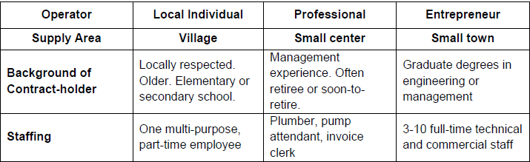Source: Valfrey-Visser (2006) Table 3, page 10
According to a World Bank study (2009) that conducted a world-wide survey of small network providers of water supply, private operators appear to be formal enterprises, with the majority of them holding an operating license issued by a government authority. Due to the large initial capital costs required for the investment private operators are likely to have some form of legal status, which could take the form of a license. Smaller network providers that are connected to up to 50 connections are typically owned by a single person who may have started the business as a private borehole owner and gradually expanding his business to connect other people. Larger providers are often owned by user associations established specifically for the purpose of developing a network for members’ use (20 to 500 connections).
Table 3 groups these operators by the scale of their operations and provides examples from each group.
Table 3 Profiles of WSS private operators
Country | Initiative | Profiles of operators
International
Cote d'Ivoire | Sodeci | Subsidiary of the multinational SAUR
Gabon | SEEG | Vivendi bought a controlling interest in SEEG the state- owned national water and electricity provider in 1997 when it was privatised
Burkina Faso | PAR and Sector Policy | Vergent Hydro, a French company, and its affilliate, Faso Hydro were awarded build and operate contracts for 7 piped schemes
India | Naandi | The Naandi Foundation, a large and successful India NGO partnered with Water Health International, a US manufacturing firm that sells its products in the US, Latin America and Asia and has entered into similar public private partnerships in Ghana, the Philippines, and India
National
Paraguay | 4th RWSS Project | The build and operate contracts under this project were awarded to consortia, led by construction firms with the capacity to meet the formal bidding requirements and raise the capital necessary to bridge periods until payments are received. The first winning consortia hired aguateros, small independent providers found largeley in urban areas, to manage the schemes. The final contract required that an aguatero be part of the consortium.
Bangladesh | Water supply program project | The project largely failed to attract genuine private sector operators, due to risk, low returns, and lack of financing. Operators are NGOs (which in Bangladesh operate for profit) and wealthy individuals who are interested for charitable reasons.
Benin | Sector Policy | Among the 80 operatos in Benin, the majority (74 percent) are national enterprises and consulting firms. The remaining operators are individuals, community associations, and small micro- enterprises.
Local
Niger | Sector Policy | A 2009 survey interviewed 31 out of the 41 operators who manage 175 piped schemes (including motorised boreholes). In this sample, 50% of the operators were individuals, motivated either by profit or a sense of social responsibility. They generally did not have water supply skills. Many were illiterate; some had primary or secondary school. Another almost 45% of the sample were very small enterprises or NGOs. Together the individual and small groups manage 95% of the schemes that have been delegated to operators.
Mauritania | Sector Policy | 100% of the operators are individuals
Cambodia | Rural Entrepreneurs | These are individuals who live in the area. The systems are built and slowly expanded with family savings. The family manages the schemes and possibly associated activities such as ice-making or vehicle washing. The entrepreneurs' motivations are providing family employment, a steady revenue, and assurance o a retirement income.
Source: World Bank, Private operators and rural water supplies, 2010

Choice of technology
A study by WSP provides a categorisation of the piped scheme technologies managed by private operators in Africa. Motorised point sources and simple piped schemes comprise over half of the piped supplies in Burkina Faso, Benin, Mali and Niger. The multi village schemes are mainly found in Senegal, Malawi and Rwanda
Figure 4 Categorisation of piped schemes for domestic water supply
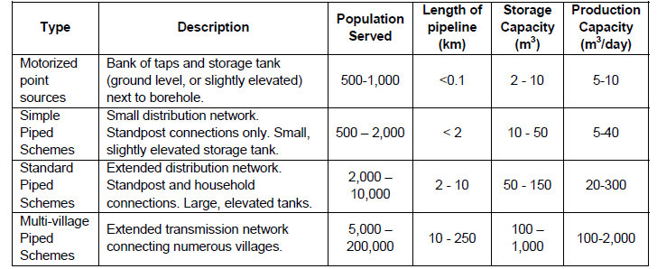
Source: WSP study cited above.
Private operators have taken responsibility for the full range of rural water supply technologies, from protected springs to large piped systems. Figure 5 gives a general overview of the technologies involved in the 25 initiatives reviewed here. The most common type of technology is a piped scheme with a pump or pumps and some level of water treatment. Only three initiatives included hand-pumps. Of those, Rwanda also included a few protected springs.
Figure 5 Rural private operator initiatives by technology
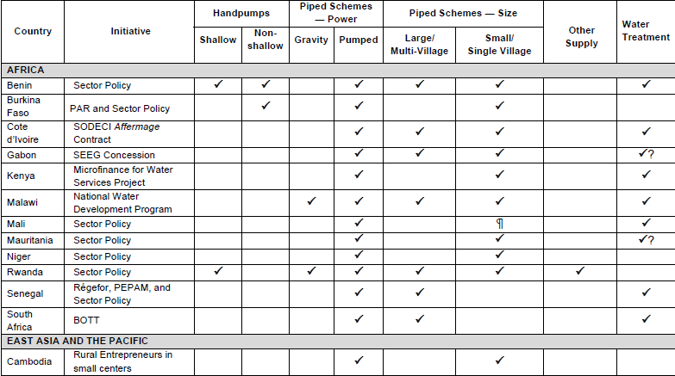

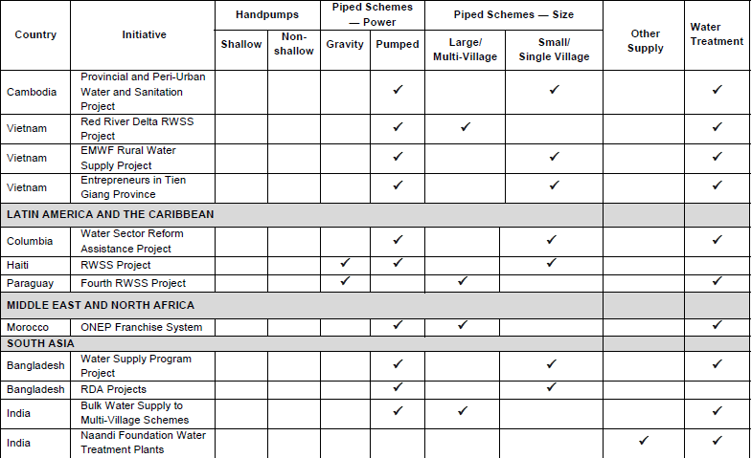
Source: World Bank, Private operators and rural water supplies (2010)

Main challenges faced by DPSPs
Looking at the various studies and international experiences, some of the main challenges faced by small domestic private service providers are identified as follows:
- Unclear legal and investment framework
- A lack of access to funding
- No local technical assistance available.
The subsections below briefly discuss the above points.

Unclear legal and investment framework
The majority of Governments in developing countries have taken some steps in improving the legislative framework for private sector participation in the provision of water and sanitation services. Even in those countries were several laws have been enacted that aim to facilitate the involvement of private operators in the supply of water have failed to implement them efficiently.
Moreover, in most countries the regulatory processes, such as obtaining a license, is unclear and at times too complicated and bureaucratic, and more importantly, there are no clear rules regarding tariff setting, such as the case in Cambodia. In many countries, the validity of licenses is only a couple of years which generates high risks for potential investors. The majority of licences also do not include important parameters such as quality standards for water, technical performance standards of operators and required treatment of water.
In most countries, small private network providers operate in the informal sector and they are not regulated for their services.
Reform of the water supply sectors in developing countries should take place in order to set the necessary regulatory authorities that will regulate the provision of water supply in rural areas and small towns, provide guidance on tariff policy and give a legal status to small private providers.

A lack of access to finance
The amount of capital requirement for investment varies widely and depends on factors including the nature and size of the piped network and the number of connections. However, limited access to capital to finance the investment appeared to be a constrained in most cases. According to a World Bank survey conducted in 2005, small private sector providers of water supplies supported that they depended on three sources to fund their initial investment:
- Own earnings and savings
- Loans from friends and family
- Money borrowed from formal and informal lenders
Banks and financial institutions are reluctant to provide loans to WSS service providers because of their lack of knowledge and experience regarding private sector participation in the supply of water, and also because some areas the affordability of the community is really low and therefore the tariff that can be charged are not able to repay the loans.
As a result the great majority of investors cannot access any fund from the banking sector. This situation is not only faced by individuals or very small businesses, who have no assets to use as collateral, but also by providers holding public sector contracts, such as municipal standpipe operators, or vehicle licenses.
Therefore, the only option left for potential private operators is to borrow money from the informal sector, which includes friends and family members. Even though the interest rate charged can be even higher, the loan conditions are flexible, the grace period is revisable and no collateral is needed.
Formal lending institutions need support from the public sector in order to facilitate the access of funds for those that want to invest in the provision of water supply and sanitation services.

No local technical assistance available
Professionals that are willing to become network providers of water and sanitation services have very limited resources to develop their skills and knowledge. The majority of private network providers are civil engineers trained either in national or international schools. No courses are available in urban water engineering.
Educational institutions should recognise the knowledge gap and offer the opportunity to your professionals to learn about hydraulic engineering, how to design a water production plant and how to operate a small business.

Preliminary Hypotheses
Based on the literature reviews and analysis conducted for this report, the preliminary hypotheses are presented in this section. These hypotheses are taken into account in forming our key conclusions and lessons learnt in presented in the Best Practice Report.

What encourages the growth of DPSPs?
Figure 6 illustrates the preliminary hypotheses, showing the main factors that influences and encourages the growth of DPSPs in the WSS sector.
Figure 6 Preliminary hypotheses

Decentralisation of public service provisions
In most countries, the decentralisation of public services to local government institutions have directly or indirectly influence the degree of private sector involvement in providing WSS services.
Decentralisation devolves public service provisions to the local government institutions, and in some cases, such as in Colombia and the Philippines, the local government institutions are allowed to choose how to provide the services. In Uganda, the decentralisation of WSS service provision was part of the WSS sector reforms, which include the regulatory framework through the performance contracts.
Factors that lead to local government institutions choosing to contract private operators to provide WSS services include:
- Lack of capacity and ability of the local government institution to provide WSS services themselves
- Poor performance of community based organisation in providing WSS services
- Lack of availability of public sources of finance, which encourages local governments to seek private sector investments.
However, decentralisation of public services can also create issues, such as the lack of experience and ability of local government institutions to procure suitable private sector partners, to design an appropriate PPP contract and to monitor the performance of the private operator. These skills and knowledge about PPPs are usually pooled in the national or central government level.

Central government support
The availability and degree of central government support to local governments also strongly influence the market making and private participation in WSS service provision. The private sector will always want to minimise risks, especially if private investment is involved (not just operation but also capital investment). Central government support can reduce many of the risks to private investments.
Central government support includes:
- Clear legal and institutional framework – having a solid foundation in the legal framework gives private sector the confidence that their operation is protected by law. The legal framework also provides clear definition of the responsibilities of the public institutions involved in the WSS sector and can reduce complicated bureaucracy for the private sector.
- Clear regulatory framework – Good regulatory framework will also ensure the private sector that their interest will also be protected. This is especially important in terms of tariff setting. It is important that the private operator be allowed to charge tariffs that can cover their costs. Having a clear tariff approval process that are not political is key.
- Financial support – this can be in the forms of guarantees, budget allocation to the local government as counterpart investment fund, or subsidies. In some cases, where the affordability of the community is low, public funds may be needed for capital investments even if the operation of the system is contracted out to private sector.
- Capacity building and technical support – both to the local government institutions as the contracting agency, to the private sector, and to the community in general.
For example, in Uganda, the Ministry of Water and Environment provides conditional grants to the small town private water operators for extension and new connections to poor areas and for rehabilitation of aging infrastructure. In the Philippines, the LWUA provides technical and financial support to water districts and possibly also to private operators (this will need to be verified during field diagnostic phase).

Economies of scale and potential for growth
In general, the private sector is motivated by the financial rewards and profits. Therefore, factors that increase the potential for profits will be a positive incentive for private sector involvements. These factors include:
- Population density and average income of residence – high population density decreases costs to connect households to the water supply network, and higher average household income improves household’s willingness and ability to pay. Both of these improves the financial performance of the private operator and hence their ability to make profit. In the Philippines, there are very few cases of private sector management of the primary water supply system in a small town because small towns tend to have low population densities and high per capita investment costs. The high risks and low profits associated with these systems appear to have discouraged most private service providers.
- Economies of scale – small rural systems far from water source require high investment costs with small potential for cost recovery. If the rural area is close to another village, and it is possible for the private operator to provide both areas using one network, the potential for economies of scale will be an attractive attribute to the private sector. In Uganda, this was one of the constraints for the private operators, and the government is currently looking into the clustering of small towns in order to achieve economies of scale attractive to the private operators.
- Potential for growth – similar to the above point, successful private operators would like to expand their business to other locations. This is occurring in the Philippines, Uganda and Colombia.
- Availability of alternative sources – in the case of the Philippines and Uganda, the availability of private boreholes and other sources of water becomes a serious competition to small private operators. Awareness of communities of the importance sand benefit of safe water supply needs to be improved to support the private operators.
In summary, to get involved in the provision of WSS services, the private operator must feel confident that it can cover their costs and make a reasonable return on their investments.

Availability of financial products
The private sector needs to have access to financing products to provide the investment required by their contracts. In the Philippines, as well as in other countries not included in this study, such as Indonesia and Kenya, the lack of available financial product has hamper the growth or private operators in the WSS sector.
For example, commercial banks in Indonesia do not have much knowledge about the operation of a WSS company. They therefore require high collateral for loans to establish WSS operations. The small private operators in most cases have difficulties in providing forms of guarantee or collateral acceptable to the commercial banks.
As mentioned in the previous section, in some cases where cost recovery tariffs are not feasible due to low affordability, which led to commercial banks being reluctant to provide loans, public funds may be needed to cover capital costs. The private sector may then operate the system and provide for initial O&M costs.

What support can be provided?
Based on the above hypothesis, to encourage more DPSPs in WSS service provision, support should be given to both public institutions and private institutions.

To public institutions
At the national level, support is need in terms of providing an enabling environment for the DPSPs, which include:
- A review of the legal framework for the WSS sector to ensure that the legal framework provides clear mandate for all institutions involved in the WSS sector and that there are no major overlaps on the responsibilities and functions of the key institutions
- A review of the regulatory framework to ensure that regulatory functions are performed by competent institutions to ensure stable operating environment for the DPSPs. Investigation should be made on whether a separate regulatory agency can improve the regulatory environment
- Capacity building for key WSS sector institutions in the national level on how to design, implement and monitor PPP type contracts.
For sub-national level, especially for local government institutions, support is generally needed to improve the capability of the local government institutions, especially in the following areas:
- How to procure and select the most suitable private partner to operate and manage the WSS system in the area
- How to monitor the performance of the private operators
- Improve understanding of the management of WSS services, such as the importance of having tariff levels that covers the cost of operations.
In general, a study on clustering of WSS service provision will be beneficial. For example, it may be better for a provincial government to contract with a DPSP that will provide services to several local governments under that provincial government, as this will be more attractive to the DPSP given the economies of scale.

To private institutions
Clearly, capacity building support to DPSPs will be beneficial and will encourage further involvement in the WSS sector. The types of capacity building for DPSPs should be tailored to what is needed to be improved. Therefore, an initial diagnostics of what improvements are needed the most by the DPSPs should be conducted. In general, capacity building for WSS service providers (private or public) will include the following (but not limited to):
- Non-revenue water reduction
- Tariff calculation
- Collection and billing
- Financial management
- Asset management
- Customer relations.
In addition, given that many DPSPs in various countries have problems accessing financial products from commercial (or public) banks, it will be beneficial to improve these commercial and public banks’ understanding of WSS service provision so that they can provide tailored financial products, such as revenue-based loans to DPSPs.

ANNEXES

- Detailed Analytical Framework
  - National level analysis
The national level analysis focuses on the water supply and sanitation sector and how it is organised at the national level. The objective is to gain good understanding of the WSS sector in each country, what the governing laws, regulations, national policies and targets are, who the key players are at the national level, how the WSS sectors are being financed, and whether or not there is a specific PPP framework that the government is promoting. Table 4 summarises the national level analysis for each of the phases.
Table 4 National level analysis – topics and questions for each phase
Topics of analysis | Phase 1 – Desk Review | Phase 2 – Field-based Diagnostic | Phase 3- Knowledge dissemination
 | How things are meant to work in theory? | How things are really working in practice? | What lessons can be learnt?
Legal framework of WSS sector | - Was there a reform in the WSS sector that changed the sector significantly?  - If yes, what were the drivers for reform?  - What was the purpose of the reform?  - What were the main changes?  - What legislation and other legal instruments emerged from the reforms? | - Did the reform achieve the intended objectives?  - Did it succesfully address or improve the sector?  - What were the main drivers for the reform? Was there a particular individual 'champion' of the reforms?  - Was there any opposition to the reform?  - How was opposition handled? | - What worked well and what did not?  - How can the reform process be improved?  - Are there further reforms which are being planned?
WSS sector policies and national targets | - What are the short, medium, and long term goals for the WSS sector?  - Is there a published national policy and/or strategic plan for water supply and sanitation?  - Who is responsible for implementing the policies and plans?  - If yes, do the plans include investment requirements in the sector? | - In practice, are the policies and strategic plan being implemented?  - Who in practice is driving the implementation of the policy or plan?  - Are the targets being met?  - Are the plans being upated regularly? | - What needs to be updated and improved in terms of policies and strategies?  - Are the targets realistic?
Institutional and regulatory framework of WSS sector | - Who is suppose to be doing what in the WSS sector according to legislations and policy documents?  - Which ministries are responsible for setting policy and long term objectives?  - Is there a regulator?  - If not, who is performing the regulatory functions?  - In particular, who is designated to set and approves water tariffs? | - Who is actually doing what in practice?  - Which institution is leading the water sector in practice?  - In practice, is the institutional and regulatory framework effective?  - Are there regular water tariff reviews and adjustments?  - Is the process of tariff approvals and setting transparent and fair?  - Is there a formal structure for regulating sanitation?  - What are the perceived main problems with the existing structures?  - What are the perceived strengths? | - What are the weaknesess of the existing institutional and regulatory framework?  - What are the strengths?  - What areas need improvement?  - What can be done to improve public institutions?
Public Private Partnership (PPP) framework | - Is there a PPP framework in place?  - Are there any specific pieces of legislation or regulations for PPP?  - What are the incentives for PPP?  - Who are the key actors in PPP in the public sector? | - What is the experience with PPP so far (not just in WSS)?  - How many PPP transaction has there been to date? In which sectors?  - Is the PPP framework an incentive or a hinderance?  - What is the main constrain for PPP? | - What can be done to encourage more PPP?
Financing framework of WSS sector | - How is the government budget allocated to the different sectors?  - Who allocates the government budget?  - In the WSS sector, which institution prioritises investments?  - What tools or methods are used to prioritise investment?  - What percentage of the budget is allocated to the WSS sector on average?  - Is there a WSS sector investment plan?  - Is there significant donor funding available for WSS investments? | - In practice, who allocates the government budget?  - In practice, how are invetsments prioritised?  - What are the main sources of funding for investments in the WSS sector? | - What can be improved in terms of making the budget process more efficient and effective?  - What can be done to attract more private investment?

  - Sub-national level analysis
The sub-national level analysis seeks to understand the definition of small towns (expected to be different in each country), the dynamics of rural and urban areas, and the way the different levels of governments and public institutions provide public services. The objective is to see if there are certain factors that influence the way public services are provided by the different levels of governments. Table 5 summarises the sub-national level analysis for each phase.
Table 5 Sub-national level analysis – topics and questions for each phase
Topics of analysis | Phase 1 – Desk Review | Phase 2 – Field-based Diagnostic | Phase 3- Knowledge dissemination
 | How things are meant to work in theory? | How things are really working in practice? | What lessons can be learnt?
Levels of government | - What are the levels of governments (ie national, provincial/regional, local governments/municipalities)?  - Who is supposed to do what in terms of the WSS sector at the different levels of governments?  - Is there any regional/local legislation or regulation for the WSS sector? | - Is there any conflict between levels of government in terms of public service provision and/or infrastructure investments?  - Who are the other key players in the WSS sector in the different levels of government? | - What can be done to improve public provision of services?  - How can the relationship between levels of government be strengthen?
Public service provision in sub-national levels | - What are the roles of each level of governments in terms of providing public services?  - Which level of government is mandated to provide water and sanitation services?  - Which level of government contracts with or engages with private service providers? | - Which level of government is most effective in providing services?  - Which level of government has the capacity to engage with private service providers?  - What services are currently provided by the private sector?  - What motivates private service providers to provide publis services?  - What demotivates private providers? | - What incentives can be provided to attract private service provision?  - What skills are needed by public institutions to provide the framework and incentives to attract private service provision?
Definition of small towns and rural areas | - What are the definition of small towns and rural areas in terms of:  - Population and demography  - Geographical location  - Economic activities  - Availability of infrastructure  - Availability of public services  - Proximity and connectivity to other small towns or rural areas | - In practice, when do rural areas become small towns? What drives this process?  - How is the process encouraged and managed by government structures?  - What measures are used in practice to define a settlement as rural or small towns? | - What are the most common definition used for rural areas or small towns?  - How does service provision vary across different forms of settlement?
Dynamics of the urban hierarchy | - How does the definition of small urban towns and rural areas change over time?  - What are the main drivers for change?  - How do the changes affect public service provisions? | - In practice, how do the changes affect public service provision?  - How do public institutions cope with increasing need for public services?  - How well are these needs being met and who finance the investments? | - How can the dynamics of change in rural growth areas and small towns best be managed?  - What can encourage the private sector to get involved in public service provision?

  - Small town WSS analysis
In this level of analysis, the focus is on WSS service provision in small towns. The objective is to further understand why in some small towns WSS services are provided by domestic private service providers and in others the local government or other public institutions choose to provide the services themselves. This level of analysis will rely mostly on discussions with key players, such as the private operators, local governments and other local level institutions, with the key information most likely being gathered during the field diagnostic phase. Information gathered during the desk review may be limited and will need to be verified in the field diagnostic phase.
Table 6 Small towns WSS analysis – topic and questions for each phase
Topics of analysis | Phase 1 – Desk Review | Phase 2 – Field-based Diagnostic | Phase 3- Knowledge dissemination
 | How things are meant to work in theory? | How things are really working in practice? | What lessons can be learnt?
Small towns with private service providers | - Population and demography  - Geographical location  - Economic activities  - Availability of infrastructure  - Proximity and connectivity to other small towns or rural areas  - What other services are provided by private service providers?  - PPP model for the private provider of water and sanitation services?  - Details of the services provided by private provider (number of customers, technology used, customer satisfaction, etc)  - How is the water tariff set?  - Who owns the assets/infrastructure?  - What are the monitoring and evaluation mechanisms?  - Who does the private service provision contract with or deal with in the public sector? | - What motivates or what is the reason for private service provision (ie, why not provided by public institutions)?  - Are the water and sanitation private service providers profitable or at least can cover costs?  - Are there any issues with asset ownership and investments?  - What incentives are in place to attract private service providers ?  - Are there any issues with water tariff setting?  - Are there issues with regulation of sanitation services provided by the private sector?  - Are the monitoring and evaluation mechanisms effective?  - Are services provided by private operators satisfactory? | - What incentives work in terms of attracting private service providers?  - What skills do public institutions need to gain or strengthen to be able to provide these incentives?  - What monitoring and evaluation mechanisms can be put in place or enahnced to improve private delivery of services?
Small towns without private service providers | - Population and demography  - Geographical location  - Economic activities  - Availability of infrastructure  - Proximity and connectivity to other small towns or rural areas  - Are there any other services provided by private service providers?  - Who provides water and sanitation services? | - Why are there no private WSS service providers?  - What difference do these small towns have compared to small towns with private provision of WSS services? | - What policies or conditions hinder private provision of WSS services?  - How can the constraints to private provision be removed or reduced?

- Summary of Questionnaire Responses
  - Water supply and sanitation sector information
Table 7 Water Supply and Sanitation Sector Information
Topic | Questions | Cambodia | Niger | Senegal
Legal framework of WSS sector | Was there a reform in the water sector that changes the sector significantly?  If yes, what were the drivers for reform?  What was the resulting legislation and other legal instruments? | Until mid-2014, Cambodia does not have clear legal framework regulating the procedures to apply and grant license for private water service providers.  In May 2014, the Ministry of Industry and Handicraft (MIH) issued ministerial decree (called Prakas) to regulate the licensing regime of both public utilities and private operators. There was a strong request from the private sector, especially the Cambodian Water Supply Association (CWA) for detail, transparent and predictable license application procedures and for longer-term license (the license term before the issuance of Prakas was 3 years, now in the Prakas it is 20 years). There was also recognition from the Department of Potable Water Supply of MIH about the absence of clear licensing procedure to follow the reporting scheme and monitoring modality; which hinder the Ministry regulatory role. | WSS services in rural was handled by national government and managed by communities before the decentralization. Due to the weak performance of community based management the PPP was tested through delegated affermage lease contract with local private sector since 1996. With the decentralization in 2005, many service provision including WSS services were allocated to communes. Since then, the central government conducted an assessment of the two types of management in the perspective of smooth handover to communes. Based on this assessment the GoN decided on the option to manage rural assets through PPP arrangement (affermage lease contract) in 2009 where communes are assets holders with responsibility to delegate the management of rural systems to private sector.  In urban area, the sector was managed by Government National company. Because au poor performance due to Government interference and other factors, the urban water reform was conducted in 1999 and finalized in 2001. In 2001 this reform led to the creation of two entities: (i) a Government body responsible of assets responsible for investment programs and debt service repayment, this body is a public company with concession contract with the Government. (ii) a private company responsible for the operation of infrastructure and marketing of water services, this company has an affermage lease contract with the Government. | The Government experiments a reform in the urban water sector by establishing on 1996 a new asset-holding company (SONES) and recruiting through a competitive process a private operator (SDE) to operate in 66 urban centres.  The aim of the reform was to improve key PIs, restore sector equilibrium and boost investments. Some years later the sector equilibrium is restored on 2003 and access rate in urban water perimeter reaches 98% by 2013.  On 2008 the SPEPA law was established to reinforce the role of private sector in the management of WSS services both in urban and rural sector.  But provision of water services in rural water and small towns still remains the responsibility of the Ministry on charge of water through DEM the government entity which supervises operation and maintenance activities conducted by the ASUFORs (water users association).  On 2014, a new reform is launched to involve private operators in the management of rural water facilities beside OFOR the new asset-holding body created for rural water in replacement of DEM.
 | Please provide information on the existing main legislation governing the water sector: | - National Policy on Water Supply and Sanitation adopted in 2003  - Ministerial decree (Prakas) on the Implementation of the Drinking Water Quality Standards dated April 27, 2004.  - Ministerial decree (Prakas) on Procedure for Issuing, Revising, Renewing, Suspending and Revoking Permit for Water Supply Business, dated May 2014. | For the urban area there the “sector policy letter“ governing the urban water reform.  In rural area, “the nation rural water supply service Guide“ governs the sector and allocates the roles and responsibility of actors involved. | On 2014, Senegal promulgates two laws to reinforce the role of private sector in the management of public services.  OFOR Law– Adopted by Parliament January 30, 2014, to establish OFOR in the place of DEM.  New PPP Act– Adopted by Parliament February 10, 2014, replacing 2004 BOT Act. The new Act:  - Enlarges the scope of PPPs by including new sectors such as agriculture, education, and health  - Includes incentive measures to improve enabling environment
Institutional framework of the WSS sector | Is there an institutional diagram for the water sector? If yes, please provide | We are attaching SDA report that provides further background reading. |  | Yes, see the 2 diagrams attached for urban and rural water sectors.
 | What national level institution is responsible for policy formulation and setting national targets and plans for the water sector? | The MIH is the national level institution that is responsible for policy formulation and regulating the water sector. | This is the Ministry of Water and Sanitation | This is the Ministry of Water and Sanitation
 | What national level institution is responsible for implementing WSS projects and/or monitoring the performance of the WSS sector? | The MIH, specifically the Department of Potable Water Supply and the Provincial Department of Industry and Handicraft. | For the Urban this is the Assets holding company SPEN.  In Rural the Ministry of Water and Sanitation is still the main responsible, but the communes can also invest. For the moment the communes own the assets and are in charge on the management of these assets. | In Senegal, these responsibilities are delegated for:  - Urban water to the asset-holding company (SONES)  - Rural water to the directorate of water development (DH) for projects implementation and OFOR for monitoring the performance of WSS services delivery.
 | Is there a national level strategic plan or road map or master plan document for the water sector? Is yes, what are the main goals or targets for the water sector? | - The 2003 National Policy on Water Supply and Sanitation. The main goals/targets of the Policy include:  - the communities should be involved in the decision making process and the choice of the service;  - the promotion of private sector participation in investing and managing water systems shall be sought to extend coverage and improve efficiency and accountability in the water sector;  - a Water Authority will be established to regulate the piped-water sector in Cambodia; and  - tariffs should be set to allow both economic efficiency and financial sustainability of the systems; and facilities should be put in place to facilitate access for the poorest and subsidies shall be used for that purpose.  - The National Strategic Development Plan (NSDP) 2014-2018. The main objectives of NSDP include:  - At least 80% of urban population has access to improved water supply by 2015 and 85% of urban population with access to direct piped water by 2018;  - Develop a legal framework for urban water supply, namely the Water Law;  - Transfer full autonomy for service delivery to all 10 provincial waterworks by 2018;  - Increase sector financing by encouraging and motivating investment by the private sector;  - Improve sector performance and access to safe, affordable and sustainable water supplies;  - Improve water source protection and enforcement of regulations. | There is the National Program for Water Supply and Sanitation covering both the urban and the rural. In addition the urban has also the master plan for infrastructure investment. | On 2005, Senegal established the roadmap and the millennium country program (PEPAM) 2005- 2015 to reach the MDGs in the water and sanitation sector
Regulatory framework of the WSS sector | If there is a separate regulatory agency, what are the regulatory functions performed? | None. The MIH is the regulatory body for urban water sector. | Niger used to have a national regulator in charge of Telecom, Energy, and Water and transport regulation. This body was dissolved for political reasons, now this body is regulating only telecom, the other sectors have their regulation bodies inside the line ministries including water sector. | In Senegal a regulatory body is not yet implemented for the water and sanitation sector. The WSS sector is regulated by contract with a Ministry leading role
 | If there is no separate regulatory agency, what national level institution is responsible for performing the regulatory functons the WSS sector? | It is MIH, department of potable water supply | A regulation body is created within the Ministry of Water and Sanitation. It is composed by people from the Ministry of Water, Civil Society, Ministry of Plan, and Ministry of Finance. | The Ministry delegates some regulatory functions to SONES and OFOR which supervise the PPP contracts on behalf the State.
 | Is there a plan to establish a regulatory agency? If yes, what is the status of this plan? | In the 2003 National Policy on Water and Sanitation, there is a plan to establish a separate regulatory agency; however, in the recent NSDP adopted in 2014, there is no such a plan in the coming 4 years, at least. | Already effective | The discussion on regulation is on-going in the country, the Government plans to review the question during the next generation of reforms
Financing of framework of the WSS sector | How does the government budget allocated to the different sectors? | The budget allocation is through the National Budget adopted by the National Assembly. The Ministry of Economic and Finance allocated the budget to all the ministries based on their agreement and budget plan worked out before submitting to the National Assembly for adoption. | The Ministry of Finance allocates the budget to various line ministries on Lump sum basis, but there some changes in perspective to allocate based on planning and results to achieve. | The Government allocates a budget line for each sub-sector: urban & rural and water &sanitation
 | Is there a water sector investment plan? | None | There is one for Urban as mentioned above and another one in the National Program. All donors and the Government are contributing to this investment plan. | The investment plan is the one prepared for the Millennium Development Goals Program (PEPAM) where Government budget allocations and contributions from Development partners are directed within the Unified Framework of Intervention (UFI).

  - Government Structure and Public Service Provision
Table 8 Government Structure and Public Service Provision
Topic | Questions | Cambodia | Niger | Senegal
Levels of government | What are the levels of governments (ie national, provincial/regional, local governments/municipalities)? | In Cambodia, we have National and sub-national governments. Sub-national governments include the province, district and commune. Commune has elected representation; district and province not. | There is the national government, and the Regional Government (equivalent to the Province), the departmental Government (equivalent to the District) and Communal council (Commune) | In Senegal with the new Decentralization Act established in 2013, there are the following levels:  - Government: national, regional, department  - Local Governments: department council, communes
 | Who is doing what in terms of the water sector in the different levels of governments? | The urban water sector is very centralized at the National level and line ministries that are the MIH and Provincial Department of Industry and Handicraft (DIH). However, Provincial government can sometimes issue permit for small scale private operators (normally below 500 connections) where there is no public utilities or licensed private operator, but this is not documented in any legal act, rather this is a practice.  The Commune plays more and more significant role in the water sector, as the private operators need to firstly check with the communal authority for viability in investing in the areas to avoid overlapping license areas and need communal approval as the first approval stage before submitting their license application to DIH and MIH. | Policy setting is the national government's responsibility, while service provision is devolved to local governments | Policy setting and service provision are the responsibilities of national government. But service provision is often delegated to public or private entities through contract arrangements
Public service provisions | What are the roles of each level of governments in terms of providing public services? | See details in SDA report (chapter 3-4) | The devolution is under way; central Government is still responsible for heavy investments for all sectors including WSS. Local governments are responsible for WSS services in terms of assets ownership and their management. They are also responsible for light investments (Generators renewal, service extension). | In Senegal the role and responsibilities are shared as described below:  - National Government: sector policy, investment, tariffs, water resources,  - National bodies: planning, project implementing, monitoring of WSS services  - Local Governments: investment  - WSS services delivery: public or private operators, CBOs
 | Which level of government is mandated to provide water and sanitation services? | It is the public utilities, but currently there are only 12 public utilities, out of which 2 are autonomous public enterprises. The remaining 10 public utilities are under the supervision of the MIH. The majority of water service providers are the private sector which accounted to 147 licensed operators or 300 private operators if we include the un-licensed operators. | Both central and local levels are responsible, but the central government has the mandate to provide this service. | The role is dedicated to National government entities which must contract with operators (public or private) and CBOs in the case or rural areas.
 | Which level of government contracts with or engage with private service providers? | Licensing contracts are done through MIH, although require commune approval and provincial approvals before being submitted to MIH | For water the communes are the one engaging with the private service providers in rural while in urban the SPEN (assets holding company) is in charge. For Sanitation the municipalities are responsible to contract with private service providers both in rural and urban. | In Senegal, it is the role of the public bodies like SONES, OFOR for urban & rural water and ONAS for urban sanitation
Definition of small towns and rural areas | Is there a formal definition of small towns? If yes, what are the definition of small towns vs rural areas? | No formal definition | Small towns are rural cities with population between 10,000 to 20,000 people | There is no formal definition for small towns, but there is a perimeter dedicated to urban water (SONES) and the remaining perimeter for rural water and small towns (OFOR)
 | If there is no formal definition of small towns, what loose definition is used to signify growth centers that can attract private sector to get involved in WSS service provision? | Growth centres of around 5000 inhabitants and upwards (smallest private providers average around 750 connections, and often connect only 50% of those in the network area); | Niger has this definition related to water and sanitation services. So it more WSS sector definition than National statistics institution | In Senegal the following segmentation is used:  - Urban areas: Population > 10,000 - Dakar & main cities  - Semi- urban areas: 5,000 < Population < 10,000 – small towns  - Rural areas: 2,500 < Population < 5,000 – growing centres  - Rural areas: Population < 2,500 – villages
 | How do changes in growth centers affects public service provisions? |  | Lack of capacity of private sector and communes led to poor service delivery with break downs and service discontinuity in case of Niger. | There is a mechanism to identify (financial study for equilibrium of urban water sector) some small towns to transfer into the urban perimeter managed by SONES and SDE. For instance there are 10 small towns already identified to be transferred to the urban water perimeter during the period 2014- 2016.

  - Private Sector Existence and Level of Involvement
Table 9 Private Sector Existence and Level of Involvement
Topic | Questions | Cambodia | Niger | Senegal
Public Private Partnership (PPP) framework | Are there any PPP specific legislation that sets up a PPP framework? |  | Niger has at Prime Minister office an institution whose role is to support PPP related activities by the way facilitating transactions in all aspects. | In Senegal the SPEPA Law (2008) is the legislation framework that enables PPP transactions in the water and sanitation sector. A specific law is promoted on February 2014 for the establishment of OFOR in the rural water sector while for SONES the 1995 PPP Law for urban water was updated by the SPEPA Law.
 | Is there any form of incentives for private sector involvement in WSS sector? |  | This need to be clarified with the PPP specialist in World Bank office. | There is a framework that facilitates doing business with the support of APIX a public body that support entrepreneurship. Private operators can also count on support from FONSIS, FONGIP and BNDE, financial institutions set up by the Government to encourage and strengthen private sector participation
 | Is there a national institution responsible for development or PPP type arrangements? |  | In Niger as mentioned above there is a PPP body in the Prime Minister office. | In 2004, Senegal set up the Infrastructure Council (CA) to facilitate the PPP transactions within the 2004 BOT act. This framework is updated on February 2014 with the new PPP Act that eenlarges the scope of PPPs by including new sectors such as agriculture, education, and health.
Experience with private sector involvement | What is the experience with PPP projects in general? |  | Niger has PPP experience in WSS sector and in telecom. Other prospectus is in the pipeline. | PPP projects are used in the infrastructure sector. In the water sector, PPP cover service delivery provision with lease contract arrangements. PPP concession contracts are signed in the telecom sector and the transport sector (toll road). For electricity sector we notice some BOT projects mainly with Independent Power Producers (IPP).
 | What is the experience with PPP, or any forms of private sector participation in WSS sector so far? |  | Niger WSS in both rural and Urban are under PPP | The success of the urban water reform with a lease contract established since 1996 encourages the Government to launch on 2014 a reform in the rural water sector by establishing OFOR (rural asset holding company) and preparing delegate management for rural water systems through lease contract in targeted clusters of rural water supply schemes.
 | What is the private sector market status? |  | In rural private sector is improving but there still way to go while in the urban the reputation is good. | The Government set a communication campaign dedicated to the private sector to present the business opportunities of the rural water sector reform. As a result, about twenty (20) private firms participate in the two first bidding processes to recruit private operators for lease contracts.
Perception of private sector involvement | What is the general perception of having private sector involvement in providing public services such as WSS? |  | Niger has opted for PPP in both rural and urban WSS. | The urban water experience is described as a success story, so the shift in the rural water is well accepted, but there is some work to do to convince the rural water actors mainly the water user associations (ASUFOR).
Challenges to the private sector | What are the perceived main challenges in encouraging private sector involvement? |  | Rural area needs capacity reinforcement of both public and private institutions to better handle the issues related to WSS.  In unban sanitation there are things to build in deep in public institutions and regulatory framework. | In Senegal rural water actors fear increase in water tariffs by involving the private sector
 | What support can be provided to public institutions to help them support and encourage more private sector participation? |  | In the case of Niger as above, capacity building in providing public services (benefit to government as well as to the community) | Some support to OFOR is needed to help the new institution in developing its activities on capacity building and communication towards local governments & ASUFOR. A support is also needed to develop a monitoring system for OFOR to supervise the management of rural water schemes operated by the private sector.
Private sector involvement in small town WSS service provision | Is there any example of PPP in the water sector in small towns? If yes, please provide information, such as:  - Population and demography  - Geographical location  - Economic activities  - Availability of infrastructure  - Proximity and connectivity to other small towns or rural areas  - What other services are provided by private service providers?  - PPP model for the private provider of water and sanitation services?  - Details of the services provided by private provider (number of customers, technology used, customer satisfaction, etc)  - How is the water tariff set?  - Who owns the assets/infrastructure?  - What are the monitoring and evaluation mechanism?  - Who does the private service provision contracts with or deals with in the public sector? |  |  | In Senegal there is currently no specific example of PPP in the small towns. The establishment of OFOR will open the door for such transactions. The first private operator will begin its activities on January 2015 for a perimeter of 350,000 people. Four (4) others transactions are on the pipe concerning about 5.2 million people in the rural areas.  NDP – GL Lease contract  - Population: 350,000  - Location: Central West (NDP) and North West (GL)  - Economic: Agriculture, Fisheries, Livestocks, Tourism, Industry  - Infrastructure: available for electricity, telecom, transport  - Proximity: close to centres in urban water perimeter  - PPP model: lease contract  - Service delivery: provision of drinking water, connection work  - Tariff: tariff setting is the responsibility of Government  - Asset: OFOR owns the asset  - M & E: It is the responsibility of OFOR on behalf the Government  - Contract: contracts are prepared by OFOR and submitted to Government for approval (MWS and MEF)

  - Conclusions and Key Lessons Learnt
Table 10 Conclusions and Key Lessons Learnt
Topic | Questions | Cambodia | Niger | Senegal
Water and sanitation sector | Provide a summary of the current key situation and elements of the water and sanitation sector in the country |  |  | - There are now 2 public bodies at national level responsible respectively for service delivery in urban water (SONES) and rural water (OFOR)  - There is not yet a regulatory agency, regulation issues are shared between Ministry of Water, SONES and OFOR  - Responsibility of providing WSS services has been delegated to private sector through lease contracts.
 | What is the key conclusion or lessons learn that can be useful for other countries? |  |  | The legal and institutional framework defines clearly the role of each actor involved in the PPP arrangements (State, Asset-holding company, Private operator) and the Government has a strong commitment to complete the sector reforms.
Government structure and public service provision | How does the country's government structure affect public service provision? |  |  | The government and two dedicated public bodies (SONES, OFOR) have the mandate to develop private sector participation in the management of water and sanitation services.
 | What is the key conclusion or lessons learn that can be useful for other countries? |  |  | The experience of setting up a public body to manage, develop the asset and monitor the service provision by the private operator is a successful arrangement that increase access and sustain the reliability of water service provision.
Private sector existence and involvement | What is the status of private sector involvement in public services in the country in general |  |  | The urban water sector experience is seen as a success, this encourages the private sector to be involved in water service provision and other sectors like electricity, telecom and transport.
 | Do the public institutions have the capacity and ability to enter into contracts with private sector? |  |  | Public bodies are gaining knowledge and experience in working with private sector through PPP arrangements. They need only to be supported at the beginning of the processes.
 | Is there a good presense of local private sector that are interested in PPP? |  |  | The private sector has seen the interest to be involved in PPP transactions and there is a growing demand for the on-going rural water sector reform.
 | What is the public perception of private sector providing public services? |  |  | The public perception is to be provided with good water service at affordable price, no mind if the provider is public or private.
 | Are there any key lessons learnt from the country's experience with PPP? |  |  | The PPP model of transaction in water sector (lease contract) has been experimented with some weak investments devolved to the private sector. It is time to explore more investments from the private sector side.
Support for the public institutions | What support is most needed by the public institutions in order to encourage more private sector participation? |  |  | The support can provided in terms of:  - Capacity building for ASUFOR in their new role of representing consumers  - Strengthening the capacity of the Asset holding company in its core missions.
 | What support has been received so far that are most useful and why? |  |  | WSP has provided support to Government to design OFOR and prepare due diligence and bidding documents for the PPP transactions.

The different definitions for countries across the globe are given on the UN DESA web site http://esa.un.org/unpd/wup/DataSources/Default.aspx
Well, PPP and the Poor in Water Supply Projects: The Ghanaian Experience (2005) http://www.lboro.ac.uk/well/resources/fact-sheets/fact-sheets-htm/RSA%20PPP%20and%20the%20poor.htm
World Bank, Private operators and rural water supplies (2010)
http://www.worldbank.org/projects/P057602/urban-water-supply-sanitation-project?lang=en&tab=overview
Well, PPP and the Poor in Water Supply Projects: The Ghanaian Experience (2005) http://www.lboro.ac.uk/well/resources/fact-sheets/fact-sheets-htm/RSA%20PPP%20and%20the%20poor.htm
World Bank, Private operators and rural water supplies (2010)
WSP, Private Operator Models for Community Water Supply (2010)
World Bank, Private operators and rural water supplies (2010)
World Bank, Private operators and rural water supplies (2010)
World Bank, Private operators and rural water supplies (2010)
World Bank, Private operators and rural water supplies (2010)
http://www-wds.worldbank.org/external/default/WDSContentServer/WDSP/IB/2014/07/01/000442464_20140701145221/Rendered/PDF/ICR29440P089830C0disclosed060270140.pdf
World Bank, Private operators and rural water supplies (2010)
World Bank/PPIAF, 2009, Reforming Urban Water Utilities in Western and Central Africa: Experiences with Public-Private Partnerships
World Bank/PPIAF, 2009, Reforming Urban Water Utilities in Western and Central Africa: Experiences with Public-Private Partnerships
AFD, 2011, Public-Private partnerships for Urban Water Utilities: The Senegalese experience, presentation Water and Sanitation EC-EIB Seminar
World Bank, Opportunities and Challenges for Small Scale Private Service Providers in Electricity and Water Supply (2009)
World Bank, Private operators and rural water supplies (2010)
http://www.lboro.ac.uk/well/resources/fact-sheets/fact-sheets-htm/PPP.htm
Valfrey-Visser, Bruno, David Schaub-Jones, Bernard Collignon, and Emmanuel Chaponnière, Access through Innovation: Expanding Water Service Delivery through Independent Network Providers, 2006
World Bank, Opportunities and Challenges for Small Scale Private Service Providers in Electricity and Water Supply (2009)
World Bank, Small-Scale Private Service Providers of Water Supply and Electricity (2005)
WSP Bilan et perspectives de la délégation de gestion sur les réseaux d'adduction d'eau en milieu rural et semi-urbain au Bénin, Burkina Faso, Mali, Mauritanie, Niger, Rwanda, et Sénégal, Dakar: Water and Sanitation Program (2010)
World Bank, A Review of Incidence, Structure, Pricing and Operating Characteristics (2005)
Water and Sanitation Program, Independent Water and Sanitation Providers in African Cities (2000)
The Cambodian Water Supply Association was established in August 2011. As of October 2014, it has 67 members (out of the total 147 licensed private operators) representing 80 water stations.

